**VIETNAM NATIONAL UNIVERSITY HO CHI MINH CITY**

**UNIVERSITY OF INFORMATION AND TECHNOLOGY**

**FACULTY OF INFORMATION SYSTEM**

-----🙞🙜🕮🙞🙜-----

**SUBJECT**

**ANALYSIS AND DESIGN INFORMATION SYSTEM**



**COFFEE SHOP MANAGEMENT**

**LECTURER:**

**Mr. Dương Phi Long**

**Ms. Cao Thị Nhạn**

**GROUP 4**

**Nguyễn Trần Hà Đức - 18520615**

**Nguyễn Thái Hòa – 18520763**

**Nguyễn Hữu Nhật Tân – 18520354**

**Phạm Thanh Nhựt - 20521728**

***TP. HỒ CHÍ MINH, 2022***

**TABLE CONTENTS**

CHAPTER 1: OVERVIEW OF THE PROJECT 7

1.1 Problems 7

1.2 Solutions 7

1.3 Objects 7

1.4 Tools used 8

CHAPTER 2: DETERMINATION AND ANALYSIS OF REQUIREMENTS 9

2.1 Content of the project 9

2.2 Current status survey 10

2.2.1 Interview plan 10

2.2.1.1 Interview plan 10

2.2.1.2 The General table of Interview Plan 11

2.2.1.3 Questionnaire and Recognition table 12

2.3 Business Descriptions 15

2.3.1 Business Descriptions “Employee information management” 15

2.3.2 Business description “Material information management” 22

2.3.3 Business description “Service Process Management” 29

2.3.4 Business description “Financial Statistics” 47

CHAPTER 3: SYSTEM DESIGN 52

3.1 Usecase Diagram 52

3.1.1 General Usecase Diagram 52

3.1.2 Admin Use Case Diagram 53

3.1.3 Storekeeper use case diagram 55

3.1.4 Cashier use case diagram 57

3.2 List of actors 58

3.3 List of Activity Diagram Specification 60

3.3.1 Activity Diagram Specification “Employee information management” 60

3.3.1.1 Add Personal Activity Diagram 60

3.3.1.2 Delete Personel Activity Diagram 61

3.3.1.3 Edit Personel Activity Diagram 62

3.3.1.4 Search Personal Activity Diagram 63

3.3.1.5 Add Account Activity Diagram 64

3.3.1.6 Delete Account Activity Diagram 65

3.3.1.7 Edit Account Activity Diagram 66

3.3.1.8 Search Account Activity Diagram 67

3.3.2 Activity Diagram Specification “Material information management” 68

3.3.2.1 Delivery_note_creation Activity Diagram 68

3.3.2.2 Material_add Activity Diagram 69

3.3.2.3 Material_delete Activity Diagram 70

3.3.2.4 Material_update Activity Diagram 71

3.3.2.5 Receipt_note_creation Activity Diagram 72

3.3.2.6 Search_delivery_note Activity Diagram 73

3.3.2.7 Search_Receipt_note Activity Diagram 74

3.3.3 Activity Diagram Specification “Service process management” 75

3.3.3.1 Add_Drink Activity Diagram 75

3.3.3.2 Add_Table Activity Diagram 76

3.3.3.3 Delete_drink Activity Diagram 77

3.3.3.4 Delete_Table Activity Diagram 78

3.3.3.5 Edit_Drink Activity Diagram 79

3.3.3.6 Payment Activity Diagram 80

3.3.4 Activity Diagram Specification “Financial statistics” 81

3.3.4.1 Revenue Statistic Activity Diagram 81

3.3.4.2 Revenue Statistic of Area Activity Diagram 81

3.3.4.3 Revenue Statistic of Drinks Activity Diagram 83

3.3.4.4 Revenue Statistic of Days Activity Diagram 84

3.3.4.5 Search Revenue Statistic Activity Diagram 85

3.4 List of Sequence Diagram 86

3.4.1 Sequence Diagram: Employee information management 86

3.4.1.1 Add Personnel Sequence Diagram 86

3.4.1.2 Delete personnel Sequence Diagram 87

3.4.1.3 Edit personnel Sequence Diagram 88

3.4.1.4 Search personnel Sequence Diagram 89

3.4.1.5 Add account Sequence Diagram 90

3.4.1.6 Delete account Sequence Diagram 91

3.4.1.7 Edit account Sequence Diagram 92

3.4.1.8 Search account Sequence Diagram 93

3.4.2 Sequence Diagram: Material information management 94

3.4.2.1 Delivery_note_creation Sequence Diagram 94

3.4.2.2 Materials_add Sequence Diagram 95

3.4.2.3 Materials_delete Sequence Diagram 96

3.4.2.4 Materials_update Sequence Diagram 97

3.4.2.5 Receipt_note_creation Sequence Diagram 98

3.4.2.6 Search_delivery_note Sequence Diagram 99

3.4.2.7 Search_receipt_note Sequence Diagram 99

3.4.3 Sequence Diagram: Service process management 100

3.4.3.1 Add drink Sequence Diagram 100

3.4.3.2 Add table Sequence Diagram 101

3.4.3.3 Delete Drinks Sequence Diagram 102

3.4.3.4 Delete Table Sequence Diagram 103

3.4.3.5 Edit Drinks Sequence Diagram 104

3.4.3.6 Edit Table Sequence Diagram 105

3.4.3.7 Payment Sequence Diagram 106

3.4.4 Sequence Diagram: Financial statistics 106

3.4.4.1 Revenue Statistic of Area Statistics 106

3.4.4.2 Revenue Statistic of Drinks Statistics 108

3.4.4.3 Revenue Statistic of Days Statistics 109

3.4.4.4 Revenue Statistic Statistics 110

3.5 List of Class Diagram 111

3.5.1 Class Diagram: Employee information management 111

3.5.1.1 Personnel Management 111

3.5.1.2 Account Management 111

3.5.2 Class Diagram: Material information management 112

3.5.2.1 Delivery_note_creation Class Diagram 112

3.5.2.2 Materials_add Class Diagram 113

3.5.2.3 Materials_delete Class Diagram 114

3.5.2.4 Materials_update Class Diagram 114

3.5.2.5 Receipt_note_creation Class Diagram 116

3.5.2.6 Search_delivery_note Class Diagram 117

3.5.2.7 Search_Receipt_Note Class Diagram 118

3.5.3 Class Diagram: Service Process Management 119

3.5.3.1 Add drink Class Diagram 119

3.5.3.2 Add table Class Diagram 120

3.5.3.3 Delete Drinks Class Diagram 121

3.5.3.4 Delete Table Class Diagram 122

3.5.3.5 Edit Drinks Class Diagram 123

3.5.3.6 Edit Table Class Diagram 124

3.5.3.7 Payment Class Diagram 125

3.5.4 Class Diagram: Financial statistics 126

3.5.4.1 Revenue Statistic of Area Statistics 126

3.5.4.2 Revenue Statistic of Drinks Statistics 127

3.5.4.3 Revenue Statistic of Days 127

3.6 List of State Diagram 128

3.6.1 Payment State Diagram 128

3.6.2 Table booking State Diagram 129

CHAPTER 4: DATABASE DESIGN 130

4.1 Detailed description of Entity Models (Concept Level) 130

4.1.1 Name of entity: ACCOUNT 130

4.1.2 Name of entity: BILL 131

4.1.3 Name of entity: BILL_DETAIL 132

4.1.4 Name of entity: DRINKS_MENU 133

4.1.5 Name of entity: DELIVERY_NOTE 134

4.1.6 Name of entity: DELIVERY NOTE DETAIL 135

4.1.7 Name of entity: RECEIPT_NOTE 136

4.1.8 Name of entity: RECEIPT NOTE DETAIL 136

4.1.9 Name of entity: MATERIALS 137

4.1.10 Name of entity: TABLE NUMBER 138

4.1.11 Name of entity: EMPLOYEE RECORD 139

4.2 Entity model / Associate (ERD) model to Physical model (Physical Level) 141

CHAPTER 5: INTERFACE DESIGN AND HANDLING 142

5.1 Login 143

5.2 Input Warehouse 143

5.3 Output Warehouse 144

5.4 Material table 145

5.5 Add, edit materials 145

5.6 Slip management 146

5.7 Order 146

5.8 Payment 147

5.9 Menu Management 147

5.10 Add, Edit Menu 148

5.11 Employee Management 148

5.12 Add, edit employee 149

5.13 Account management 149

5.14 Add account, change password 150

5.15 Table Management 150

5.16 Add table 151

5.17 View Statistic of Area 151

5.18 View Statistic of Days 152

5.19 View Statistic of Area 152

CHAPTER 6: CONCLUSION 153

6.1 Gained result 153

6.2 Disavantages 154

6.3 Development 154

# OVERVIEW OF THE PROJECT

## Problems

Information technology has been applied to build and organize systems scientifically, closely, helping management avoid unnecessary errors and minimize the possibility of data loss through information, thereby helping the business and operations of the company, businesses can become smooth, increase productivity, and minimize management costs, as well as increase the convenience for users, helping them work better.

Coffee shops appear to meet the needs of people working and entertainment, they need a quiet and comfortable place to be able to work effectively or have a quiet time to relax or relax. is simply a place for couples and friends to meet and talk to each other. However, with more and more people coming to the cafe, the customer service and management of coffee so that the efficiency will be more focused.

## Solutions

To optimize the system of coffee shop management, the team proposed to build a coffee management system for easy and accurate management. Moreover, the functions of the system help the shop to save manpower and save time.

## Objects

* Building software to manage cafes and sales with the requirements set out:
* Building a new database stored on the computer.
* Ensure system security and user information security.
* Intuitive, lively interface easy to use, user friendly.

## Tools used

* In order to build the cafe management software, the team used the following tools:
* StarUML: supporting to draw all diagrams.
* IntelliJ: an IDE for java coding to do the demo.

# DETERMINATION AND ANALYSIS OF REQUIREMENTS

## Content of the project

The owner of a coffee shop requests to develop a software to systematize the business process of the cafe, meeting the actual needs of customers in order to solve difficulties, inconveniences and minimize errors. bar. Software needs to manage facilities, materials; Financial statistics; employee information management and service process management.

Managing the current facilities of the cafe (for example, the number of tables in each area, ...) and managing the materials for the cafe are very important, helping the owner know the status of the ingredients currently in stock to import additional materials if needed.

Service process management: Detailed information on drinks including: ingredients, quantities, prices; types of drinks (coffee, soft drinks, ice cream, fruit smoothies, cocktails ...). The system supports the function of updating and searching information of drinks, showing the availability or unavailable status.

Employee management: the system can manage details of each employee working in the shop, specifically about background information, what department to take, the corresponding salary, number of days worked in the month. Especially, the system has the function of decentralizing the employees working in the shop, specifically for each type of employee as follows:

* Service staff, dispensers: Perform the work assigned by the owner, do not use the system.
* Cashier: Can use the system to log in, create invoices, look up table information, look up and manage customer information, look up menu information.
* Shop owner: Full authority to use the system to run the restaurant's working process.

In addition, to make financial management easier, the system manages revenues and expenditures; sources of spending such as: purchasing raw materials; revenue from the statistics of invoices of customers using the service at the shop. The system also has the function of summarizing sales in a specific period of time (for example: day, month, year ...) The financial management of the shop owner will become more transparent and easier when the system meets the above requirements.

## Current status survey

### Interview plan

#### Interview plan

|  |  |  |  |  |
| --- | --- | --- | --- | --- |
| ***General Interview Plan***  System: Management Coffee shop  Founder: Nguyễn Trần Hà Đức Date: 03/05/2022 | | | | |
| **Number order** | **Topic** | **Demand** | **Date of beginning** | **Date of Finishing** |
| **1** | Management of goods and raw materials | Understand the process of importing goods and issuing invoices. | 03/05/2022 | 03/05/2022 |
| **2** | Service Process Management | Grasp the recruitment process and assign jobs to employees. | 03/05/2022 | 03/05/2022 |
| **3** | Financial statistics | Understand the data import and export process, revenue and revenue reports. | 03/05/2022 | 03/05/2022 |
| **4** | Employee Management | Understand the process of ordering drinks for guests, making menu lists and updating new drinks. | 03/05/2022 | 03/05/2022 |

#### The General table of Interview Plan

|  |  |
| --- | --- |
| **Table of interview plan** | |
| **Interviewee:** Vũ Đăng Khương – Manager of coffee shop | **Analyst**: Nguyễn Thái Hòa |
| **Location:** Coffee Shop  **Form of interview:** Direct | **Time of starting**  9h - 25/04/2022 **Time of finishing** 11h30 - 25/04/2022 |
| ***Detail of Interview:*** | **Estimated time:** |
| − Introduction  − Overview of System  − Overview of Interview  + Topic 1: Management of goods and raw materials  + Topic 2: Service Process Management  + Topic 3: Financial statistics  + Topic 4: Employee Management | 45’ |

#### Questionnaire and Recognition table

|  |  |  |
| --- | --- | --- |
| **Question** | **Record** | |
| **Anwser** | **Observation results** |
| **Topic 1:** Management of goods and raw materials | | |
| ***Question 1***: What information does the system need to store for facilities and material management? | We need to know specific information about each material: Date of import, quantity, price, use status of that material. | Definitely Answer |
| ***Question 2***: How to import facilities and raw materials? | At the end of the working day, the owner will review the information of the materials to have an appropriate import plan. | Definitely attitude |
| **Topic 2: Service Process Management** | | |
| ***Question 1***: What is the way to determine the target / target customers hat the store is aiming for? | Young and teen customers | Definitely attitude |
| ***Question 2:*** How to manage the general pricing for beverage services so optimally? | Based on the costs spent, such as raw materials, staff, cash, etc. |  |
| **Topic 3: Financial statistics** | | |
| ***Question 1***: How much revenue can you make a profit? How long does it take to recover capital? | Revenue minus money spent on an amount greater than zero is profitable, and how long it takes to recover capital depends on how much it is spent and how much money is collected to determine the time | Definitely Answer |
| **Topic 4: Employee Management** | | |
| ***Question 1*:** How do your coffee shops organize staff tranning activities? | Former employees will be managed by the manager to supervise the work and supervise the work of new employees. | Definitely attitude |
| ***Question 2*:** How to schedule a full-time and part-time employee? | Based on the time that employees register for working hours. | Definitely attitude |
| ***Question 3*:** How to arrange the number of employees between sessions? Holidays, New Year days compared to weekdays? Is there a reward or not? Salary like? | The number of employees working during the holidays will increase. Based on the time of the holidays, Tet will recruit new employees before that time.  Doing holidays will be rewarded according to the regulations and doing wrong also deducted according to the prescribed level. | Definitely attitude |
| ***Question 4*:** Are there any specific constraints on each type of employee? | Employees working at the restaurant are citizens of 18 years of age, with good morals.  For waiters and dispensers that do not require an education; Cashier reaches a minimum level of 12/12.  For new employees, the maximum number of shifts per employee is 3.  After working for 3-5 months, employees can receive more shifts, the maximum number of shifts up to 5.  The number of employees for each task will be recruited according to the specified number. | Definitely attitude |

## Business Descriptions

### Business Descriptions “Employee information management”

|  |  |  |
| --- | --- | --- |
| **Task:**  **Personnel management** | **Work/Handling:**  **Add personnel information** | **Serial: 01**  **Established date: May 10, 2022** |
| 1. **Job description (what will the job do)** | * Add personnel information. | |
| 1. **Conditions for starting a job (activation)** | * When a person become to personnel. * Lack of personnel information. | |
| 1. **Input information (information to make a task)** | * Data include Full name, gender, year of birth, phone number, ID card number, position of the candidate, notes about schedule, type of employee (Admin account, Cashier, Store Keeper) | |
| 1. **Results** | * Personnel information was added to Employee record * If valid, give the notice: "The record was added completed". If invalid, give the message: "The record has not been added". | |
| 1. **Place of use (frequency of work performance) :** | * Time: Occurs on Saturday, Sunday. * Frequency: 0-1 times per month. * Position: Admin. | |
| 1. **The rules and conditions accompany:** | * Do not match the ID card number. Age range: over 17 years old and not over 30 years old. | |

|  |  |  |
| --- | --- | --- |
| **Task:**  **Personnel management** | **Work/Handling:**  **Delete personnel information** | **Serial: 02**  **Established date: May 10, 2022** |
| 1. **Job description (what will the job do)** | * Delete personnel information | |
| 1. **Conditions for starting a job (activation)** | * When personnel quitted work. | |
| 1. **Input information (information to make a task)** | * Employee code * Reason for quitting | |
| 1. **Results** | * Employee records are deleted from the database and give notice "Delete completed". | |
| 1. **Place of use (frequency of work performance) :** | * Time: coming out on Saturday, Sunday. * Frequency: 0-1 times per month. * Position: Admin. | |
| 1. **The rules and conditions accompany:** | * Employee code existed. | |

|  |  |  |
| --- | --- | --- |
| **Task:**  **Personnel management** | **Work/Handling:**  **Edit personnel information** | **Serial: 03**  **Established date: May 10, 2022** |
| 1. **Job description (what will the job do)** | * Edit personnel information | |
| 1. **Conditions for starting a job (activation)** | * Information is misleading compared to reality. * Information to be changed: Full name, gender, year of birth, phone number, ID card number, position of the candidate, notes about work schedule, type of employee (Admin, Cashier, Store Keeper). | |
| 1. **Input information (information to make a task)** | * Employee code. * The information needs to change. | |
| 1. **Results** | * When finished, export the message "Information has been edited completed". | |
| 1. **Place of use (frequency of work performance)** | * Time: occurs Monday to Sunday. * Frequency: 0-1 times per month. * Position: Admin. | |
| 1. **The rules and conditions accompany:** | * Do not duplicate data * Employee code existed | |

|  |  |  |
| --- | --- | --- |
| **Task:**  **Personnel management** | **Work/Handling:**  **Search personnel information** | **Serial: 04**  **Established date: May 10, 2022** |
| 1. **Job description (what will the job do)** | * Search personnel information. | |
| 1. **Conditions for starting a job (activation)** | * Manager request searching information of employees. | |
| 1. **Input information (information to make a task)** | * Employee name, employee code, gender, type of employee. | |
| 1. **Results** | * Export search results as employee records | |
| 1. **Place of use (frequency of work performance)** | * Time: occurs Monday to Sunday. * Frequency: 0-2 times per week. * Position: Admin | |
| 1. **The rules and conditions accompany:** | * Employee name and employee code existed. | |

Personnel account manage

|  |  |  |
| --- | --- | --- |
| **Task:**  **Personnel management** | **Work/Handling:**  **Add personnel account** | **Serial: 05**  **Established date: May 10, 2022** |
| **1. Job description (what will the job do)** | * Add accounts and authority account type. | |
| 1. **Conditions for starting a job (activation)** | * When a person become to personnel. | |
| 1. **Input information (information to make a task)** | * Account name * Password * Location, type of account. | |
| 1. **Results** | * The account is added and is saved in the database. | |
| 1. **Place of use (frequency of work performance)** | * Time: occurs Monday to Sunday. * Frequency: 0-1 times per month. * Position: Admin. | |
| 1. **The rules and conditions accompany** | * Employees on the personnel list. * Only admin account can do this. | |

|  |  |  |
| --- | --- | --- |
| **Task:**  **Personnel management** | **Work/Handling:**  **Delete personnel account** | **Serial: 06**  **Established date: May 10, 2022** |
| 1. **Job description (what will the job do)** | * Delete your account from the database. | |
| 1. **Conditions for starting a job (activation)** | * Excess and unused accounts. | |
| 1. **Input information (information to make a task)** | * Account name * Account code. * Employee code. | |
| 1. **Results** | * Account delete completely from the database | |
| 1. **Place of use (frequency of work performance)** | * Time: occurs Monday to Sunday. * Frequency: 0-1 times per month. * Position: Admin. | |
| 1. **The rules and conditions accompany** | * Only admin account can do this. | |

|  |  |  |
| --- | --- | --- |
| **Task:**  **Personnel management** | **Work/Handling:**  **Edit personnel account** | **Serial: 07**  **Established date: May 10, 2022** |
| 1. **Job description (what will the job do)** | * Edit account information. | |
| 1. **Conditions for starting a job (activation)** | * Personnel change position. * Employee type changed. | |
| 1. **Input information (information to make a task)** | * Employee code. * Employee name. | |
| 1. **Results** | * Account information is updated and saved to the database. | |
| 1. **Place of use (frequency of work performance) :** | * Time: occurs Monday to Sunday. * Frequency: 0-1 times per month. * Position: Admin. | |
| 1. **The rules and conditions accompany** | * Only admin account can do this. | |

|  |  |  |
| --- | --- | --- |
| **Task:**  **Personnel management** | **Work/Handling:**  **Search personnel account** | **Serial: 08**  **Established date: May 10, 2022** |
| 1. **Job description (what will the job do)** | * Search for account information. | |
| 1. **Conditions for starting a job (activation)** | * Admin want to search account information. | |
| 1. **Input information (information to make a task)** | * Employee name. * Employee code | |
| 1. **Results** | * Search account information is displayed | |
| 1. **Place of use (frequency of work performance)** | * Time: occurs Monday to Sunday. * Frequency: 0-1 times per month. * Position: Admin. | |
| 1. **The rules and conditions accompany** | * Only admin account can do this. | |

### Business description “Material information management”

|  |  |  |
| --- | --- | --- |
| **Task:** | **Work/Handling:**  **Stock In – Create Receipt Note** | **Order number: 01**  **Established date: May 10, 2022** |
| **1. Job description (what will the job do)** | * Create Receipt Note when have goods to Stock In | |
| 1. **Conditions for starting a job (activation)** | * When receipt goods from Distributor. * When receipt goods redundant from Bartender. | |
| 1. **Input information (information to make a task)** | * List goods stock in. * Day stock in. * Employer responsibility for. | |
| 1. **Results** | * Store keeper create a receipt note to save information about stock in. * Based on Receipt note increase an amount of goods in Raw Materials record. | |
| 1. **Place of use (frequency of work performance) :** | * Create receipt note (Stock in) with bartender goods redundant every day shop’s activity. * Create receipt note(Stock in) with Distributor when receipt a new goods from Distributor. (every months) * Actor: Store Keeper | |
| 1. **The rules and conditions accompany:** | * List goods on receipt note based on checking list goods temporary with goods received. * Just creation, can’t update or delete | |

|  |  |  |
| --- | --- | --- |
| **Task:** | **Work/Handling:**  **Stock In – Search Receipt Note** | **Order number: 02**  **Established date: May 10, 2022** |
| 1. **Job description (what will the job do)** | * Search Receipt Note Detail when want to check Stock In with a day was given | |
| 1. **Conditions for starting a job (activation)** | * When Store Keeper want to check a detail of Stock In with a day was given. * When Manager want to check a detail of Stock In with a day was given. | |
| 1. **Input information (information to make a task)** | * Data Receipt Note was created in day was given. | |
| 1. **Results** | * Store Keeper or Manager check data, if exist a fault then make a Delivery Note to decrease amount of goods in Raw Materials Record. | |
| 1. **Place of use (frequency of work performance) :** | * Actor: Store Keeper * Store Keeper search and check Receipt Note everyday. | |
| 1. **The rules and conditions accompany:** | * Just watch information about receipt note, can’t delete or update. | |

|  |  |  |
| --- | --- | --- |
| **Task:** | **Work/Handling:**  **Stock Out –Create Delivery Note** | **Order number: 03**  **Established date: May 10, 2022** |
| 1. **Job description (what will the job do)** | * Create Delivery Note when Stock out goods | |
| 1. **Conditions for starting a job (activation)** | * When Bartender need goods to prepare. * When goods is out of date or broken. | |
| 1. **Input information (information to make a task)** | * List goods stock out. * Day stock out. * Employer responsibility for. | |
| 1. **Results** | * Store keeper create a receipt note to save information about stock out. * Based on Delivery note decrease an amount of goods in Raw Materials record. * Stock out goods based on Delivery note. | |
| 1. **Place of use (frequency of work performance) :** | * Actor: Store Keeper * Every day create Delivery note to stock out to Bartender. * Check date of good in Monday and Thursday every weeks | |
| 1. **The rules and conditions accompany:** | * When create delivery note to goods out of date or broken must note about a reason stock out. | |

|  |  |  |
| --- | --- | --- |
| **Task:** | **Work/Handling:**  **Stock Out – Search Delivery Note** | **Order number: 04**  **Established date: June 10, 2022** |
| 1. **Job description (what will the job do)** | * Search Delivery Note Detail when want to check Stock Out with a day was given | |
| 1. **Conditions for starting a job (activation)** | * When Store Keeper want to check a detail of Stock Out with a day was given. * When Manager want to check a detail of Stock Out with a day was given. | |
| 1. **Input information (information to make a task)** | * Data Delivery Note was created in day was given. | |
| 1. **Results** | * Store Keeper or Manager check data, if exist a fault then make a Receipt Note to decrease amount of goods in Raw Materials Record. | |
| 1. **Place of use (frequency of work performance) :** | * Actor: Store Keeper * Store Keeper search and check Delivery Note everyday. | |
| 1. **The rules and conditions accompany:** | * Just watch information about Delivery note, can’t delete or update. | |

|  |  |  |
| --- | --- | --- |
| **Task:** | **Work/Handling:**  **Warehouse – Add new materials** | **Order number: 05**  **Established date: May 10, 2022** |
| 1. **Job description (what will the job do)** | * Add new materials to Materials record | |
| 1. **Conditions for starting a job (activation)** | * When Stock In new goods not exist in Materials Record. | |
| 1. **Input information (information to make a task)** | * Data of new materials | |
| 1. **Results** | * Store keeper add new materials to Materials Record | |
| 1. **Place of use (frequency of work performance)** | * Actor: Store Keeper * Frequency: Infrequent | |
| 1. **The rules and conditions accompany** | * Can’t add name off materials was existed. | |

|  |  |  |
| --- | --- | --- |
| **Task:** | **Work/Handling:**  **Warehouse – Update materials** | **Order number: 06**  **Established date: May 10, 2022** |
| **1. Job description (what will the job do)** | * Update data of materials to Materials record | |
| 1. **Conditions for starting a job (activation)** | * When have a data in Materials record need to update. * When have a Fault in add new Materials. | |
| 1. **Input information (information to make a task)** | * New data of name or unit need to update. | |
| 1. **Results** | * Store keeper update new data to Raw materials. | |
| 1. **Place of use (frequency of work performance) :** | * Actor: Store Keeper * Frequency: Infrequent | |
| 1. **The rules and conditions accompany:** | * Can’t update a name doubling with the other materials. | |

|  |  |  |
| --- | --- | --- |
| **Task:** | **Work/Handling:**  **Warehouse – Delete materials** | **Order number: 07**  **Established date: May 10, 2022** |
| **1. Job description (what will the job do)** | * Delete data of materials to Materials record | |
| 1. **Conditions for starting a job (activation)** | * When a materials is unnecessary and store keeper decision to delete it. | |
| 1. **Input information (information to make a task)** | * Name of materials need to delete | |
| 1. **Results** | * Store keeper delete materials from materials record. | |
| 1. **Place of use (frequency of work performance) :** | * Actor: Store Keeper * Frequency: Infrequent | |
| 1. **The rules and conditions accompany:** | * Only delete a materials no use for 12 months | |

### Business description “Service Process Management”

|  |  |  |
| --- | --- | --- |
| **Task: Table Management** | **Work/Handling: Table Management** | **Order number: 01**  **Established date: May 10, 2022** |
| **1. Job description (what will the job do)** | * The cashier proceeds to manage the table after the customer has booked the table | |
| 1. **Conditions for starting a job (activation)** | * Customer has booked a table before | |
| 1. **Input information (information to make a task)** | * Table type, table type code, Order number, table name, notes, etc. | |
| 1. **Results** | * Details of customer reservation details are updated and handed over to guests when required | |
| 1. **Place of use (frequency of work performance)** | * Serve directly at the bar. The work is repeated throughout the operation of the shop | |
| 1. **The rules and conditions accompany** | * Staff dedicated, thoughtful, professional manner to make a good impression with customers | |

|  |  |  |
| --- | --- | --- |
| **Task: Menu management** | **Work/Handling: Menu management** | **Order number: 02**  **Established date: May 11, 2022** |
| 1. **Job description (what will the job do)** | - Staff conduct menu information management that guests book or request to make right at that time | |
| 1. **Conditions for starting a job (activation)** | - After the customer has booked before | |
| 1. **Input information (information to make a task)** | - Menu name, menu type code, detailed list, notes, ... | |
| 1. **Results** | - Export full menu information for guests | |
| 1. **Place of use (frequency of work performance)** | - Tasks are carried out directly at the store during the operation | |
| 1. **The rules and conditions accompany** | - Accurate update of customer requirements, professional working style and customer-friendly | |

|  |  |  |
| --- | --- | --- |
| **Task: Payment management** | **Work/Handling: Payment management** | **Order number: 03**  **Established date: May 12, 2022** |
| 1. **Job description (what will the job do)** | - Cashier updates the payment contents of customers into the system | |
| 1. **Conditions for starting a job (activation)** | - After customers request payment | |
| 1. **Input information (information to make a task)** | - Payment code, payment type, form of payment, customer information, ... | |
| 1. **Results** | - Export fully and accurately payment information of customers | |
| 1. **Place of use (frequency of work performance)** | - Directly at the store during the entire working hours of the shop | |
| 1. **The rules and conditions accompany** | - Employees with professional working style, enthusiastic customer support, information sent to customers must be accurate and complete | |

|  |  |  |
| --- | --- | --- |
| **Task: Order management** | **Work/Handling: Order management** | **Order number: 04**  **Established date: May 13, 2022** |
| 1. **Job description (what will the job do)** | - The staff proceeds to update the order information of the customer | |
| 1. **Conditions for starting a job (activation)** | - After the guests have requested to order | |
| 1. **Input information (information to make a task)** | - Type of dish, item type code, dish name, ingredients, customer information, ... | |
| 1. **Results** | - Update fully and accurately the order information of customers | |
| 1. **Place of use (frequency of work performance)** | - Conducted directly at the store during the operation of the shop | |
| 1. **The rules and conditions accompany** | - Staff enter full data, accurate order information  Of cutomer. Professional and enthusiastic working style | |

|  |  |  |
| --- | --- | --- |
| **Task: Discount management** | **Work/Handling**: **Discount management** | **Order number: 05**  **Established date: May 13, 2022** |
| 1. **Job description (what will the job do)** | - The employee updates the discount code when paying to reduce the price of the customer's bill | |
| 1. **Conditions for starting a job (activation)** | - When customers pay the bill or request to consult the discount | |
| 1. **Input information (information to make a task)** | - Discount code, discount type, name, notes, customer information, ... | |
| 1. **Results** | - Quickly and accurately update the discount information into the system and export it fully when customers request | |
| 1. **Place of use (frequency of work performance)** | - Directly at the store | |
| 1. **The rules and conditions accompany** | - Staff enthusiastically introduced and answered customers' questions, professional and enthusiastic working attitude | |

|  |  |  |
| --- | --- | --- |
| **Task: Print the copy** | **Work/Handling: Print the copy** | **Order number: 06**  **Established date: May 14, 2022** |
| 1. **Job description (what will the job do)** | - Staff printed invoice test for comparison | |
| 1. **Conditions for starting a job (activation)** | - After customers request payment | |
| 1. **Input information (information to make a task)** | - Name, type, customer information, ... | |
| 1. **Results** | - Quickly update the test information to the system and print the test copy to customers | |
| 1. **Place of use (frequency of work performance)** | - Directly at the cashier | |
| 1. **The rules and conditions accompany** | - Employees enter data, print invoices completely, accurately test samples, enthusiastically advise customers | |

|  |  |  |
| --- | --- | --- |
| **Task: Print a bill** | **Work/Handling: Print a bill** | **Order number: 07**  **Established date: May 14, 2022** |
| 1. **Job description (what will the job do)** | - Staff print invoice and update invoice information into the system | |
| 1. **Conditions for starting a job (activation)** | - After customers request to pay the bill | |
| 1. **Input information (information to make a task)** | - The amount of money received from guests, products that customers have used or added order, or discount codes (if any), invoice codes, ... | |
| 1. **Results** | - Delivering customers complete and accurate invoice information | |
| 1. **Place of use (frequency of work performance)** | - Conducted directly at the cashier | |
| 1. **The rules and conditions accompany** | - Enthusiastic cashier, professional working style to impress customers | |

|  |  |  |
| --- | --- | --- |
| **Task: Add table reservation** | **Work/Handling: Add table reservation** | **Order number: 09**  **Established date: May 15, 2022** |
| 1. **Job description (what will the job do)** | - Staff to book more table’s information for customers | |
| 1. **Conditions for starting a job (activation)** | - After customers request to book more table reservations | |
| 1. **Input information (information to make a task)** | - Table code, table name, table type, customer information, ... | |
| 1. **Results** | - Quick update and complete information to add tables to the system | |
| 1. **Place of use (frequency of work performance)** | Conducted directly at the cashier | |
| 1. **The rules and conditions accompany** | - Staff are enthusiastic, update information clearly, accurately and fully | |

|  |  |  |
| --- | --- | --- |
| **Task: Update table reservation** | **Work/Handling: Update table reservation** | **Order number: 09**  **Established date: May 16, 2022** |
| 1. **Job description (what will the job do)** | - Staff update table reservation information for customers | |
| 1. **Conditions for starting a job (activation)** | - When the customer requests to update the information of previous reservation | |
| 1. **Input information (information to make a task)** | - Desk code, table name, table type, notes, customer information | |
| 1. **Results** | - Update fully edited information into the system | |
| 1. **Place of use (frequency of work performance)** | - Directly at the cashier | |
| 1. **The rules and conditions accompany** | - Staff dedicated to consulting, with professional style work to create a good impression with customers | |

|  |  |  |
| --- | --- | --- |
| **Task: Delete table reservation** | **Work/Handling: Delete table reservation** | **Order number: 10**  **Established date: May 16, 2022** |
| 1. **Job description (what will the job do)** | - The employee deletes the customer's table reservation information | |
| 1. **Conditions for starting a job (activation)** | - After the guest requests to cancel the reservation | |
| 1. **Input information (information to make a task)** | - Code table type, Order number, table name, notes, customer information | |
| 1. **Results** | - Delete all previous reservation information of customers and update again in the system | |
| 1. **Place of use (frequency of work performance)** | - Conducted directly at the cashier | |
| 1. **The rules and conditions accompany** | - Enthusiastic service staff, professional working style to make a good impression on customers | |

|  |  |  |
| --- | --- | --- |
| **Task: Add a menu** | **Work/Handling: Add menu information** | **Order number: 11**  **Established date: May 16, 2022** |
| 1. **Job description (what will the job do)** | - Staff add menu information to customers | |
| 1. **Conditions for starting a job (activation** | - After guests request an additional menu | |
| 1. **Input information (information to make a task)** | - Menu code, menu type, name, customer information, ... | |
| 1. **Results** | - Fully updated the newly added information of customers to the system | |
| 1. **Place of use (frequency of work performance)** | - Conducted directly at the cashier | |
| 1. **The rules and conditions accompany** | - Enthusiastic service staff, professional working style to make a good impression on customers | |

|  |  |  |
| --- | --- | --- |
| **Task: Update a menu** | **Work/Handling: Update menu information** | **Order number: 12**  **Established date: May 16, 2022** |
| 1. **Job description (what will the job do)** | - Staff updates menu information of customers | |
| 1. **Conditions for starting a job (activation)** | - After the guests request to update the menu information | |
| 1. **Input information (information to make a task)** | - Menu code, menu name, notes, customer information | |
| 1. **Results** | - Update the customer reservation information and update it in the system | |
| 1. **Place of use (frequency of work performance)** | - Conducted directly at the cashier | |
| 1. **The rules and conditions accompany** | - Enthusiastic service staff, professional working style to make a good impression on customers | |

|  |  |  |
| --- | --- | --- |
| **Task: Delete a menu** | **Work/Handling: Delete menu information** | **Order number: 13**  **Established date: May 17, 2022** |
| 1. **Job description (what will the job do)** | - Staff deletes the menu information of the customer | |
| 1. **Conditions for starting a job (activation)** | - After the guests request to delete the menu information | |
| 1. **Input information (information to make a task)** | - Menu code, menu name, notes, customer information, ... | |
| 1. **Results** | - Clear all previous menu information of the customer and update it in the system | |
| 1. **Place of use (frequency of work performance)** | - Conducted directly at the cashier | |
| 1. **The rules and conditions accompany** | - Staff enthusiastic service, professional working style to make a good impression with customers | |

|  |  |  |
| --- | --- | --- |
| **Task: Add an order** | **Work/Handling: Add order information** | **Order number: 14**  **Established date: May 17, 2022** |
| 1. **Job description (what will the job do)** | - The employee adds order information for the customer | |
| 1. **Conditions for starting a job (activation)** | - After customers request more information to order new item | |
| 1. **Input information (information to make a task)** | - Item code, type, item name, notes, customer information | |
| 1. **Results** | - Add customer order information and update in the system | |
| 1. **Place of use (frequency of work performance)** | - Conducted directly at the cashier | |
| 1. **The rules and conditions accompany** | - Enthusiastic service staff, professional working style to make a good impression on customers | |

|  |  |  |
| --- | --- | --- |
| **Task: Update an order** | **Work/Handling: Update order information** | **Order number: 15**  **Established date: May 17, 2022** |
| 1. **Job description (what will the job do)** | - Staff updates order information of customers | |
| 1. **Conditions for starting a job (activation)** | - After the customer requests to correct the order information previously | |
| 1. **Input information (information to make a task)** | - Item code, item name, item type, notes, customer information, ... | |
| 1. **Results** | - Update the customer order information and update it in the system | |
| 1. **Place of use (frequency of work performance)** | - Conducted directly at the cashier | |
| 1. **The rules and conditions accompany** | - Enthusiastic service staff, professional working style to make a good impression on customers | |

|  |  |  |
| --- | --- | --- |
| **Task: Delete an order** | **Work/Handling: Delete order information** | **Order number: 16**  **Established date: May 18, 2022** |
| 1. **Job description (what will the job do)** | - The employee removes the order information of the customer | |
| 1. **Conditions for starting a job (activation)** | - After the customer requests to cancel the order | |
| 1. **Input information (information to make a task)** | - Item code, item name, item type, notes, customer information, ... | |
| 1. **Results** | - Delete all previous order information of customers and update it in the system | |
| 1. **Place of use (frequency of work performance)** | - Conducted directly at the cashier | |
| 1. **The rules and conditions accompany** | - Enthusiastic service staff, professional working style to make a good impression on customers | |

|  |  |  |
| --- | --- | --- |
| **Task: Add a discount** | **Work/Handling: Add discount information** | **Order number: 17**  **Established date: May 18, 2022** |
| 1. **Job description (what will the job do)** | - The staff adds discount codes to reduce the bill paid to customers and update discount information in the system | |
| 1. **Conditions for starting a job (activation)** | - After guests request to pay the bill | |
| 1. **Input information (information to make a task)** | - Discount code, discount type, discount name, notes, customer information | |
| 1. **Results** | - Add customer discount information and update in the system | |
| 1. **Place of use (frequency of work performance)** | - Conducted directly at the cashier and during the shop's working hours | |
| 1. **The rules and conditions accompany** | - Enthusiastic service staff, professional working style to make a good impression on customers, updating accurate and complete data | |

|  |  |  |
| --- | --- | --- |
| **Task: Update a discount** | **Work/Handling: Update discount information** | **Order number: 18**  **Established date: May 18, 2022** |
| 1. **Job description (what will the job do)** | - The staff fixes the customer's discount information | |
| 1. **Conditions for starting a job (activation)** | - After guests request to pay the bill | |
| 1. **Input information (information to make a task)** | - Discount code, discount type, discount name, notes, customer information | |
| 1. **Results** | - Update customer discount code information and update it in the system | |
| 1. **Place of use (frequency of work performance)** | - Conducted directly at the cashier and during the shop's working hours | |
| 1. **The rules and conditions accompany** | - Enthusiastic service staff, professional working style to make a good impression on customers, updating accurate and complete data | |

|  |  |  |
| --- | --- | --- |
| **Task: Delete a discount** | **Work/Handling: Delete discount information** | **Order number: 19**  **Established date: May 18, 2022** |
| 1. **Job description (what will the job do)** | - The employee deletes the customer's discount information | |
| 1. **Conditions for starting a job (activation)** | - When all types of discounts expire | |
| 1. **Input information (information to make a task)** | - Discount code, discount name, discount type, notes, customer information | |
| 1. **Results** | - Delete all discount code information and update it in the system | |
| 1. **Place of use (frequency of work performance)** | - Conducted directly at the cashier and during the shop's working hours | |
| 1. **The rules and conditions accompany** | - Enthusiastic service staff, professional working style to make a good impression on customers, updating accurate and complete data | |

### Business description “Financial Statistics”

|  |  |  |
| --- | --- | --- |
| **Project:** Coffee shop management | **Job/Handing:** Make a form of revenue statistics | **Serial: 01**  **Date: 20/06/2022** |
| 1. **Job description (what will the job do)** | - Make a revenue report when the management requires statistics over time. | |
| 1. **Conditions for starting a job (activation):** | - To the date of making the report as prescribed  - After recording the payment of the customer's bill | |
| 1. **Input information (information for real** | - List of information paid by customers' invoices | |
| 1. **Outputs information** | - Results of turnover report after tax deduction according to the provisions of Enterprise Tax | |
| 1. **Place of use (frequency of work performance):** | - Cashier, department stores revenue data  - Monday to the Sunday: each session statistic one time | |
| 1. **The rules and conditions accompany:** | - Request transparent, objective, authentic and timely data information.  - Specify specific cashier department | |

|  |  |  |
| --- | --- | --- |
| **Project:** Coffee shop management | **Job/Handing:** Search revenue statistics information. | **Serial: 02**  **Date: 20/06/2022** |
| 1. **Job description (what will the job do)** | - Conduct statistical search according to management requirements | |
| 1. **Conditions for starting a job (activation):** | - When required to search statistics required by management  - After recording the payment of the customer's bill | |
| 1. **Input information (information for real** | - List of information paid by customers' invoices | |
| 1. **Outputs information** | - Results of turnover report after tax deduction according to the provisions of Enterprise Tax according to the requirements of manager | |
| 1. **Place of use (frequency of work performance):** | - Cashier, department stores revenue data  - Monday to the Sunday: each session statistic one time | |
| 1. **The rules and conditions accompany:** | - Request transparent, objective, authentic and timely data information.  - Specify specific cashier department | |

|  |  |  |
| --- | --- | --- |
| **Project:** Coffee shop management | **Job/Handing:** Search revenue statistics information according to the area in year. | **Serial: 03**  **Date: 20/06/2022** |
| 1. **Job description (what will the job do)** | - Conduct statistical search according to management requirements about the area of year. | |
| 1. **Conditions for starting a job (activation):** | - When required to search statistics required by management about the area in year.  - After recording the payment of the customer's bill. | |
| 1. **Input information (information for real** | - List of information paid by customers' invoices in the area of year | |
| 1. **Outputs information** | - Results of turnover report after tax deduction according to the provisions of Enterprise Tax according to the requirements of manager about the area of year | |
| 1. **Place of use (frequency of work performance):** | - Cashier, department stores revenue data  - Monday to the Sunday: each session statistic one time | |
| 1. **The rules and conditions accompany:** | - Request transparent, objective, authentic and timely data information.  - Specify specific cashier department | |

|  |  |  |
| --- | --- | --- |
| **Project:** Coffee shop management | **Job/Handing:** Search revenue statistics information according to day | **Serial: 04**  **Date: 20/06/2022** |
| 1. **Job description (what will the job do)** | - Conduct statistical search according to management requirements about day. | |
| 1. **Conditions for starting a job (activation):** | - When required to search statistics required by management about day  - After recording the payment of the customer's bill. | |
| 1. **Input information (information for real** | - List of information paid by customers' invoices in day | |
| 1. **Outputs information** | - Results of turnover report after tax deduction according to the provisions of Enterprise Tax according to the requirements of manager about day | |
| 1. **Place of use (frequency of work performance):** | - Cashier, department stores revenue data  - Monday to the Sunday: each session statistic one time | |
| 1. **The rules and conditions accompany:** | - Request transparent, objective, authentic and timely data information.  - Specify specific cashier department | |

| **Project:** Coffee shop management | **Job/Handing:** Search revenue statistics information according to the drinks | **Serial: 05**  **Date: 20/06/2022** |
| --- | --- | --- |
| 1. **Job description (what will the job do)** | - Conduct statistical search according to management requirements about the drinks | |
| 1. **Conditions for starting a job (activation):** | - When required to search statistics required by management about the drinks  - After recording the payment of the customer's bill. | |
| 1. **Input information (information for real** | - List of information paid by customers' invoices in the drinks | |
| 1. **Outputs information** | - Results of turnover report after tax deduction according to the provisions of Enterprise Tax according to the requirements of manager about the drinks | |
| 1. **Place of use (frequency of work performance):** | - Cashier, department stores revenue data  - Monday to the Sunday: each session statistic one time | |
| 1. **The rules and conditions accompany:** | - Request transparent, objective, authentic and timely data information.  - Specify specific cashier department | |

# SYSTEM DESIGN

## Usecase Diagram

### General Usecase Diagram

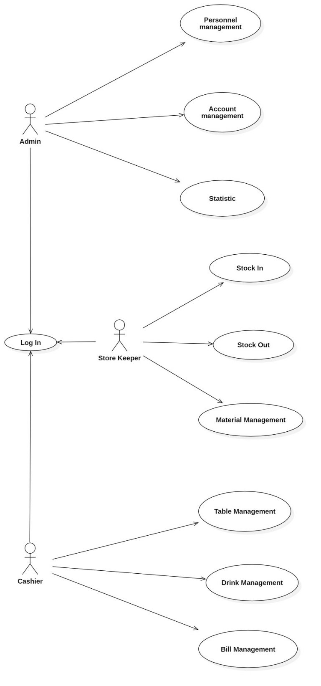

### Admin Use Case Diagram

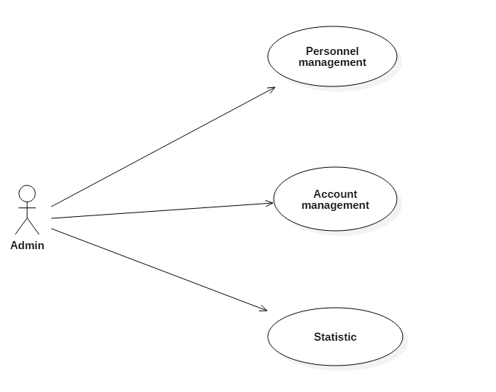

* Admin use case diagram in details

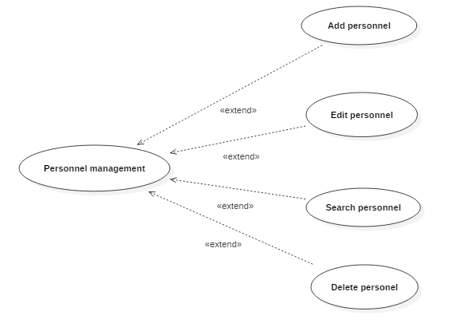

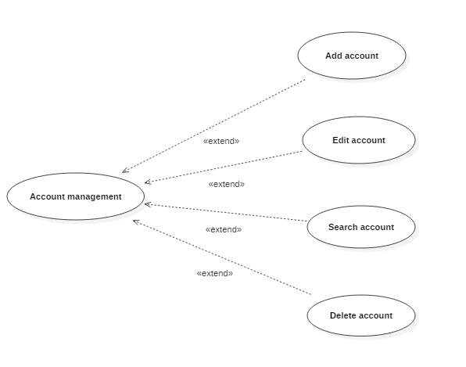

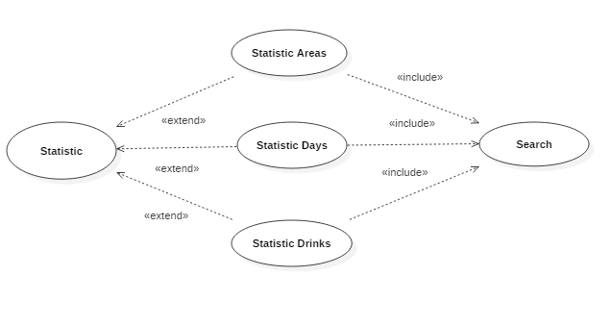

### Storekeeper use case diagram

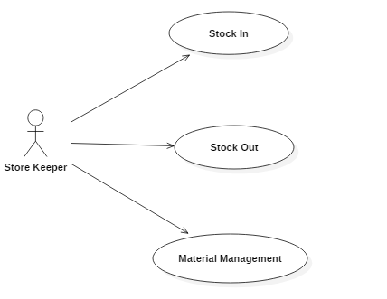

* Storekeepers use case diagram in details

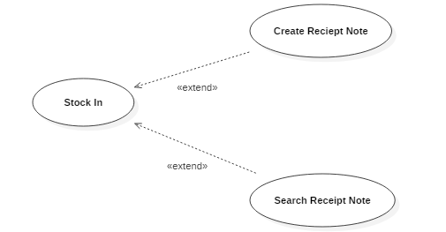

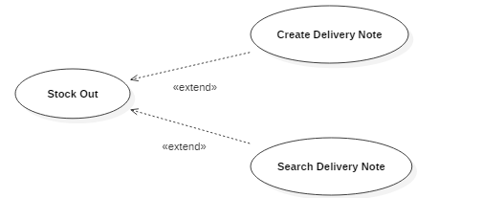

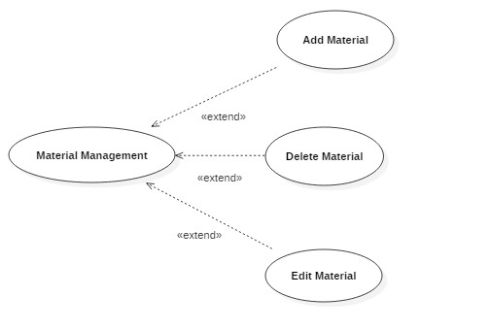

### Cashier use case diagram

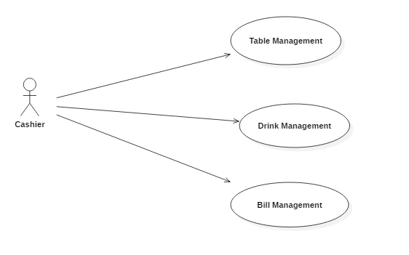

* Cashier use case diagram in details

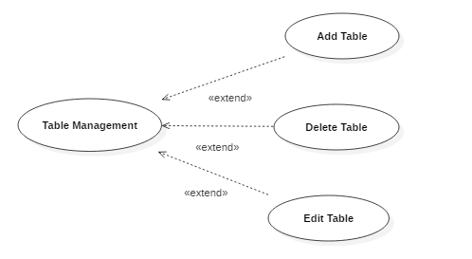

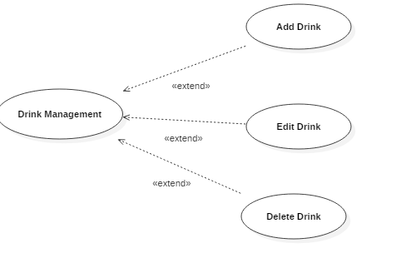

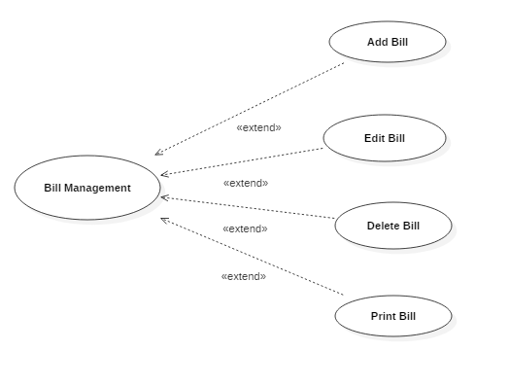

## List of actors

|  |  |  |
| --- | --- | --- |
| **SERIALS** | **Actor** | **Meaning** |
| 1 | Admin | Authorized to view the activities and features in the system |
| 2 | Store keeper | Authorized to control and manage input and output materials |
| 3 | Cashier | Be granted the right to serve drinks to customers, charge and summarize revenue |

## List of Activity Diagram Specification

### Activity Diagram Specification “Employee information management”

#### Add Personal Activity Diagram

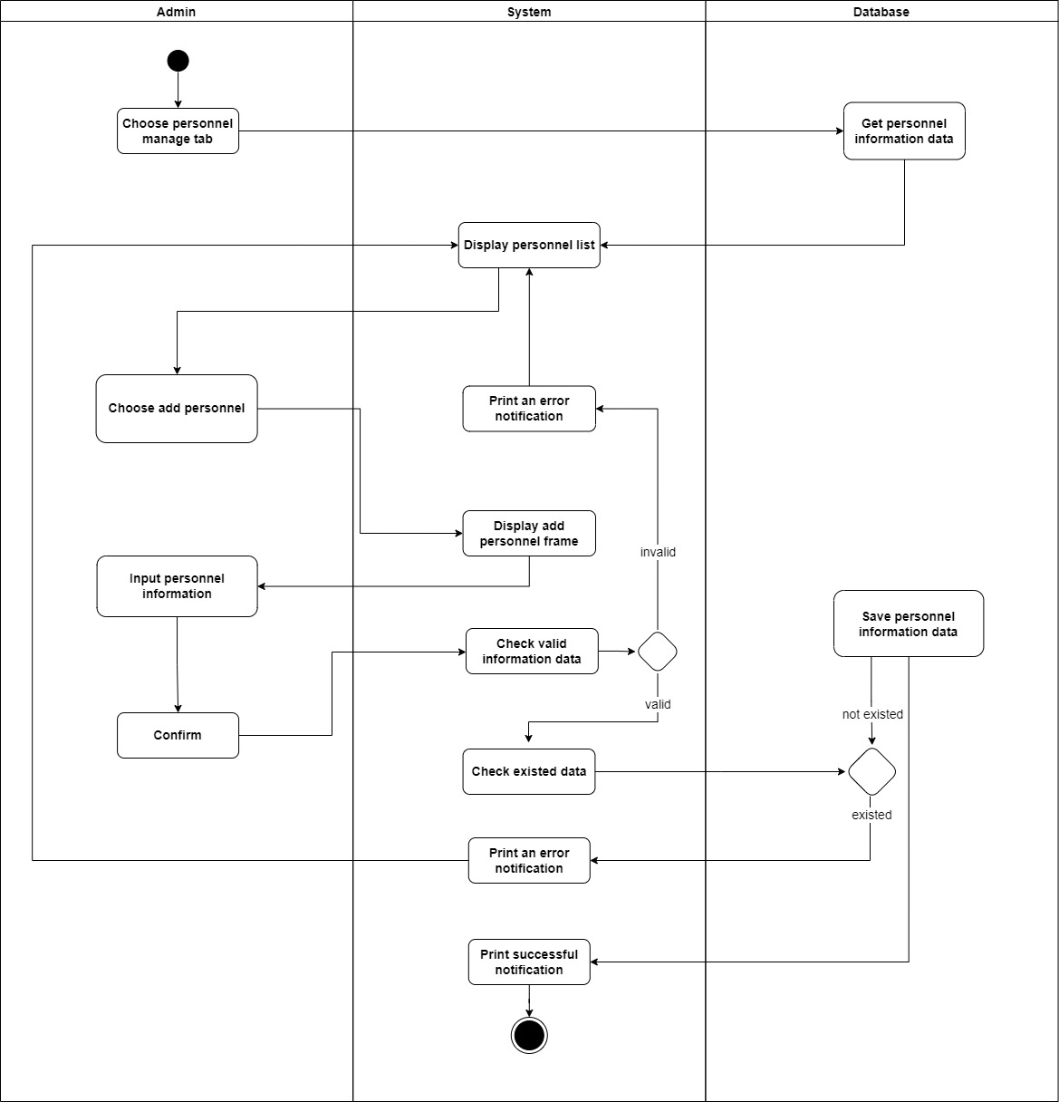

#### Delete Personel Activity Diagram

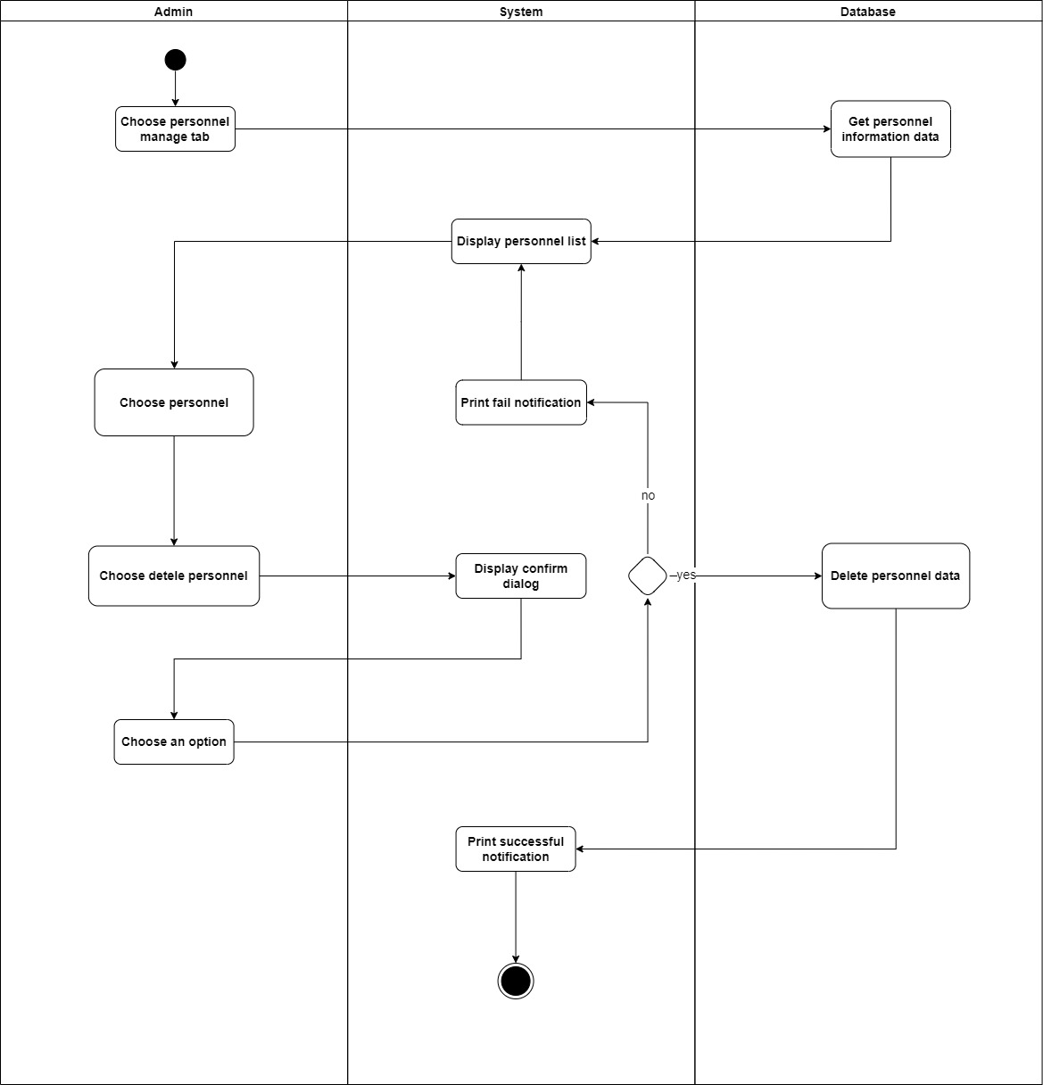

#### Edit Personel Activity Diagram

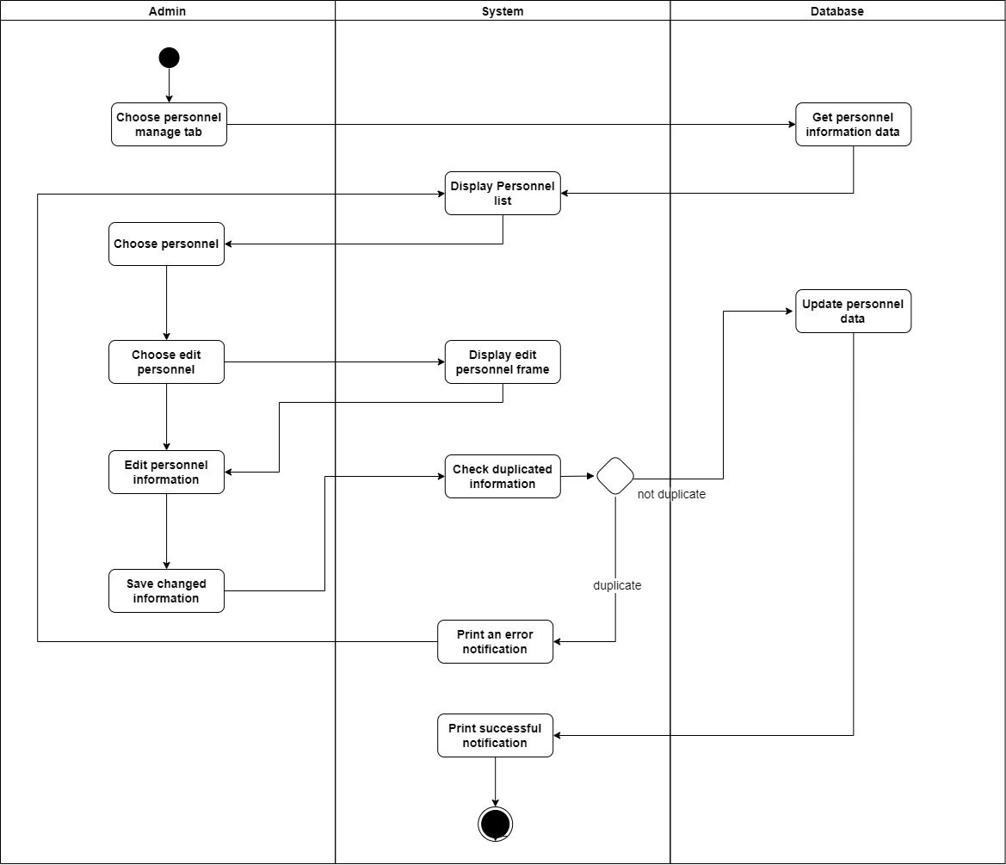

#### Search Personal Activity Diagram

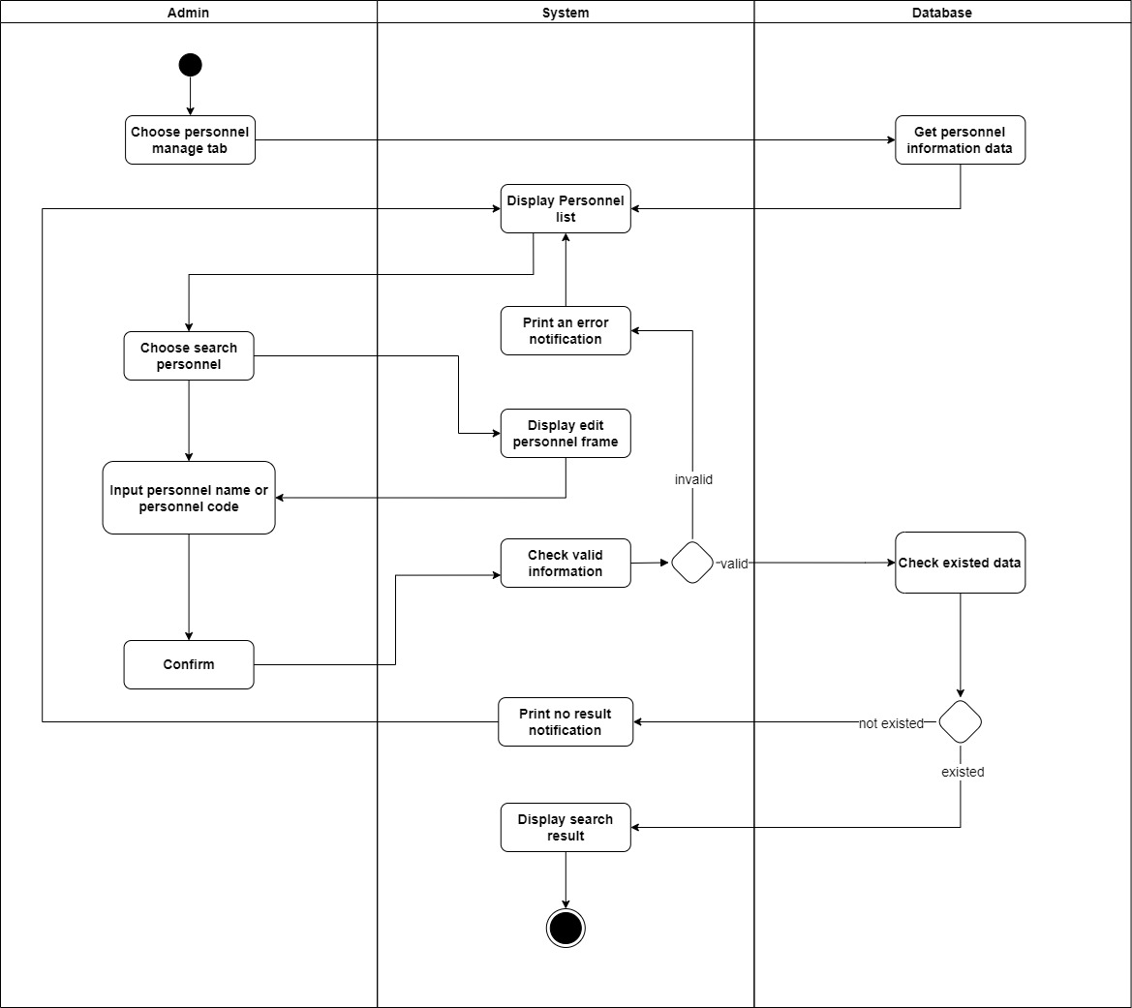

#### Add Account Activity Diagram

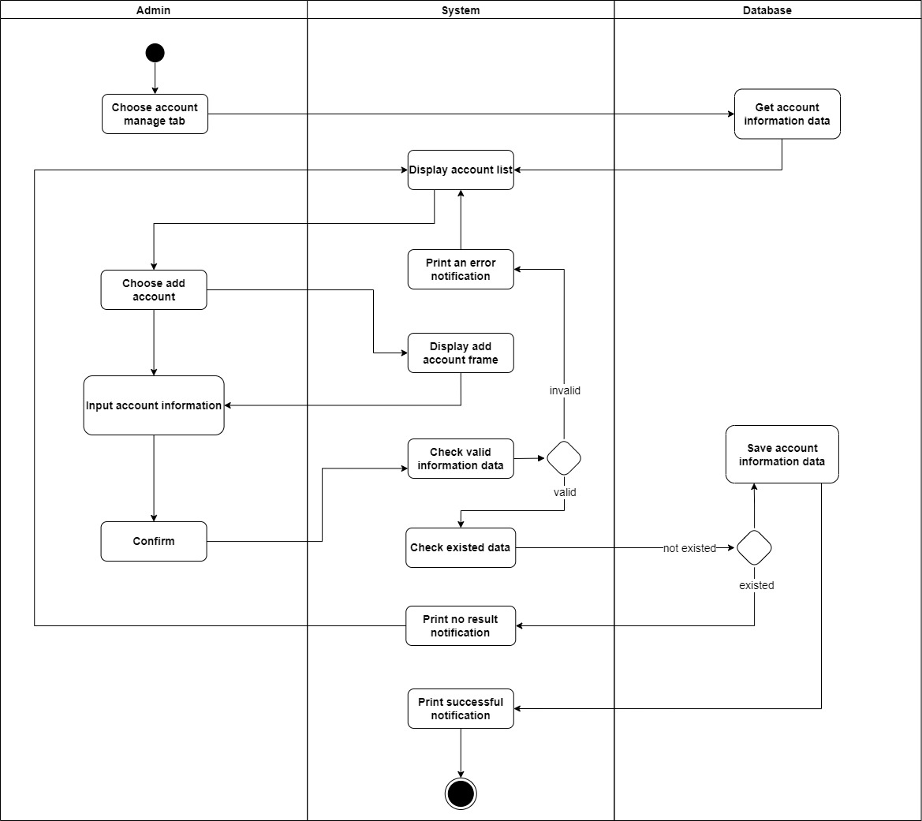

#### Delete Account Activity Diagram

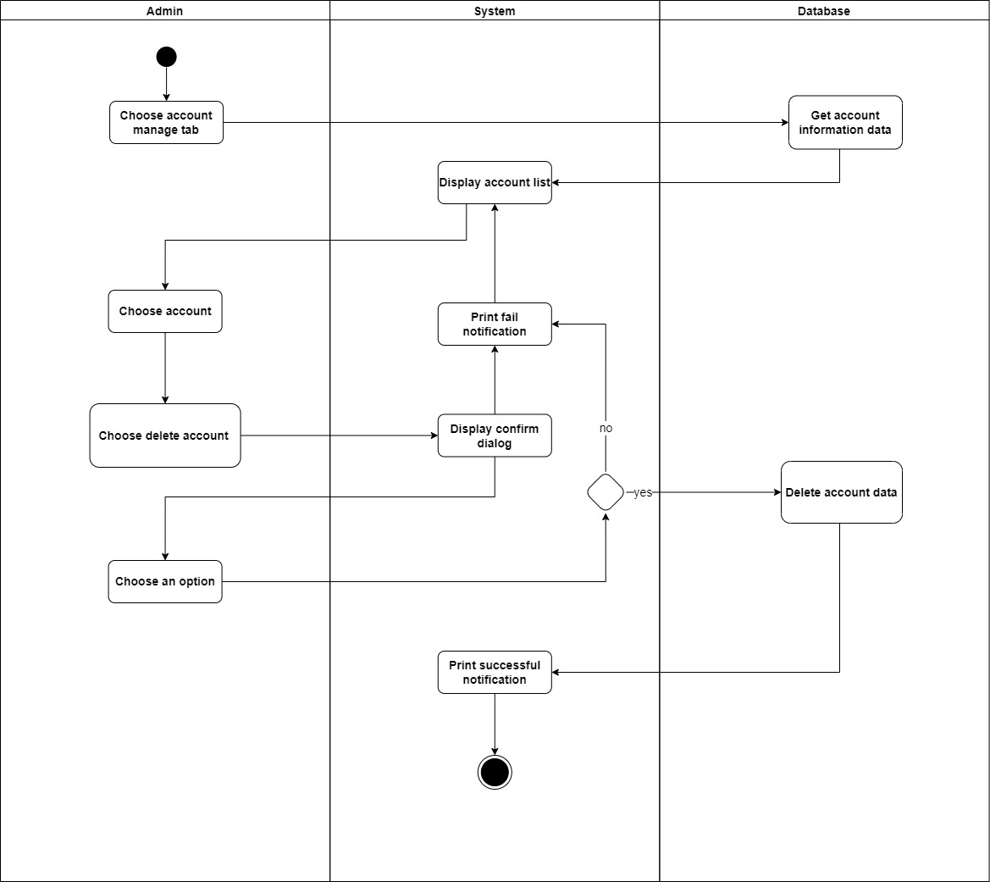

#### Edit Account Activity Diagram

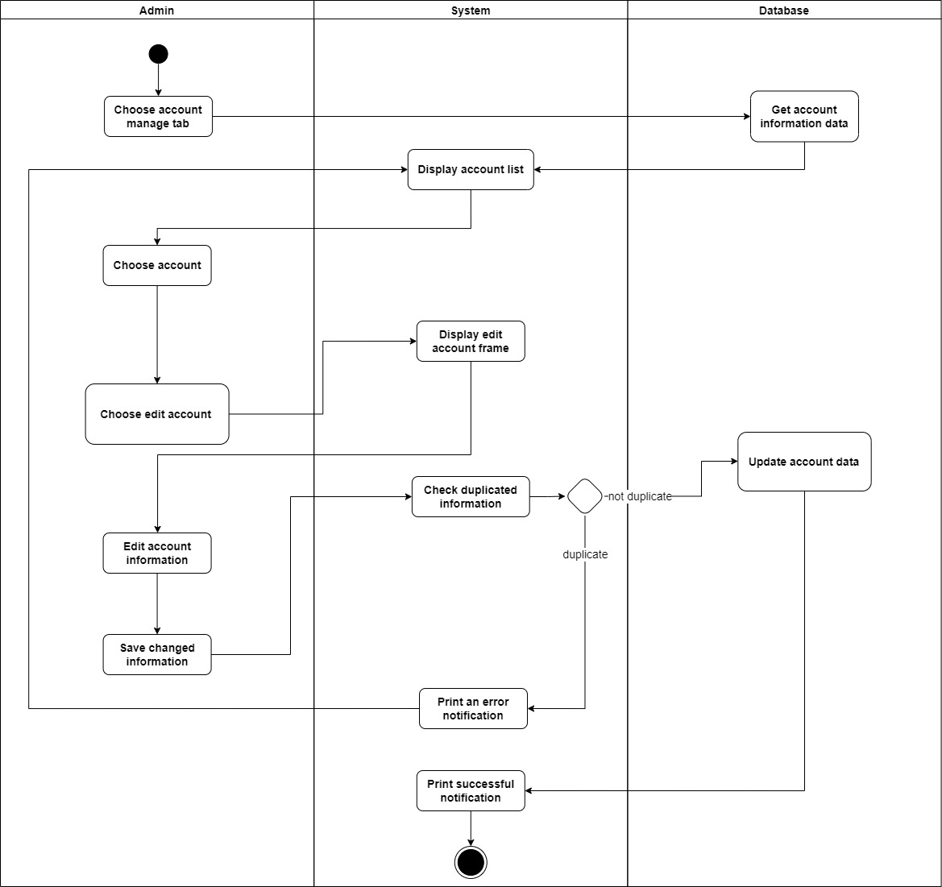

#### Search Account Activity Diagram

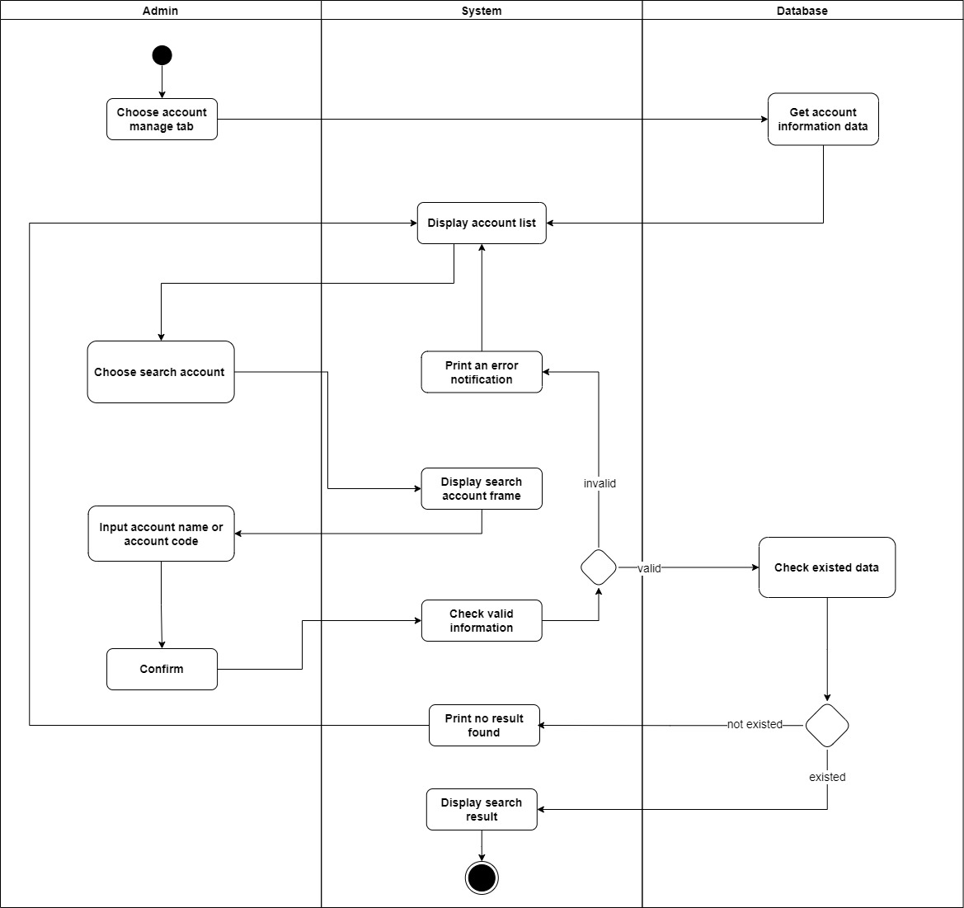

### Activity Diagram Specification “Material information management”

#### Delivery_note_creation Activity Diagram

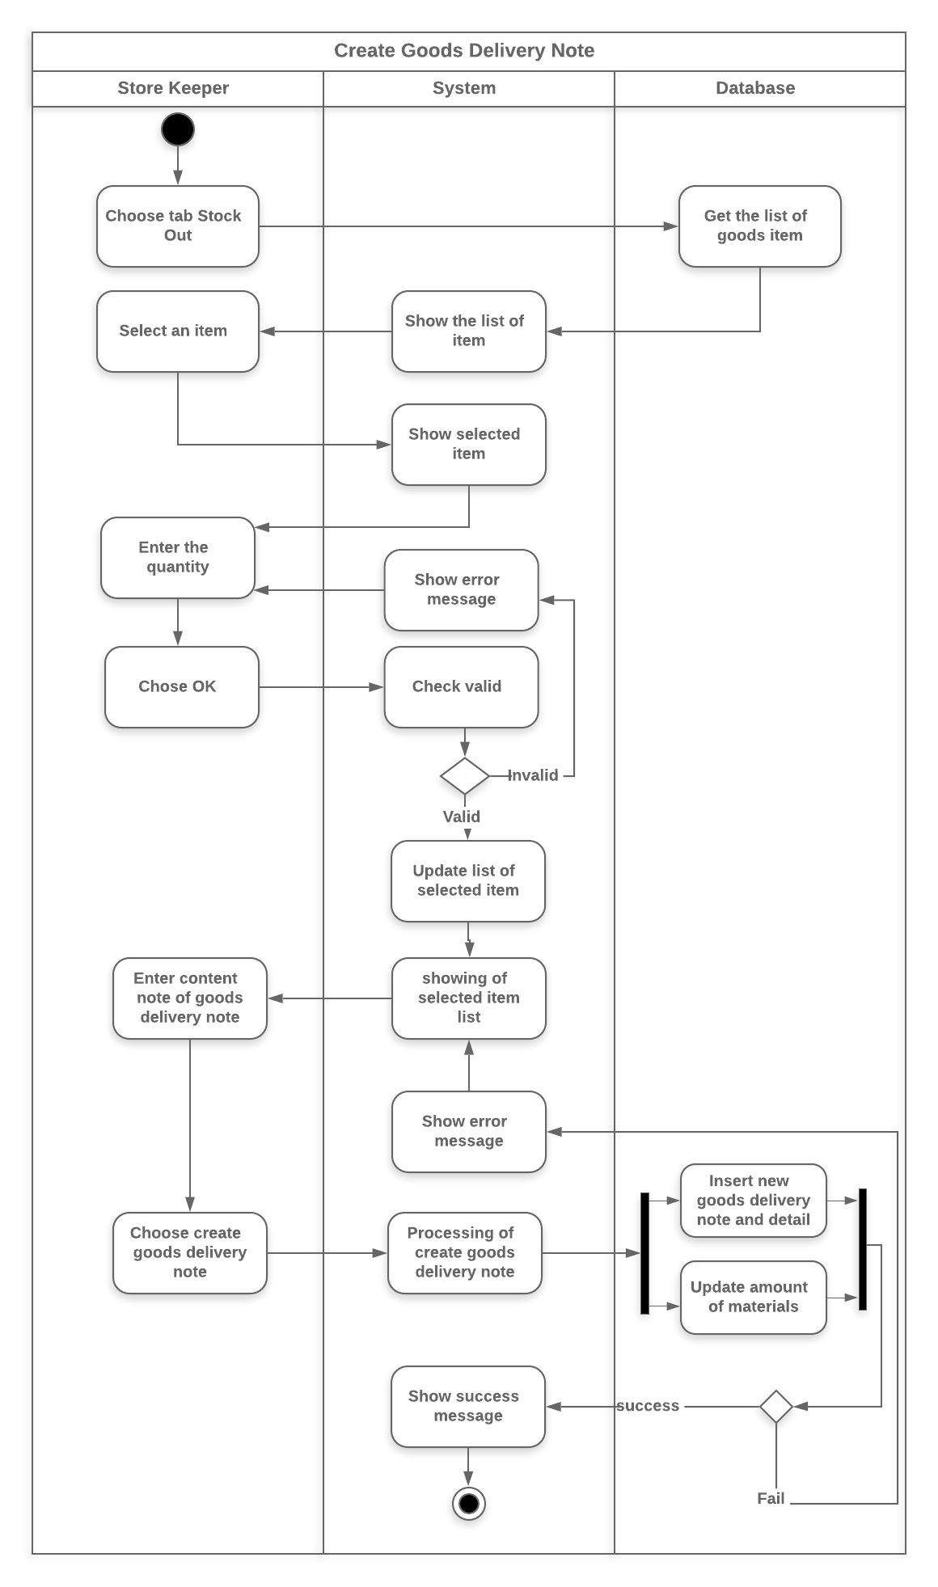

#### Material_add Activity Diagram

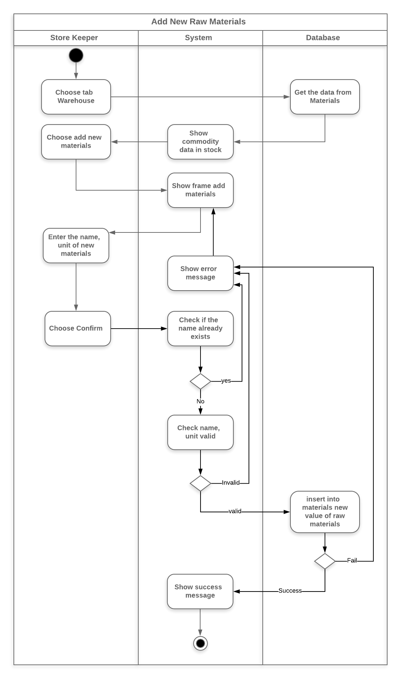

#### Material_delete Activity Diagram

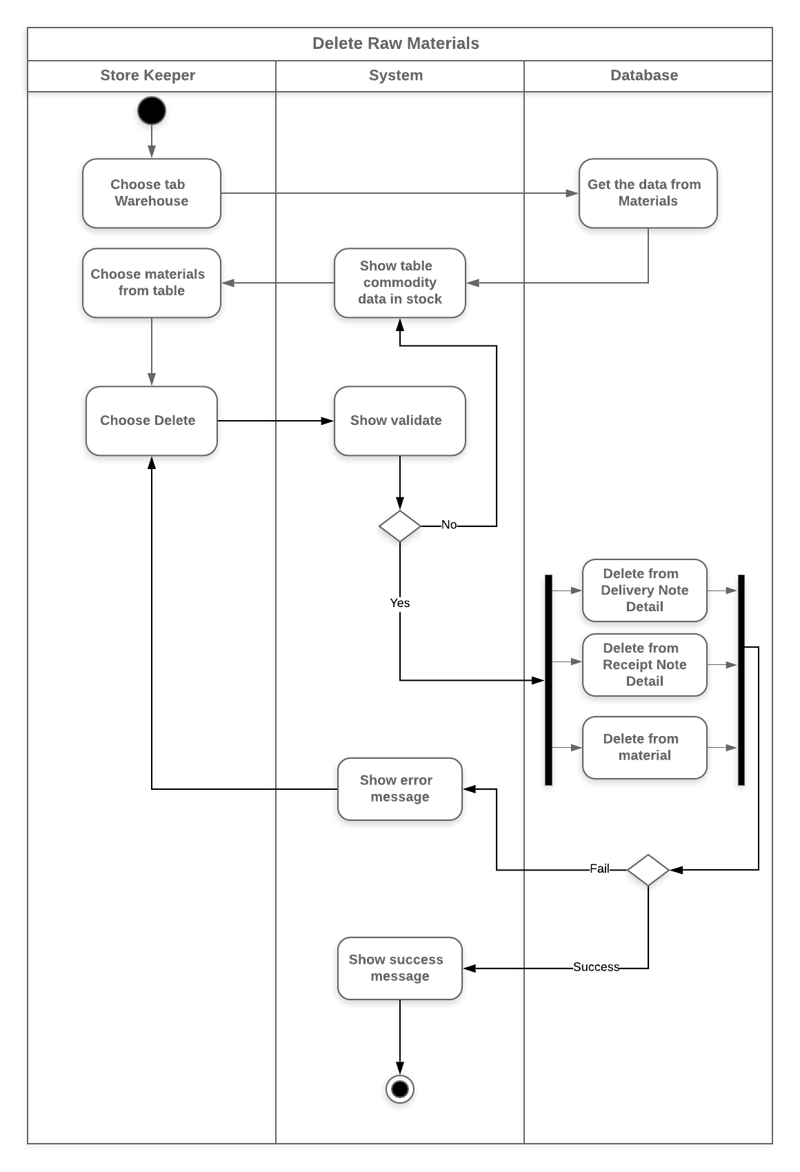

#### Material_update Activity Diagram

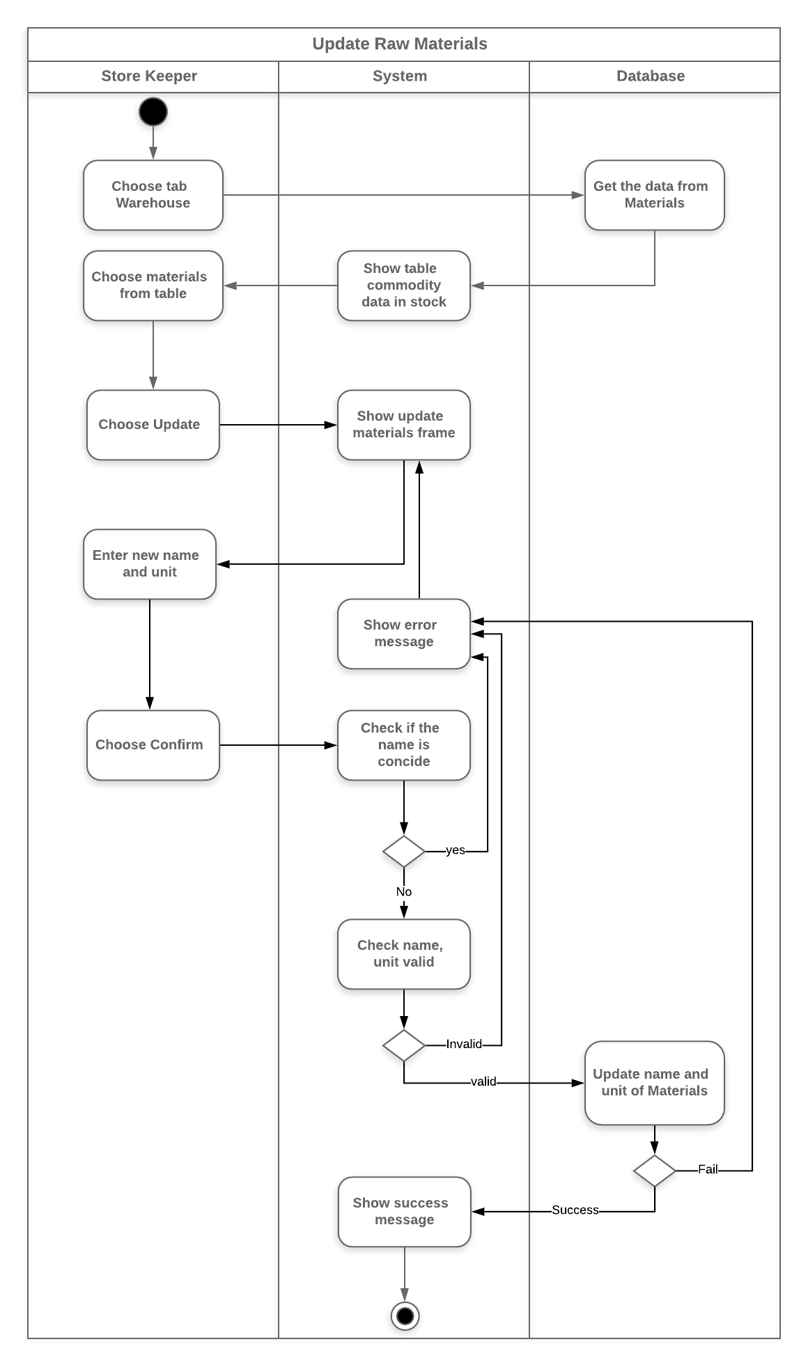

#### Receipt_note_creation Activity Diagram

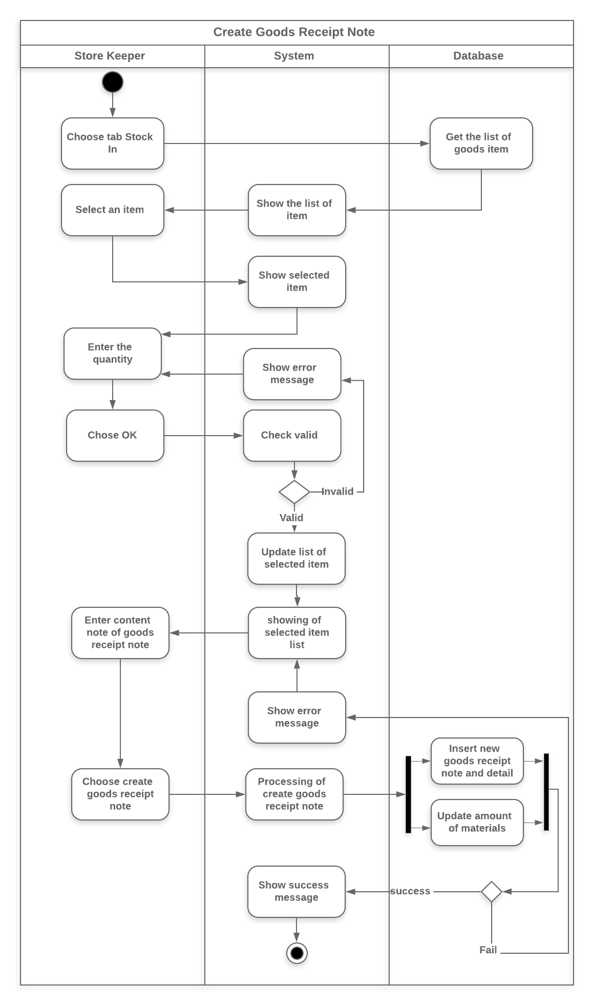

#### Search_delivery_note Activity Diagram

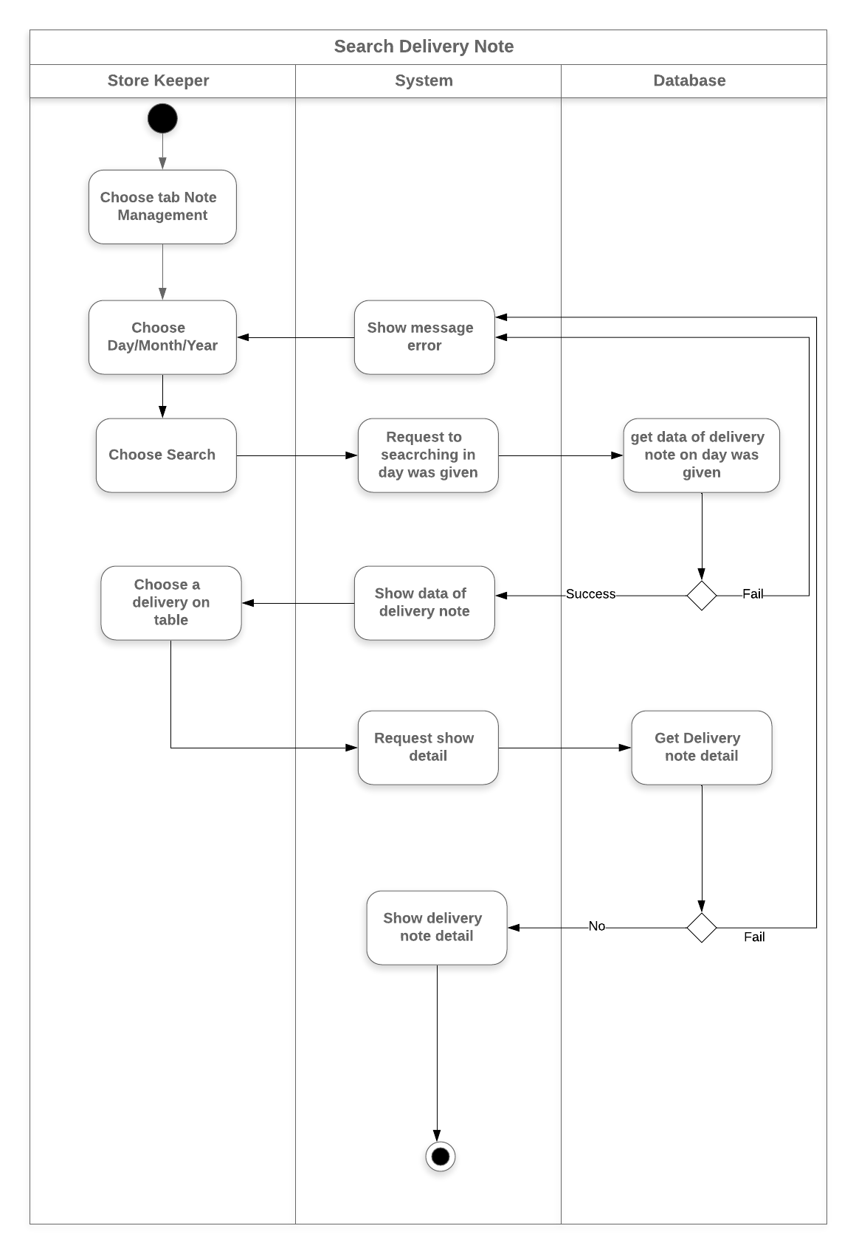

#### Search_Receipt_note Activity Diagram

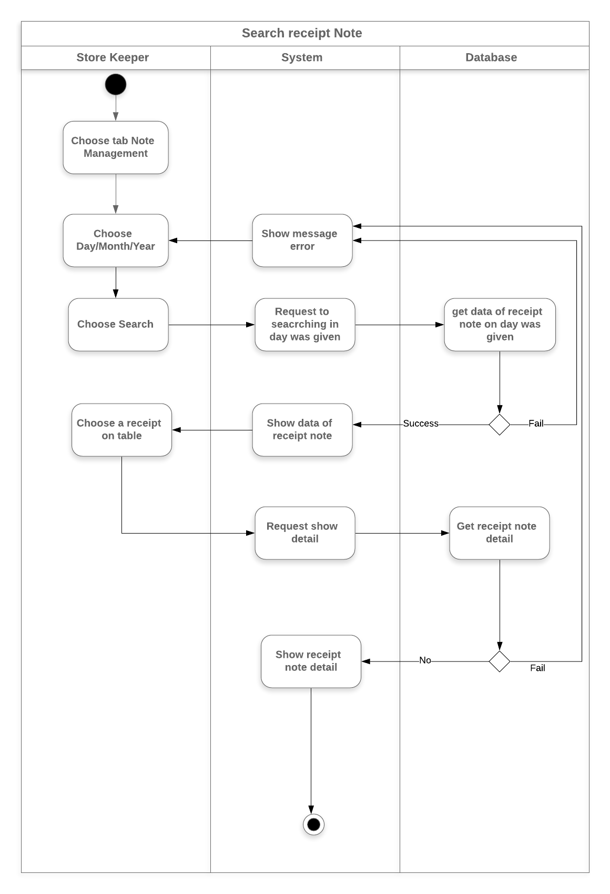

### Activity Diagram Specification “Service process management”

#### Add_Drink Activity Diagram

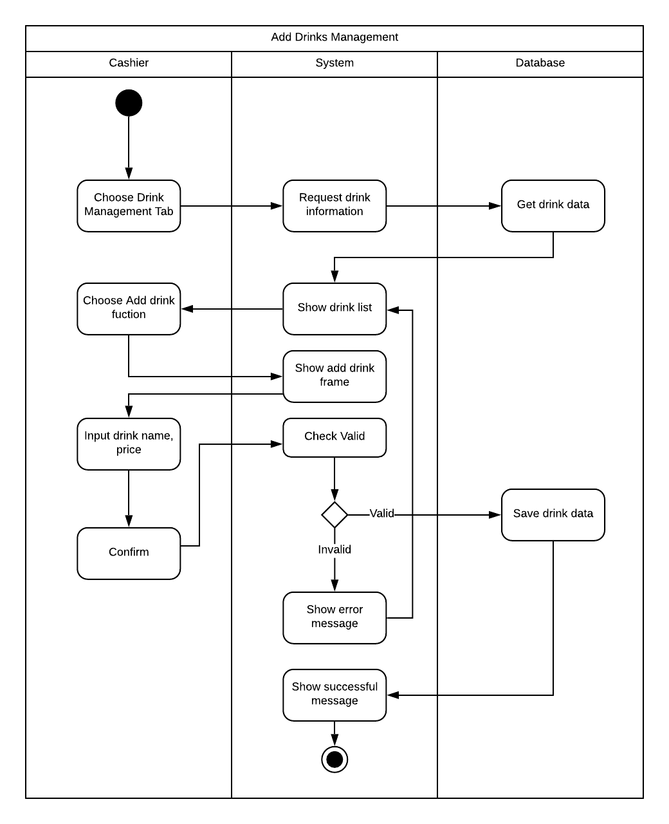

#### Add_Table Activity Diagram

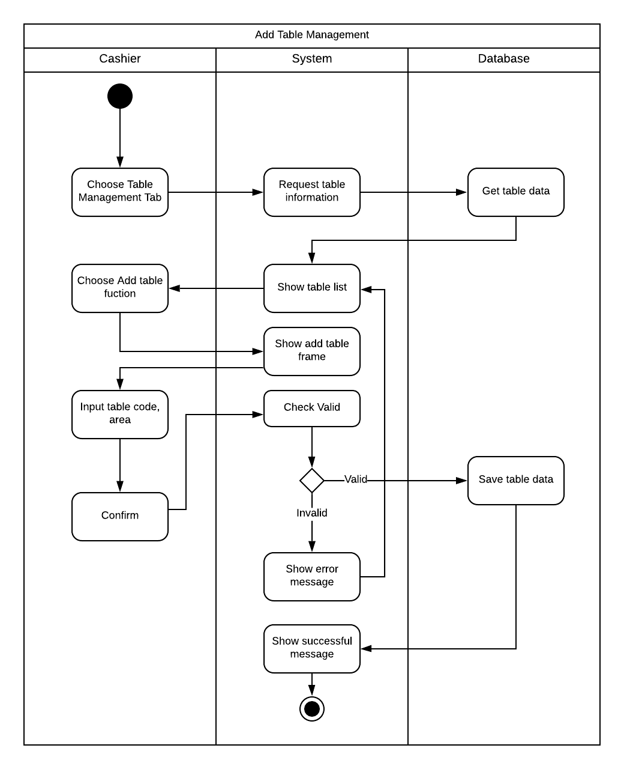

#### Delete_drink Activity Diagram

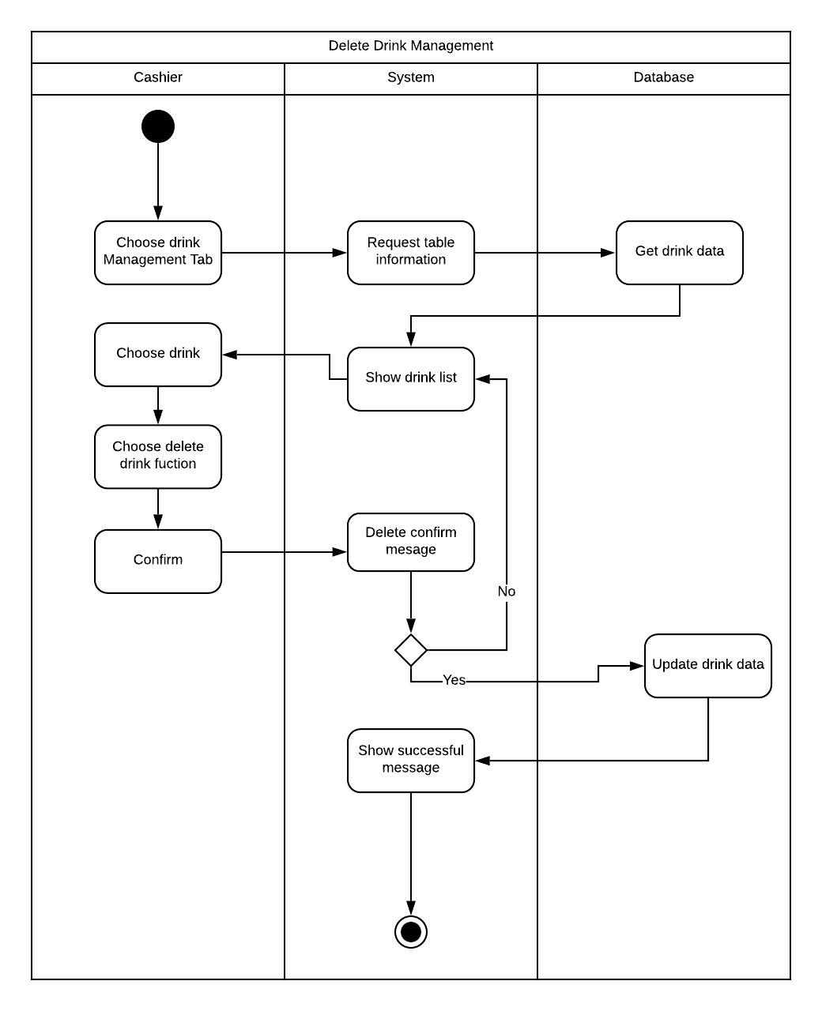

#### Delete_Table Activity Diagram

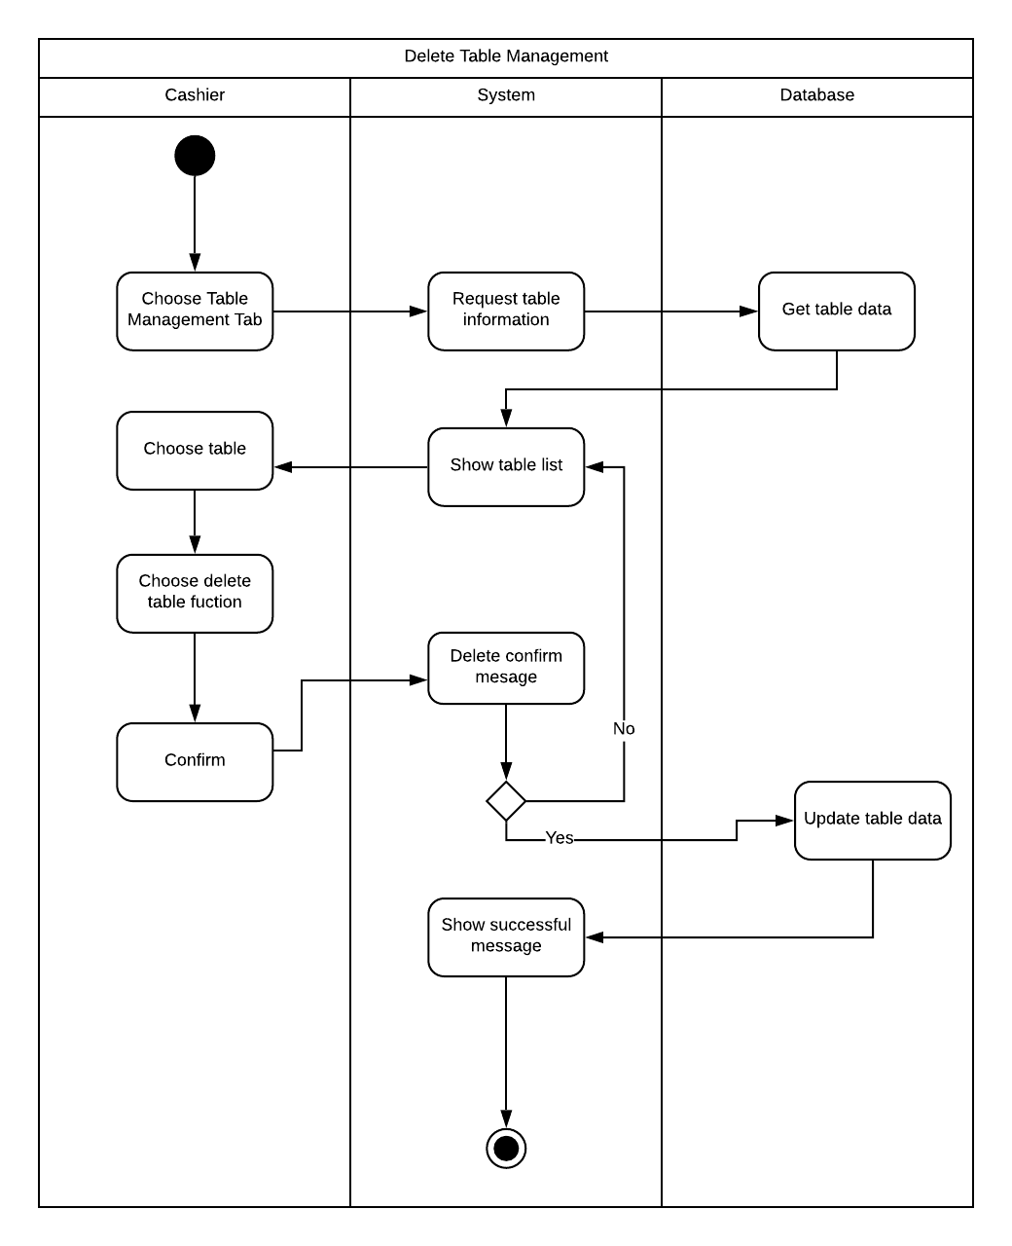

#### Edit_Drink Activity Diagram

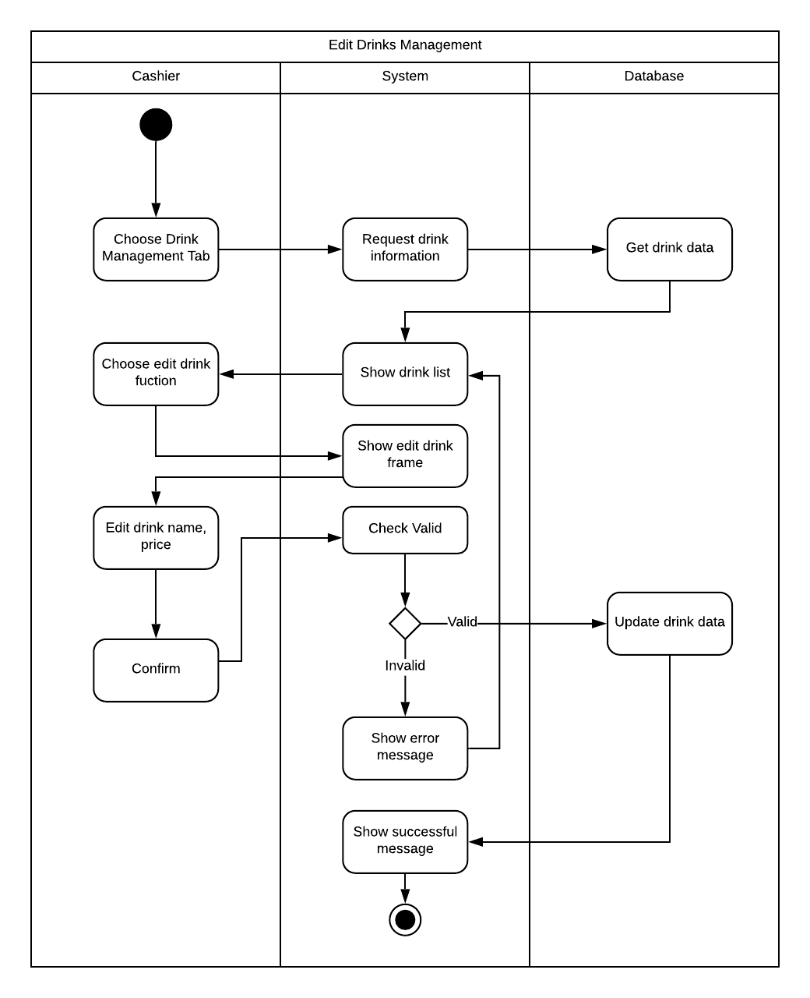

#### Payment Activity Diagram

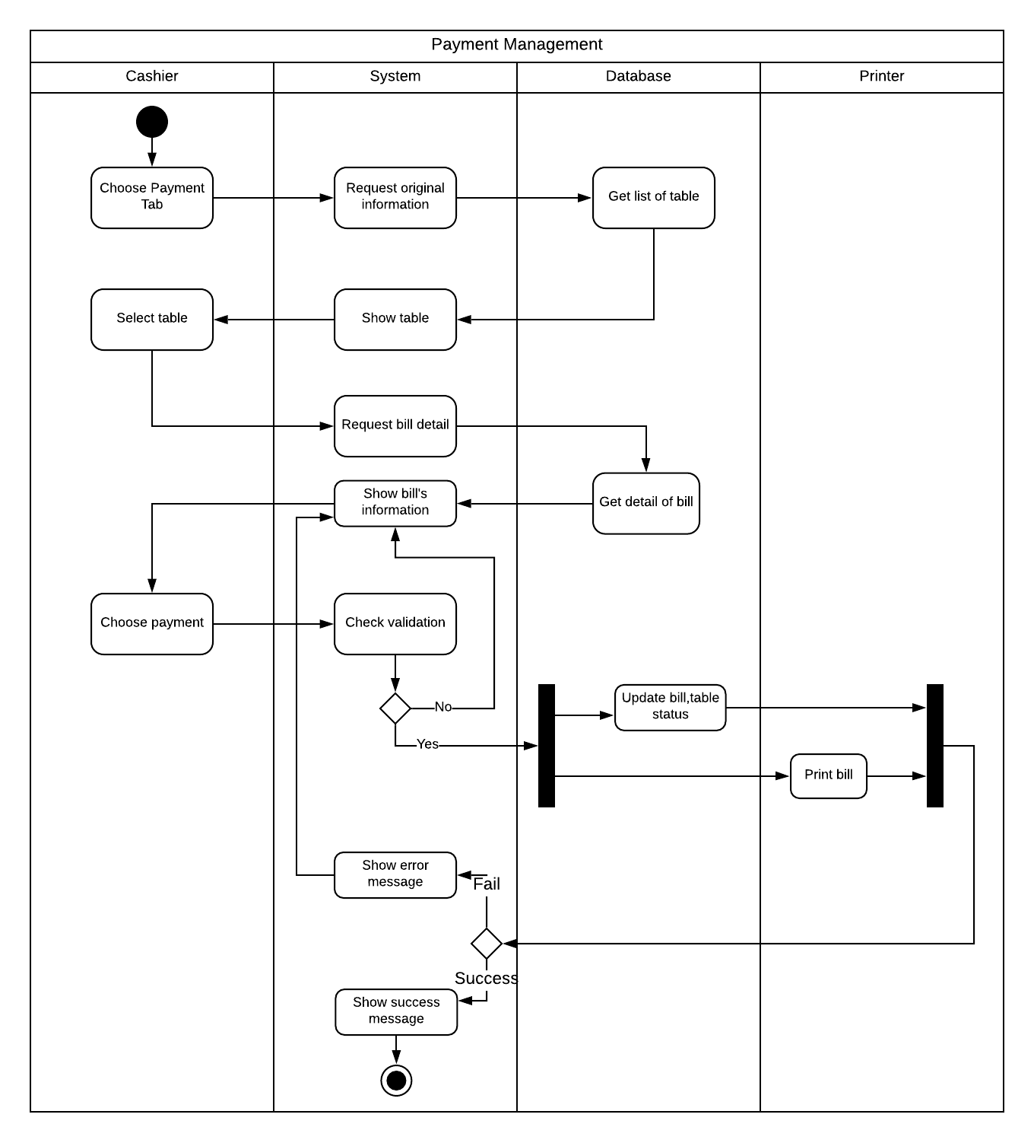

### Activity Diagram Specification “Financial statistics”

#### Revenue Statistic Activity Diagram

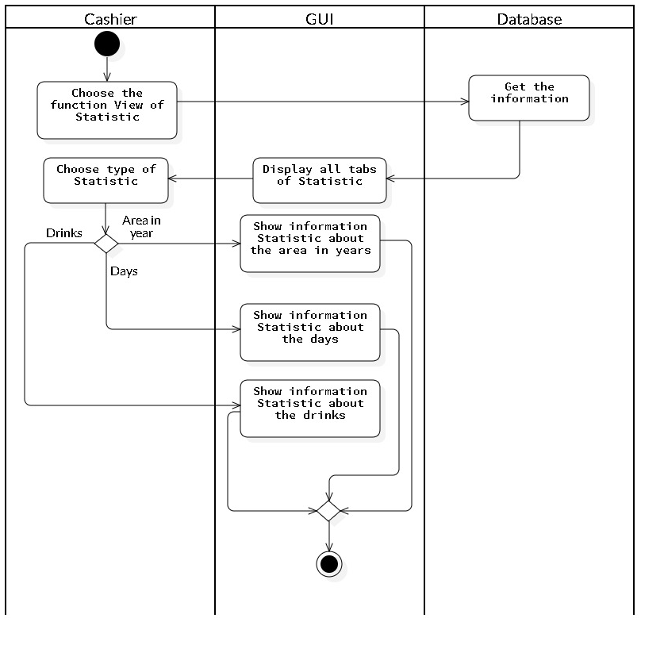

#### Revenue Statistic of Area Activity Diagram

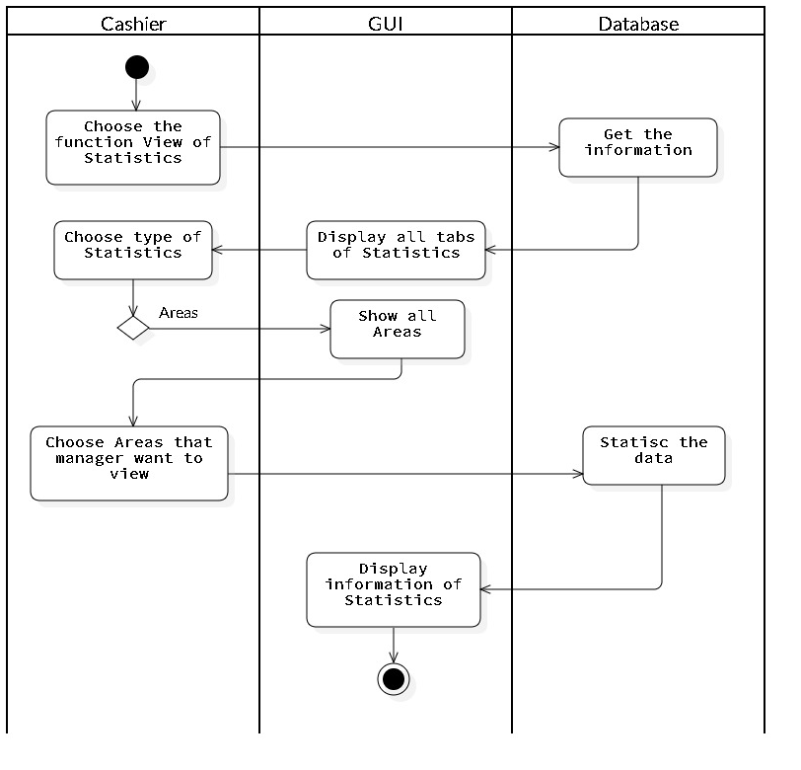

#### Revenue Statistic of Drinks Activity Diagram

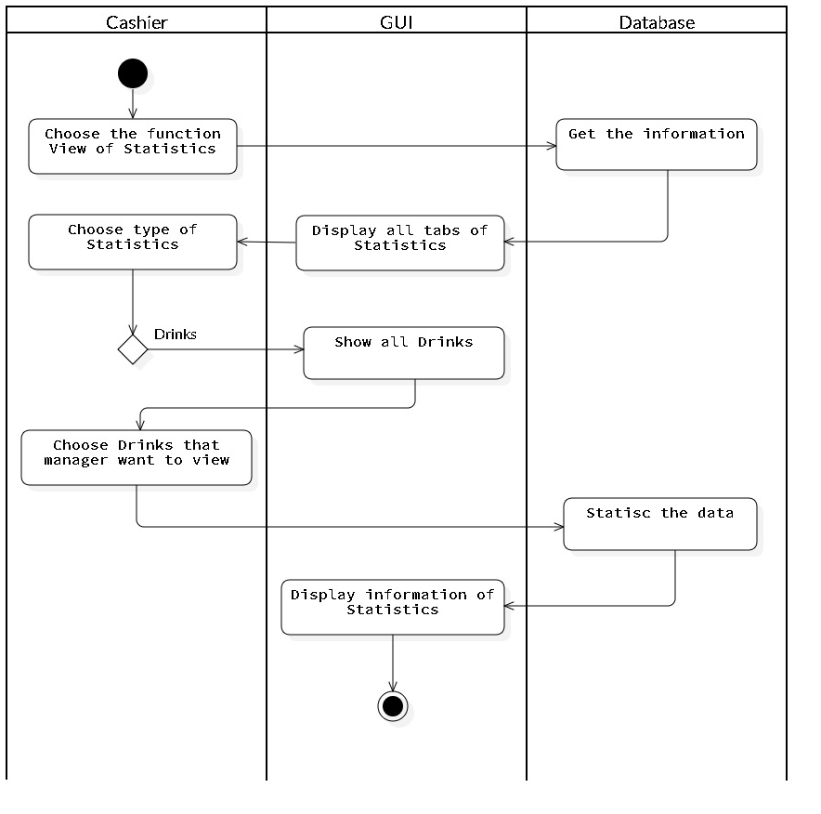

#### Revenue Statistic of Days Activity Diagram

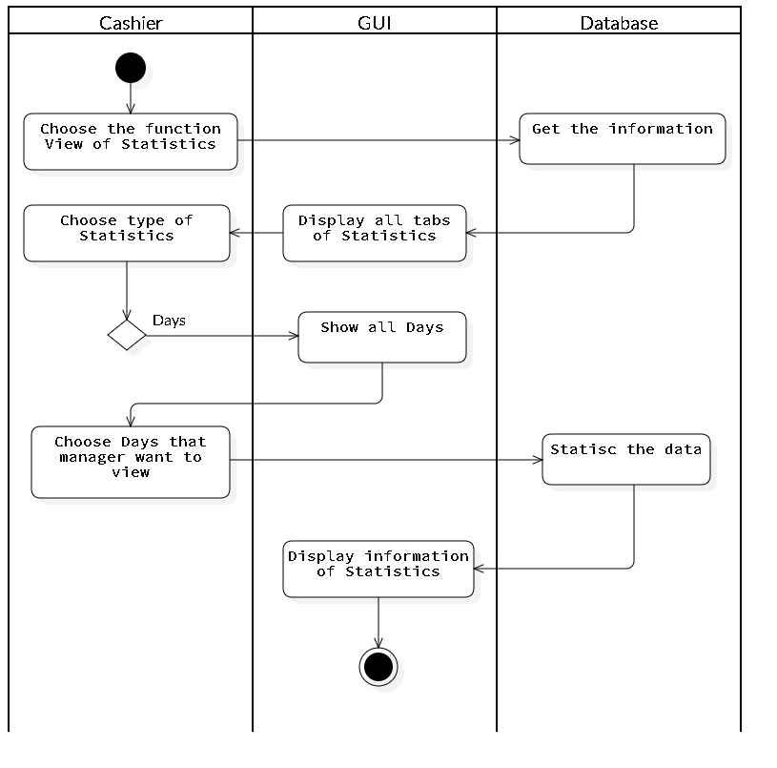

#### Search Revenue Statistic Activity Diagram

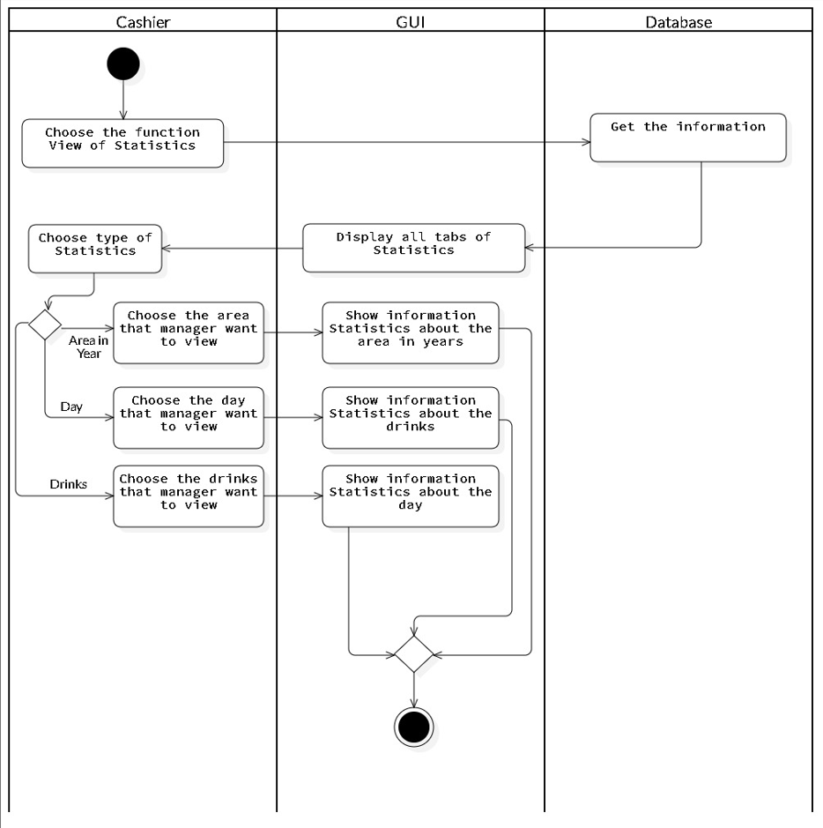

## List of Sequence Diagram

### Sequence Diagram: Employee information management

#### Add Personnel Sequence Diagram

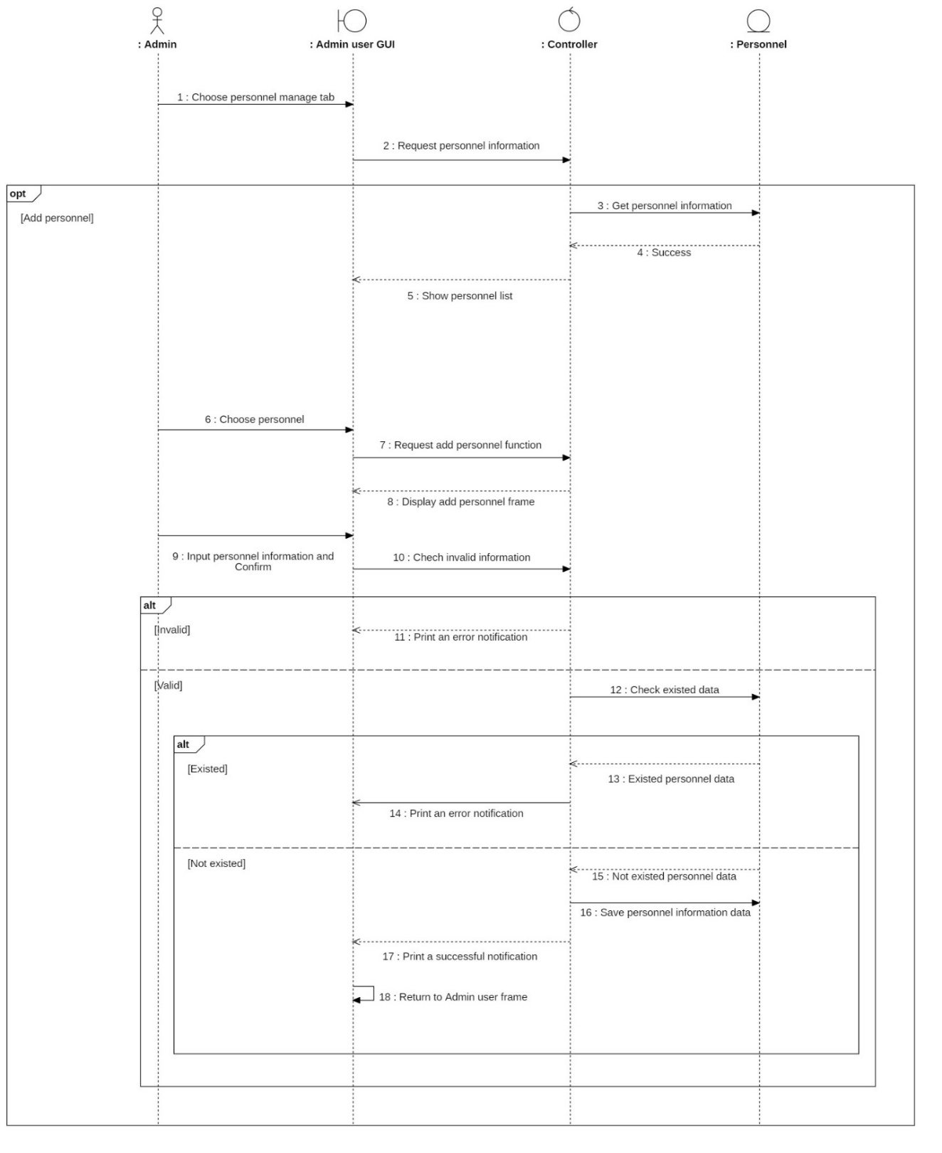

#### Delete personnel Sequence Diagram

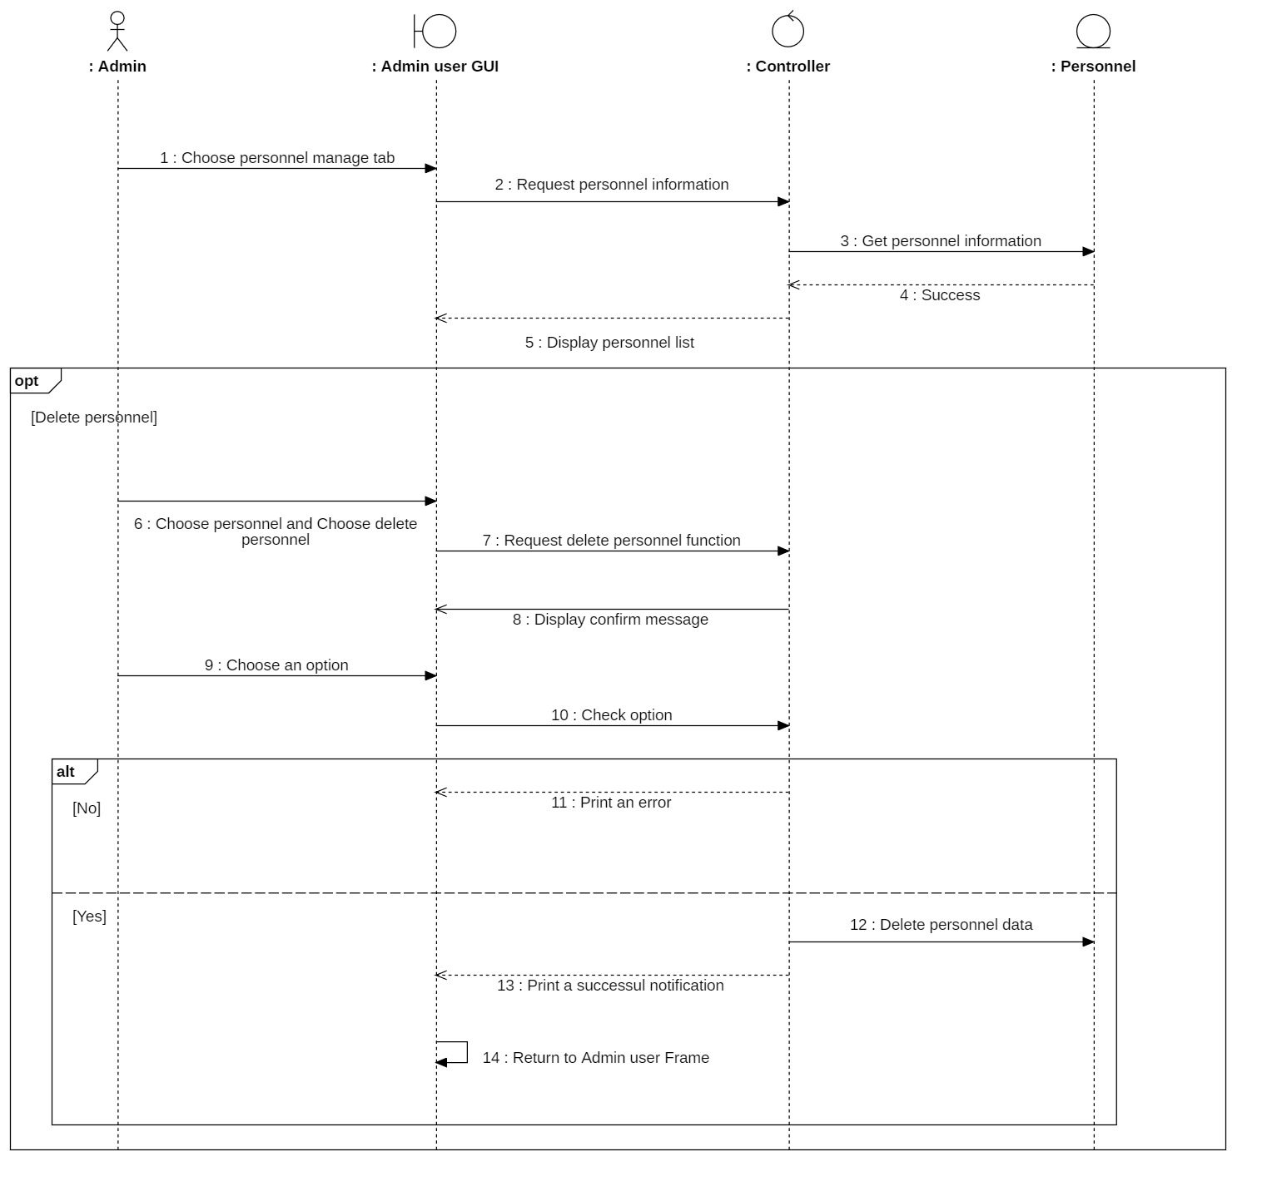

#### Edit personnel Sequence Diagram

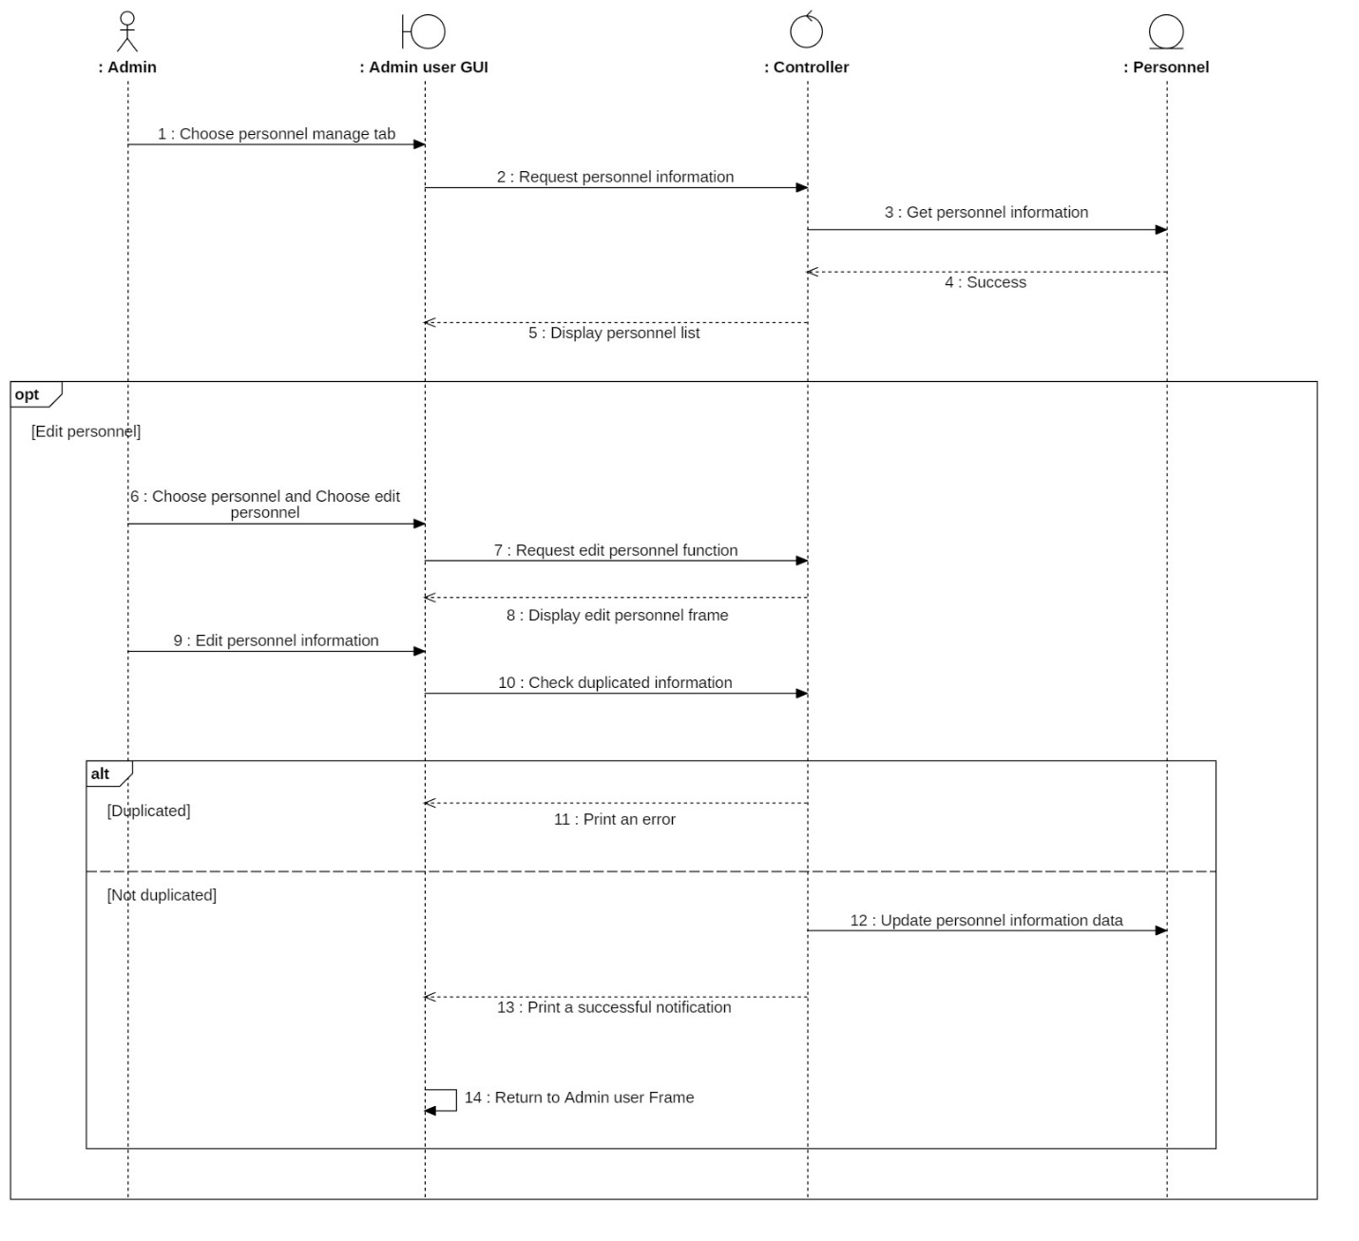

#### Search personnel Sequence Diagram

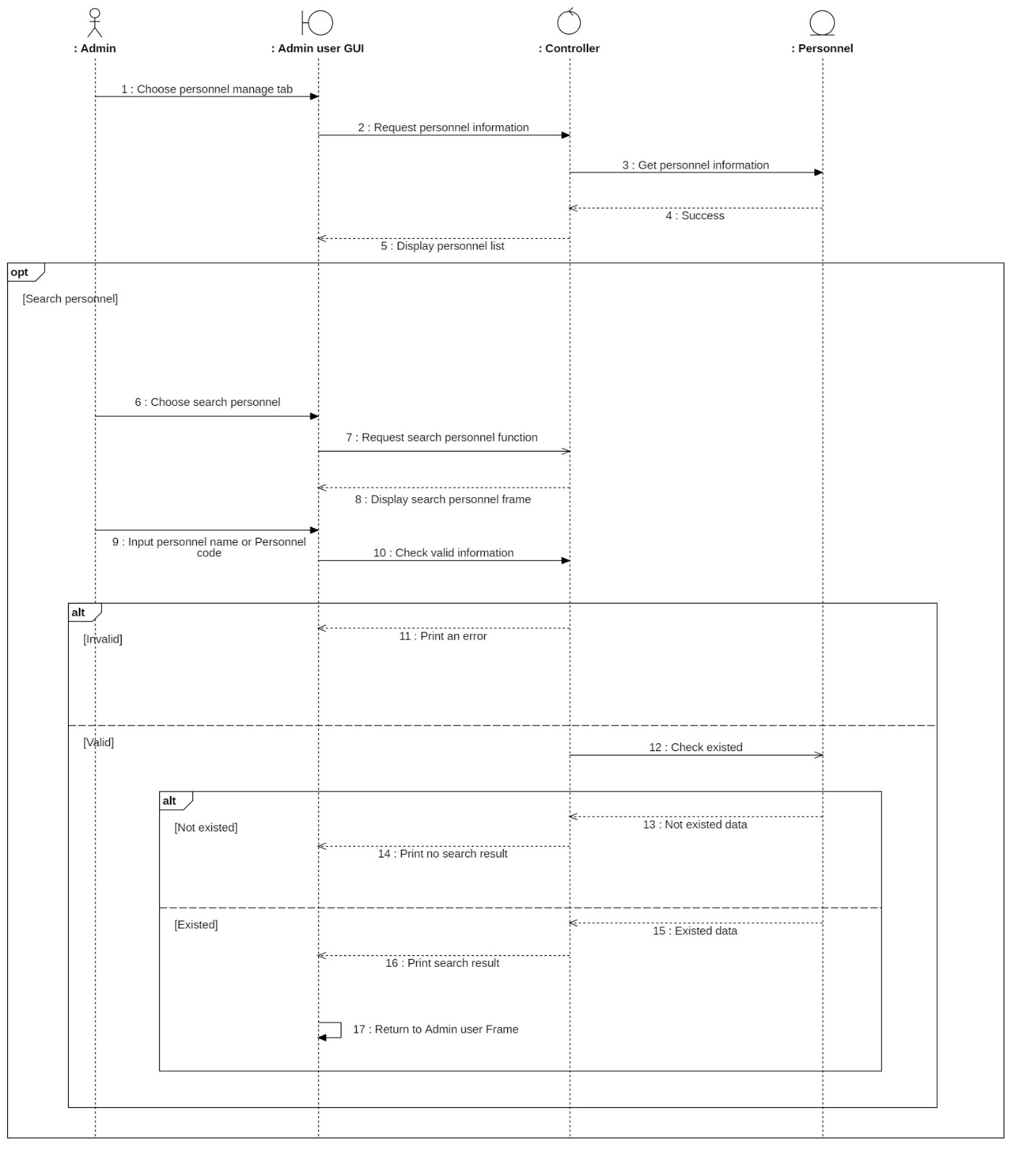

#### Add account Sequence Diagram

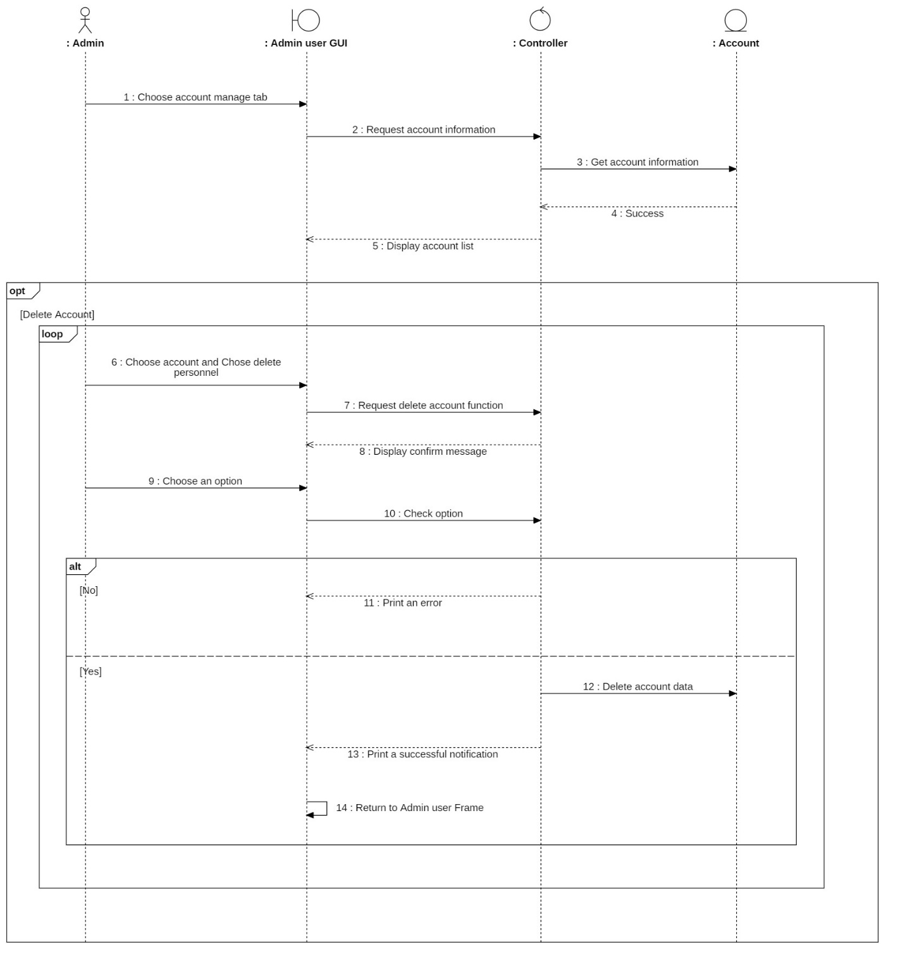

#### Delete account Sequence Diagram

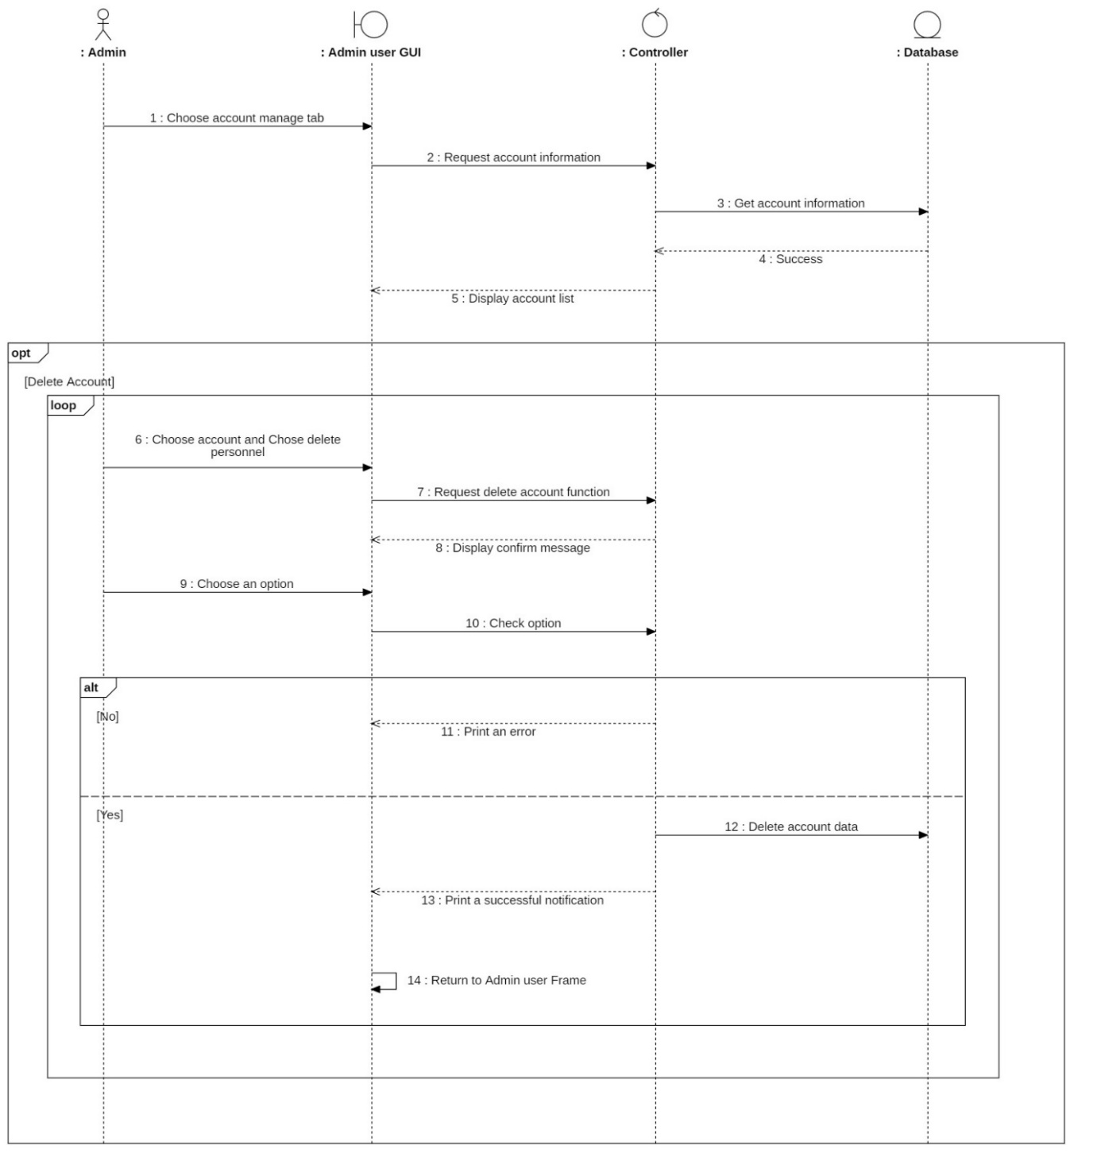

#### Edit account Sequence Diagram

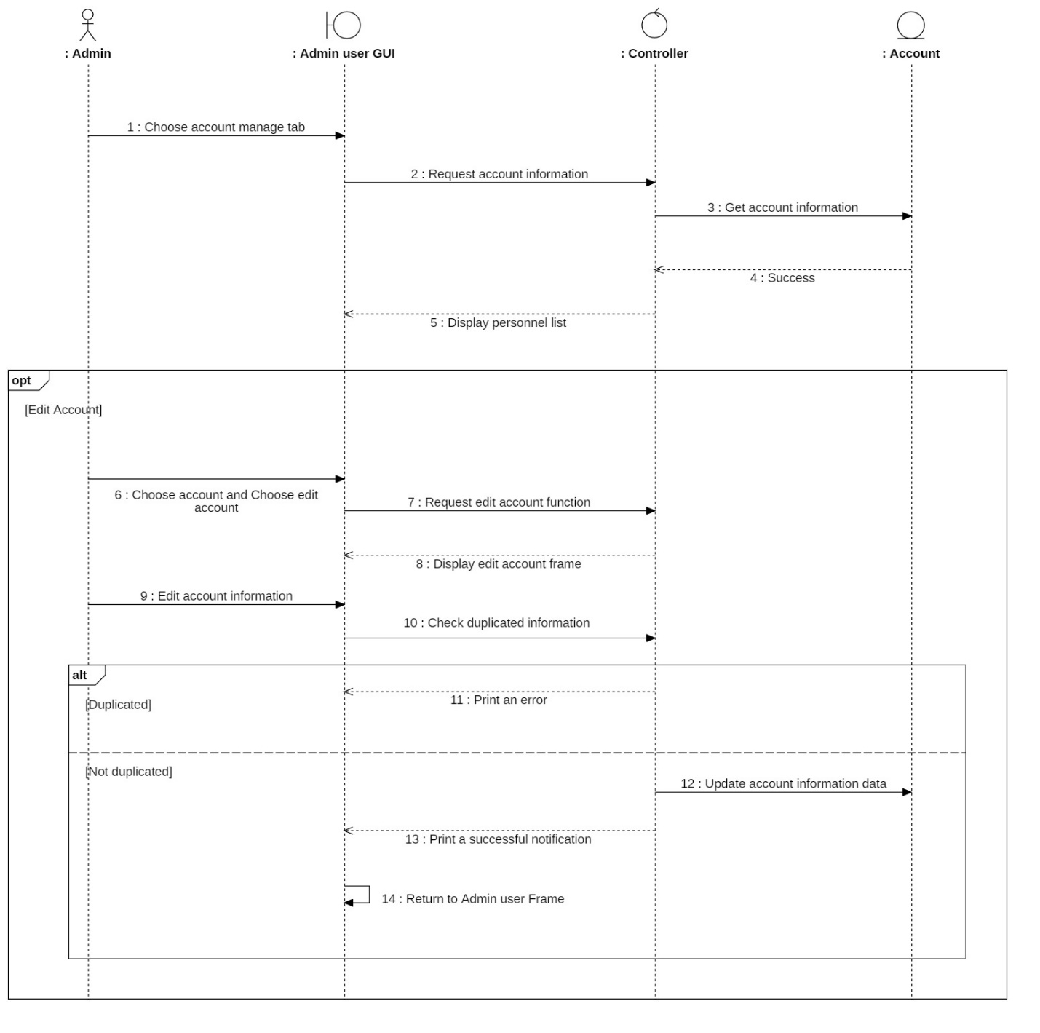

#### Search account Sequence Diagram

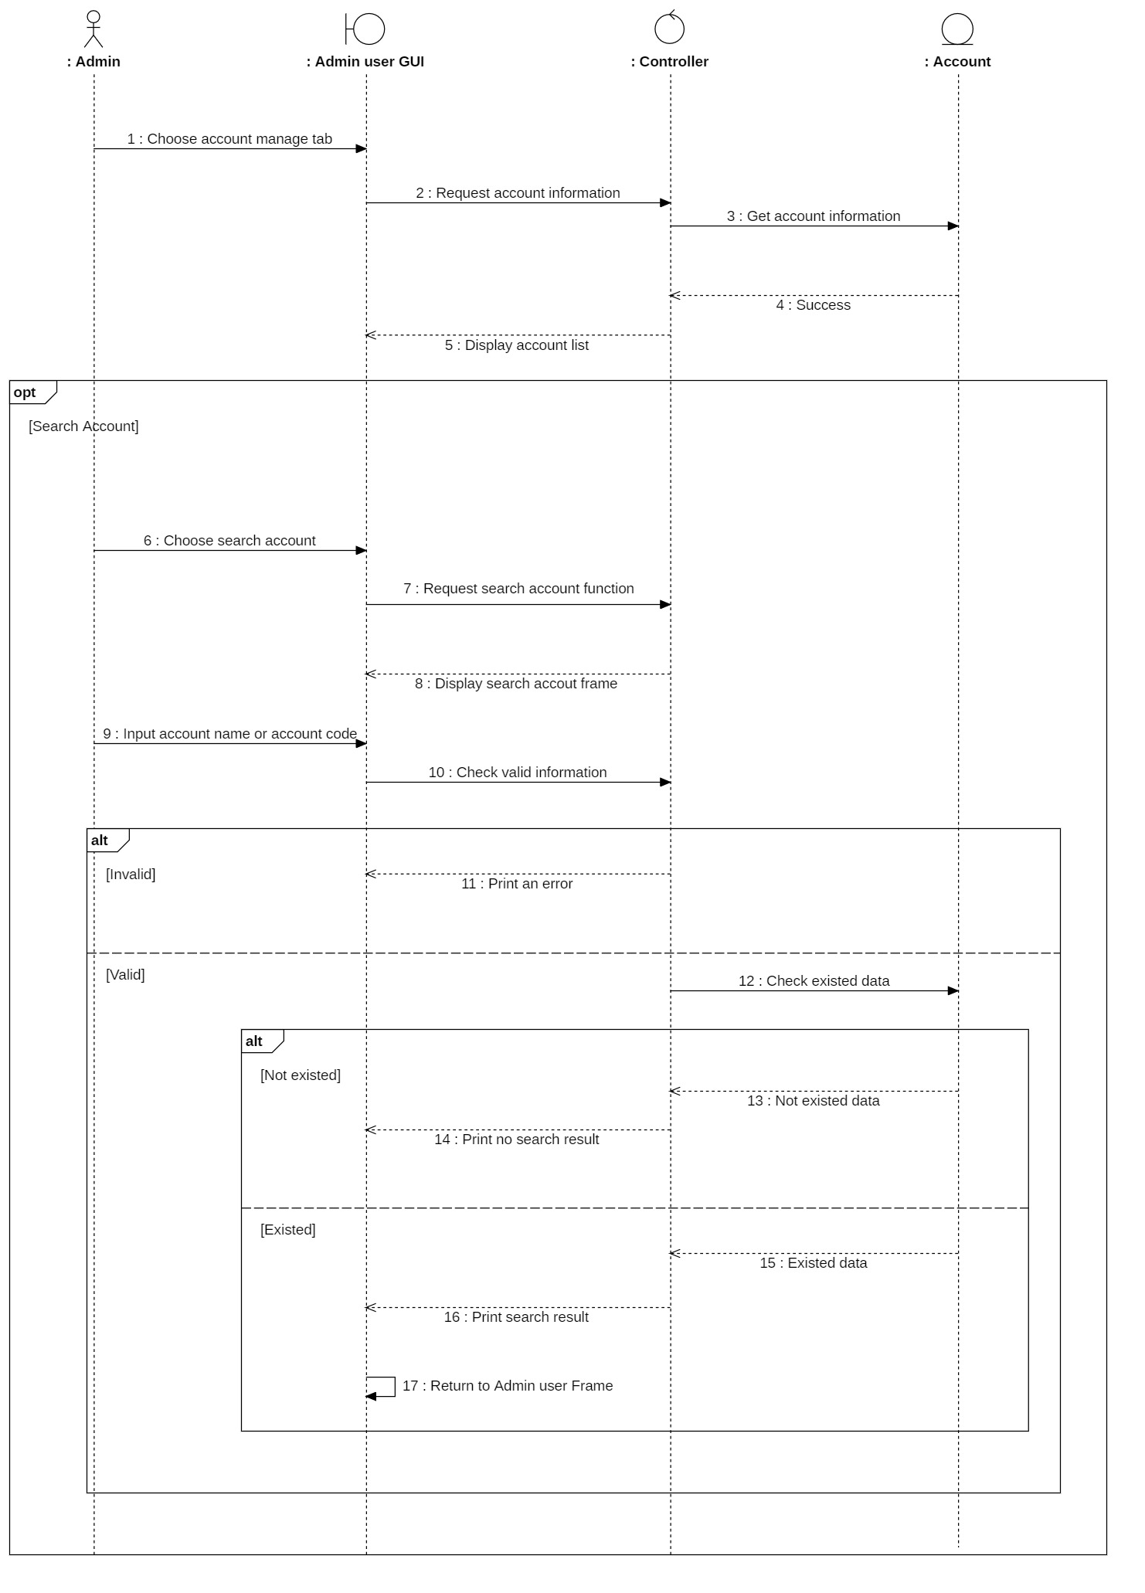

### Sequence Diagram: Material information management

#### Delivery_note_creation Sequence Diagram

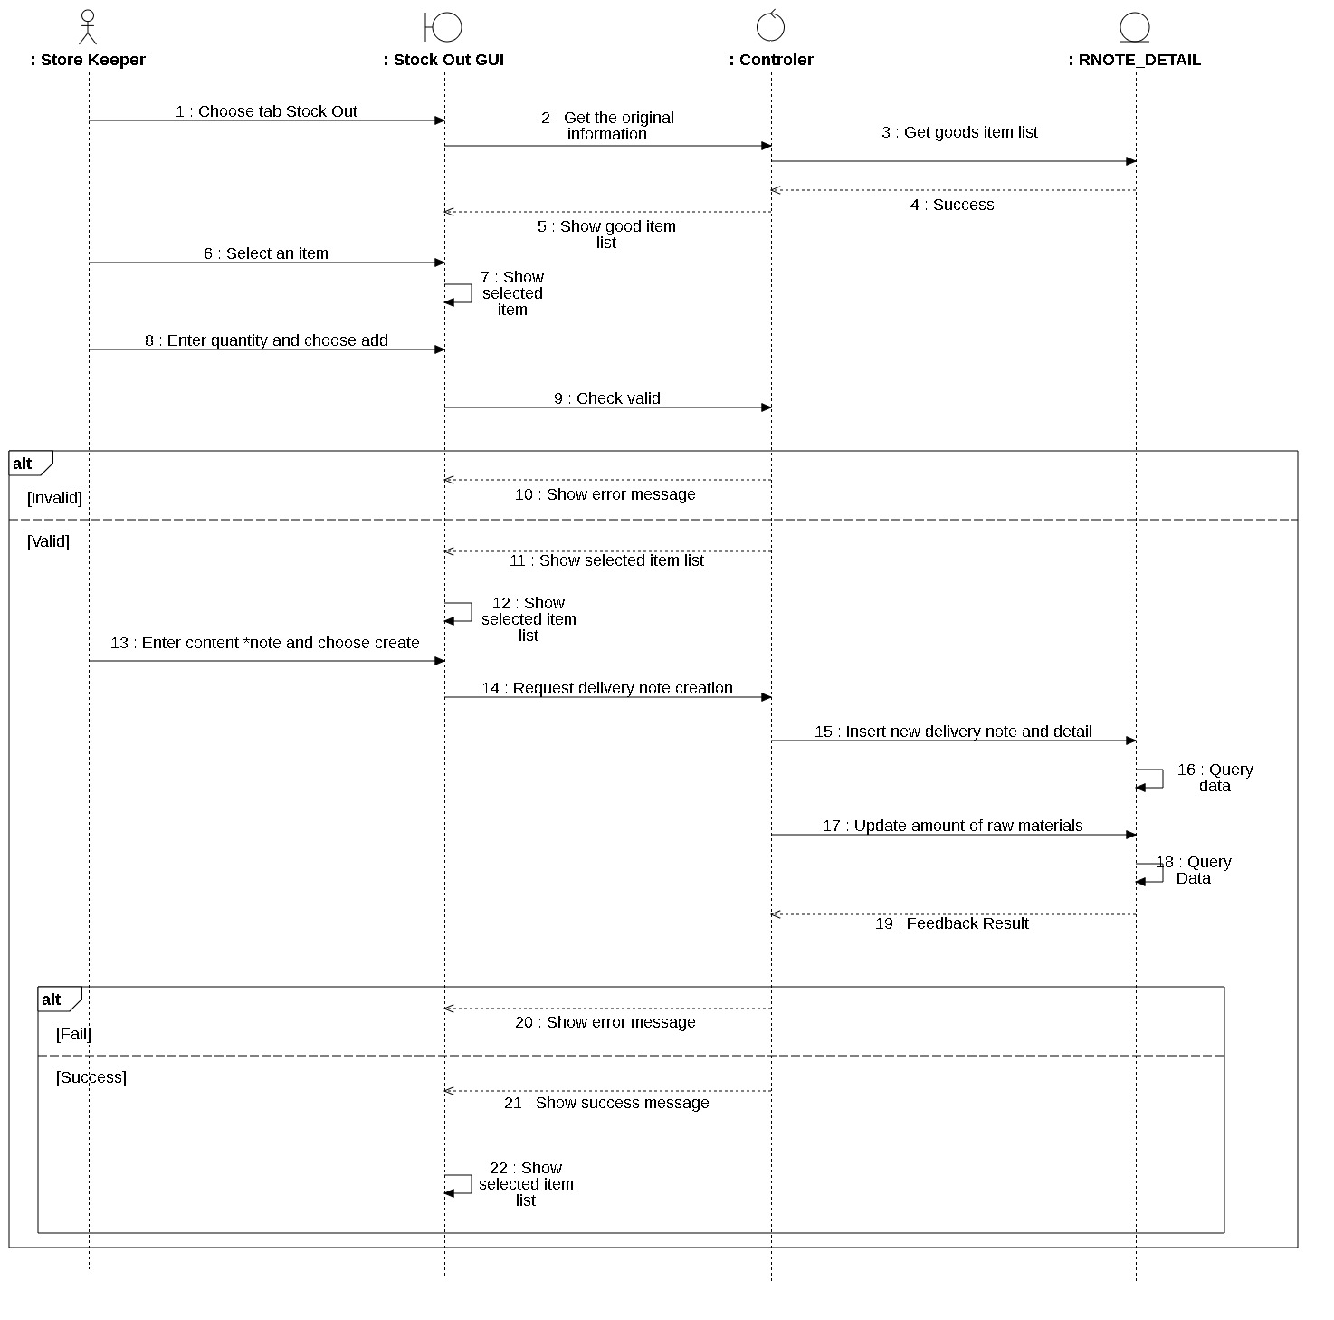

#### Materials_add Sequence Diagram

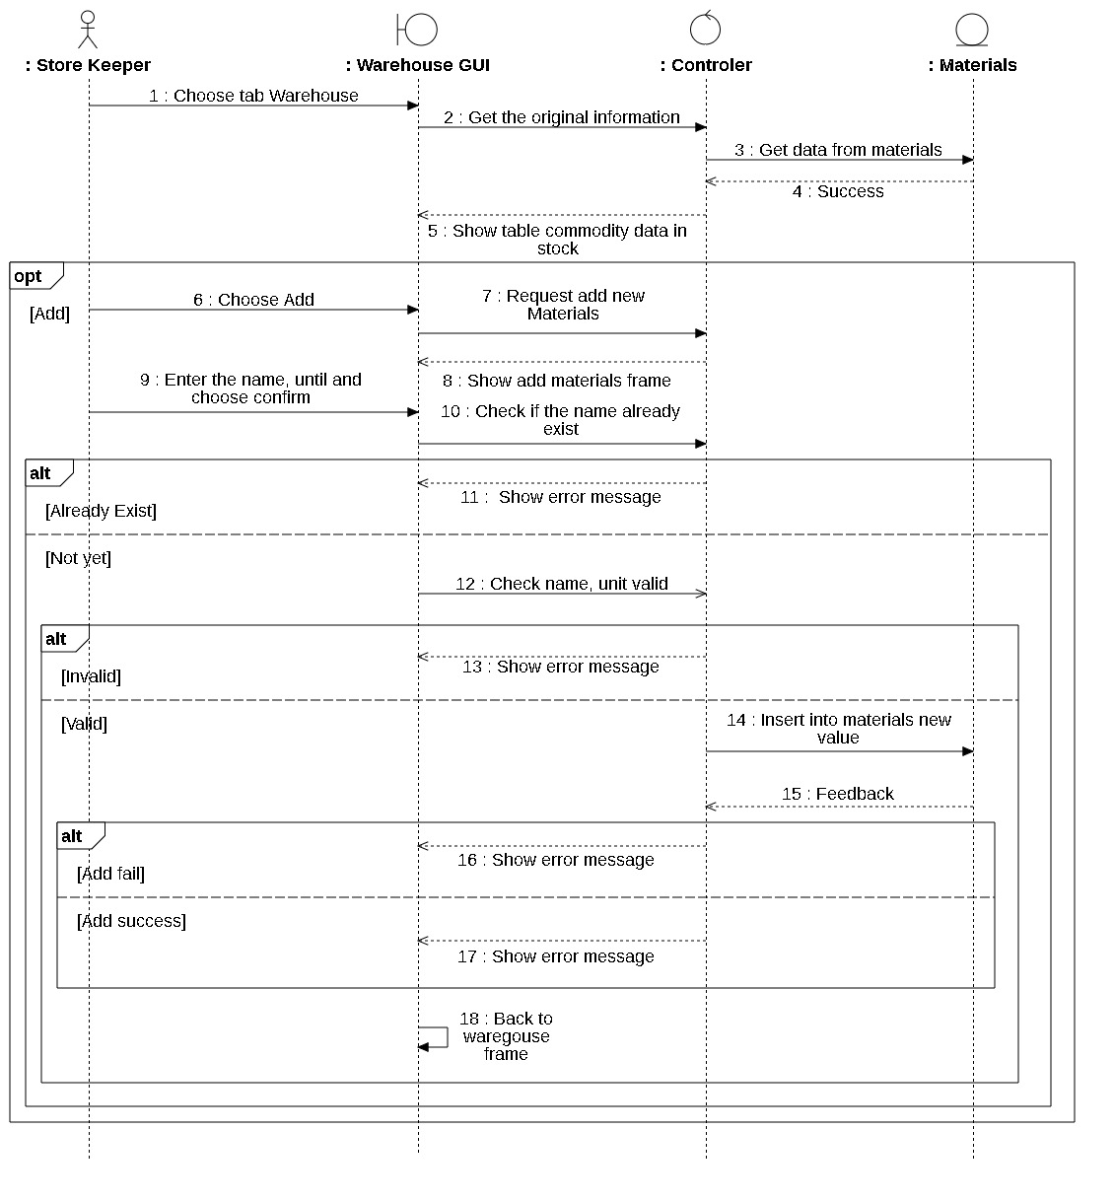

#### Materials_delete Sequence Diagram

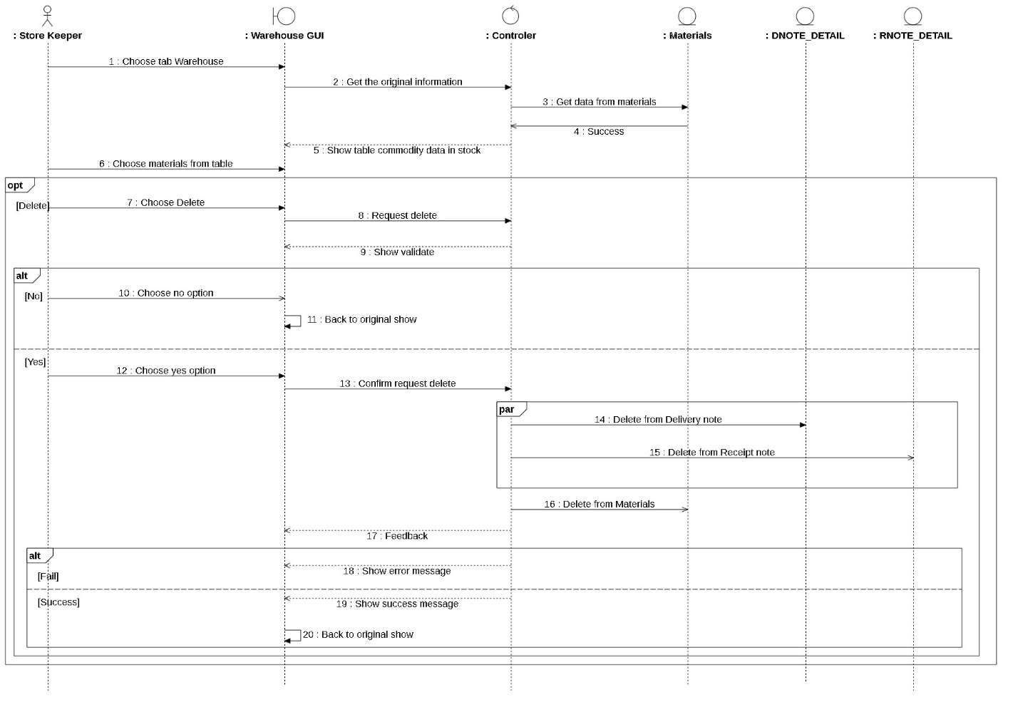

#### Materials_update Sequence Diagram

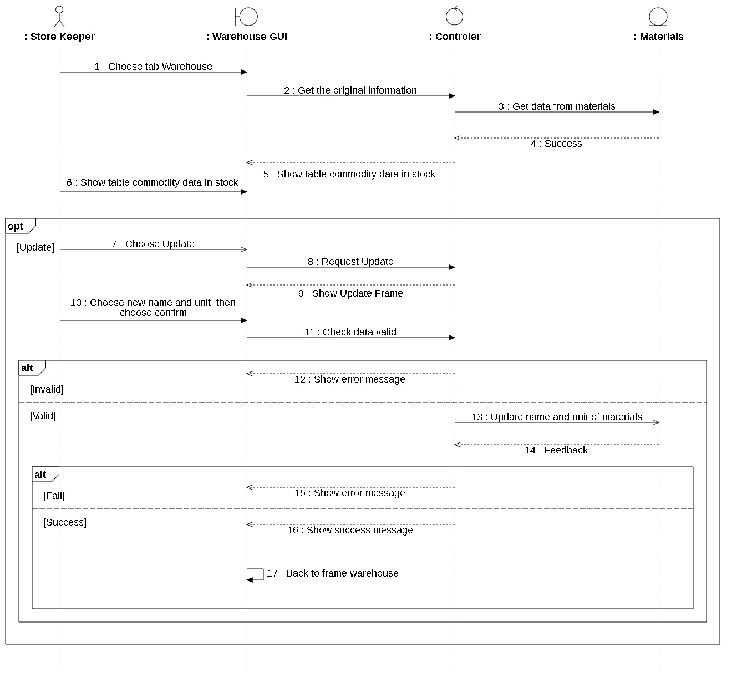

#### Receipt_note_creation Sequence Diagram

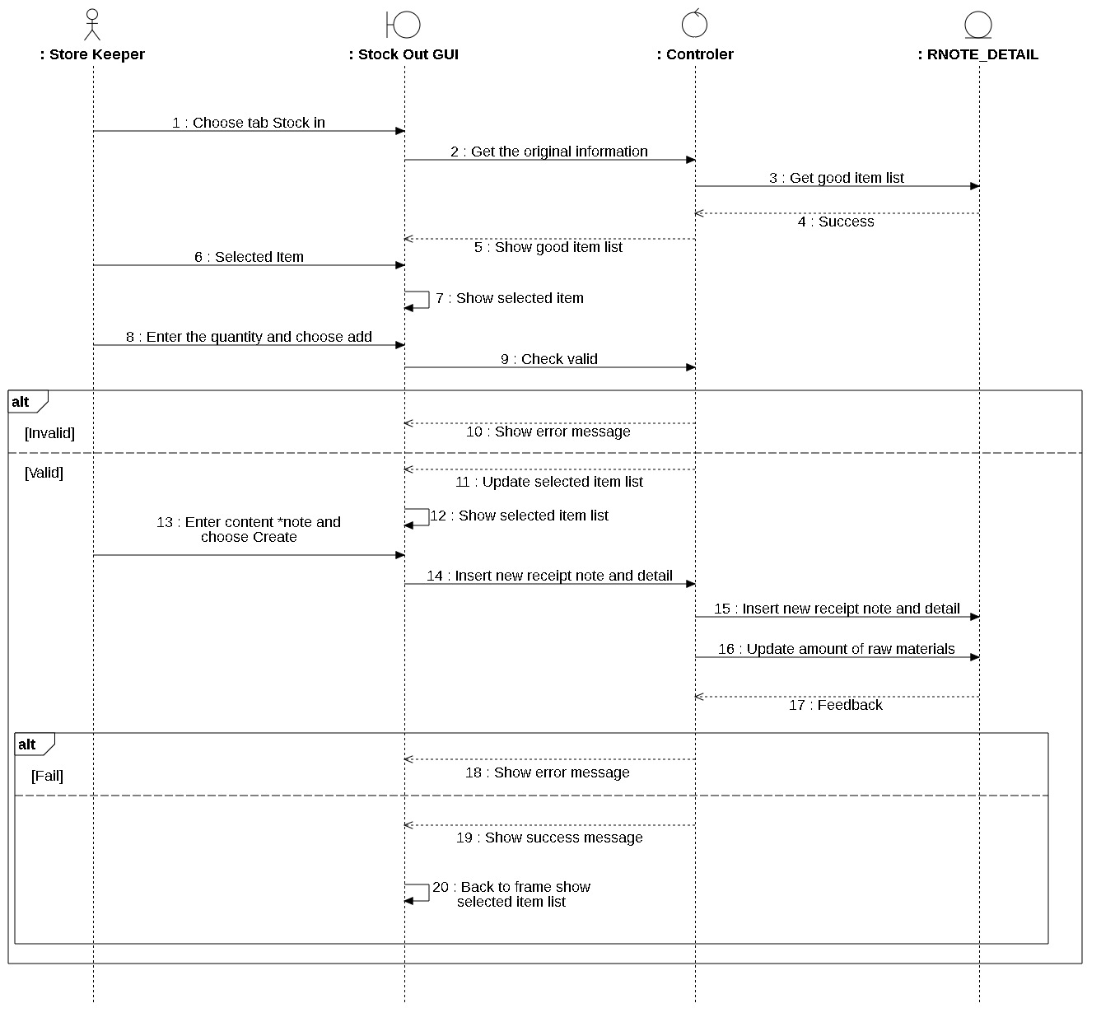

#### Search_delivery_note Sequence Diagram

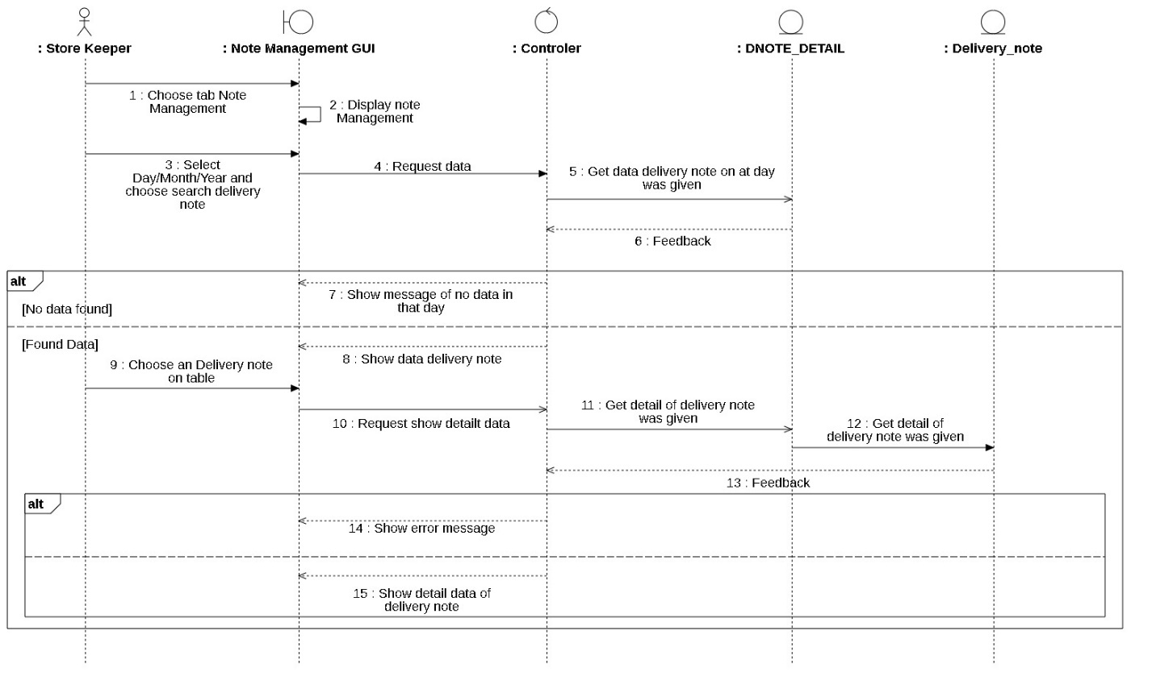

#### Search_receipt_note Sequence Diagram

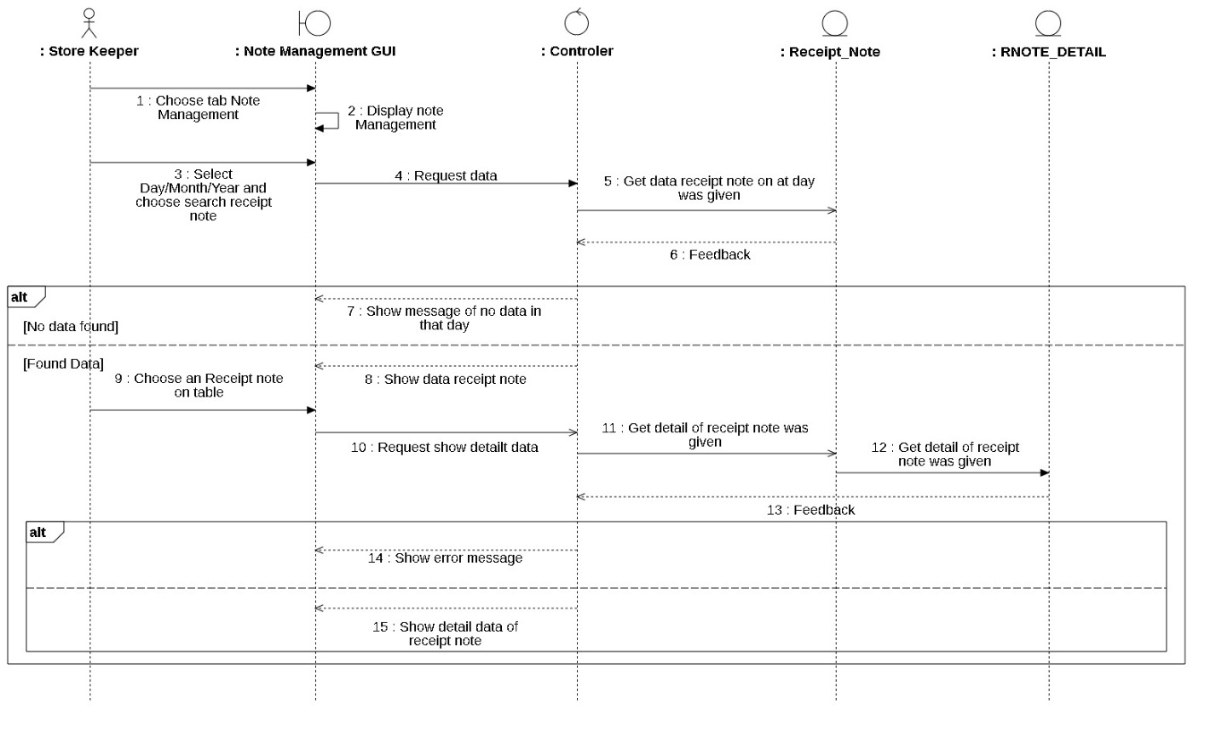

### Sequence Diagram: Service process management

#### Add drink Sequence Diagram

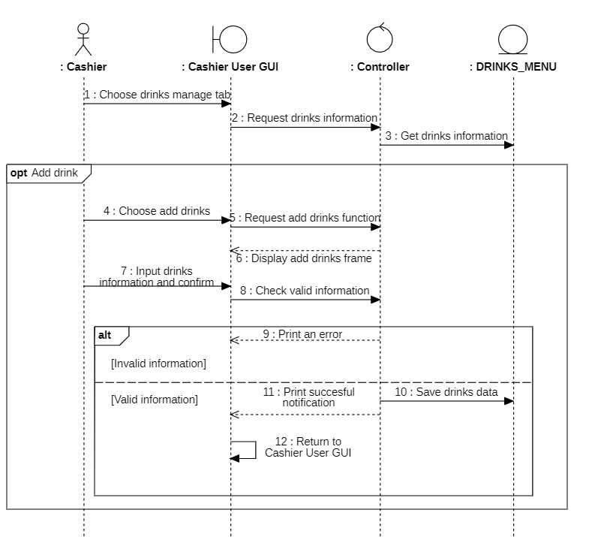

#### Add table Sequence Diagram

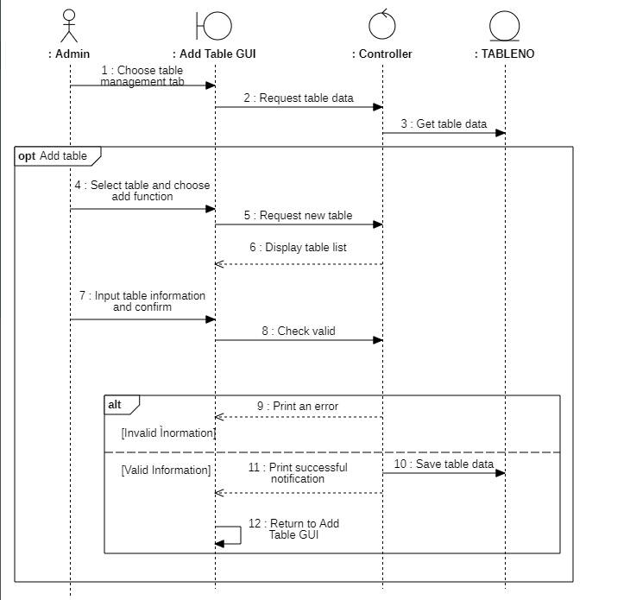

#### Delete Drinks Sequence Diagram

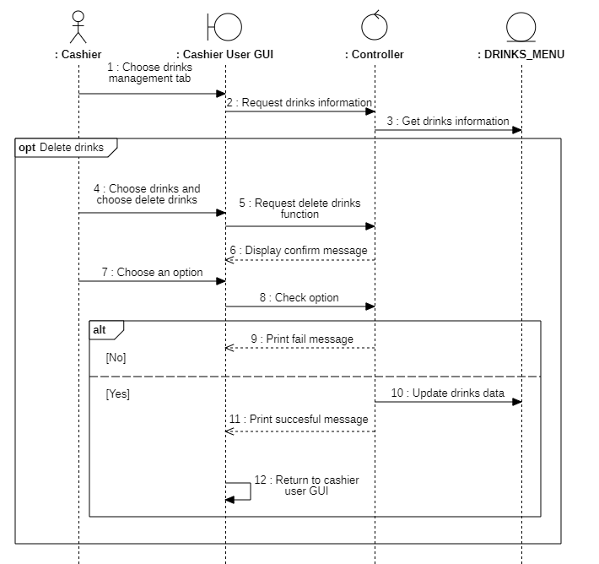

#### Delete Table Sequence Diagram

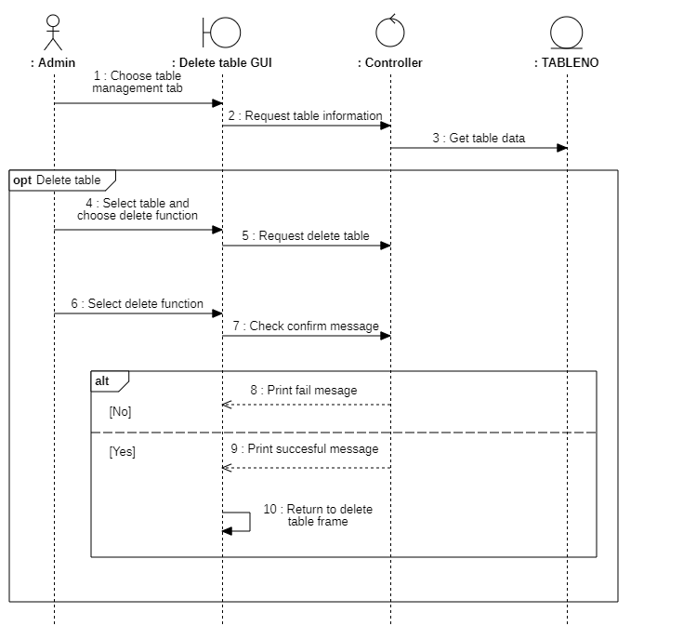

#### Edit Drinks Sequence Diagram

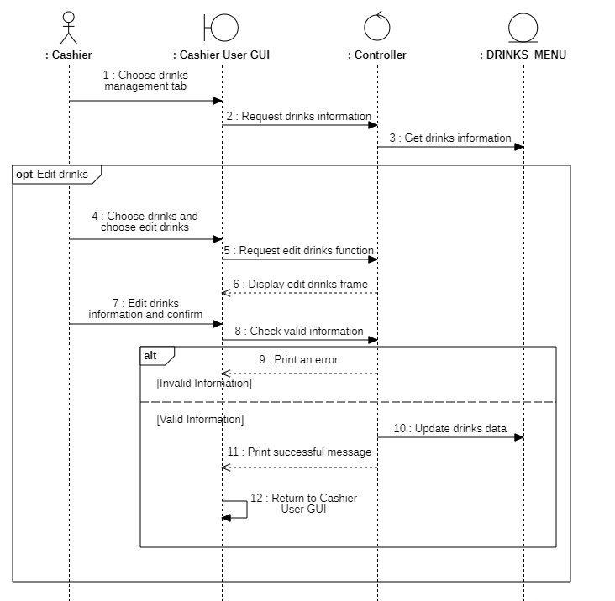

#### Edit Table Sequence Diagram

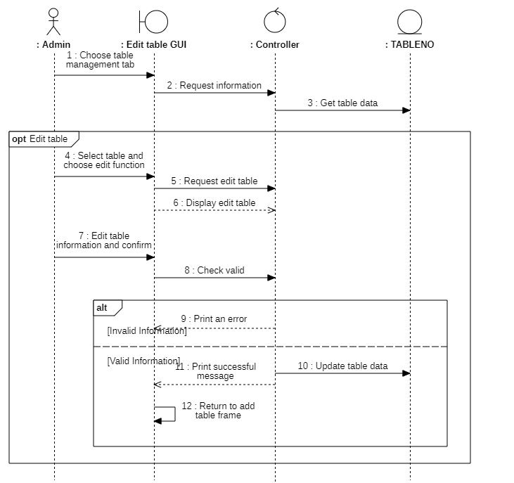

#### Payment Sequence Diagram

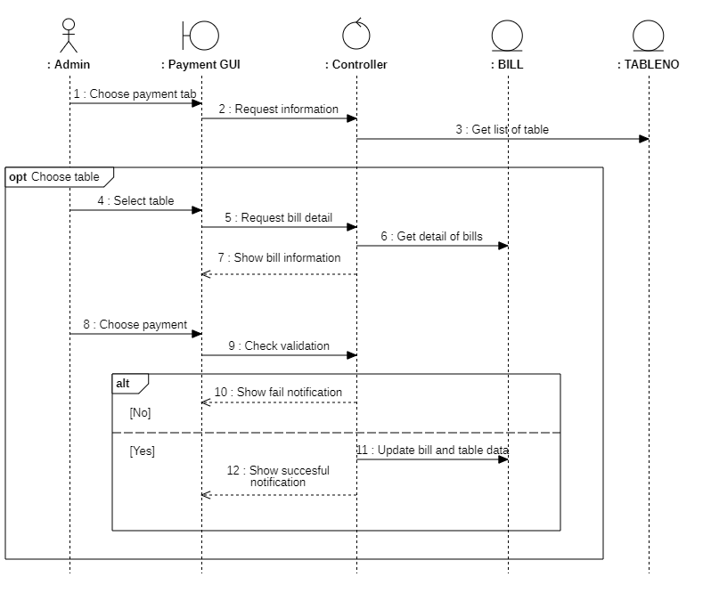

### Sequence Diagram: Financial statistics

#### Revenue Statistic of Area Statistics

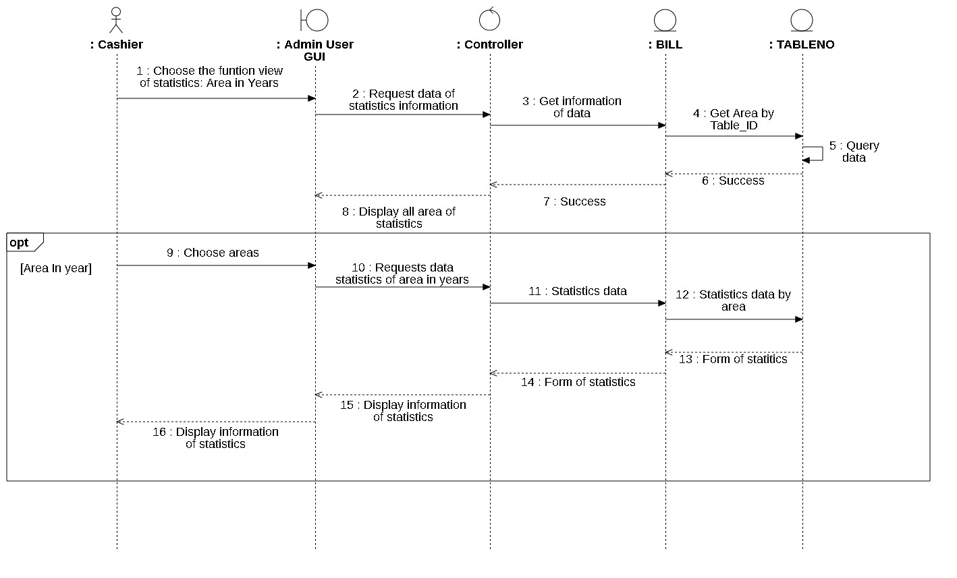

#### Revenue Statistic of Drinks Statistics

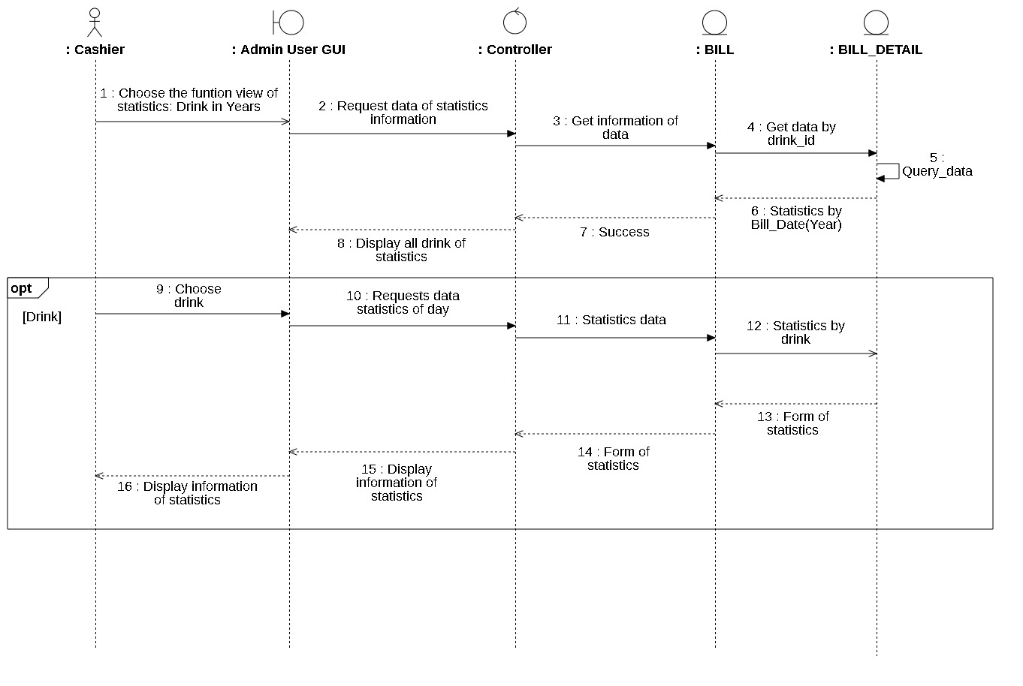

#### Revenue Statistic of Days Statistics

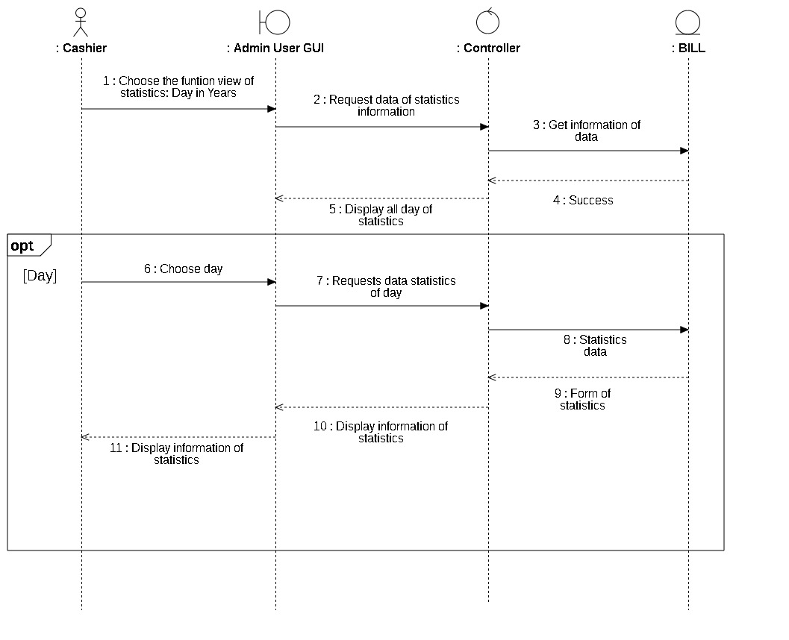

#### Revenue Statistic Statistics

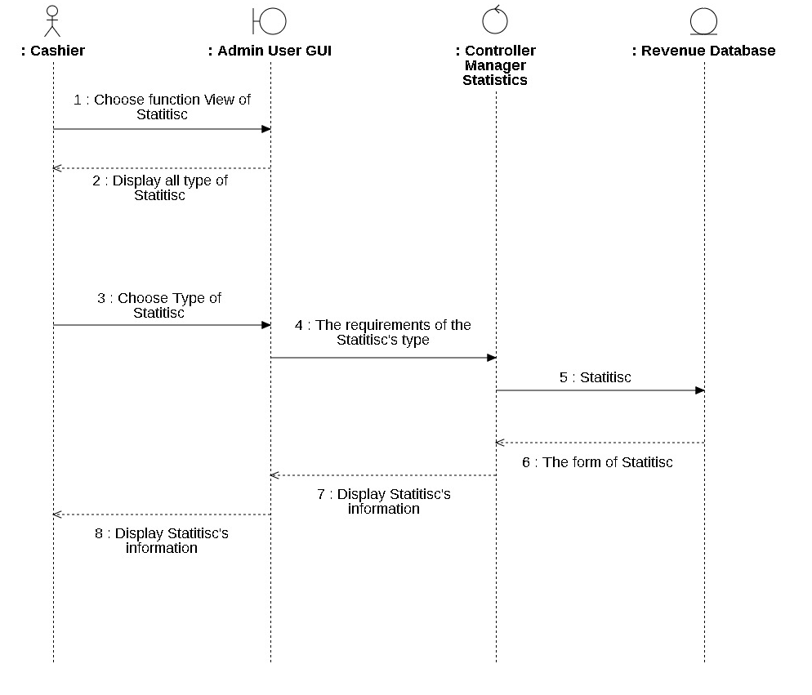

## List of Class Diagram

### Class Diagram: Employee information management

#### Personnel Management

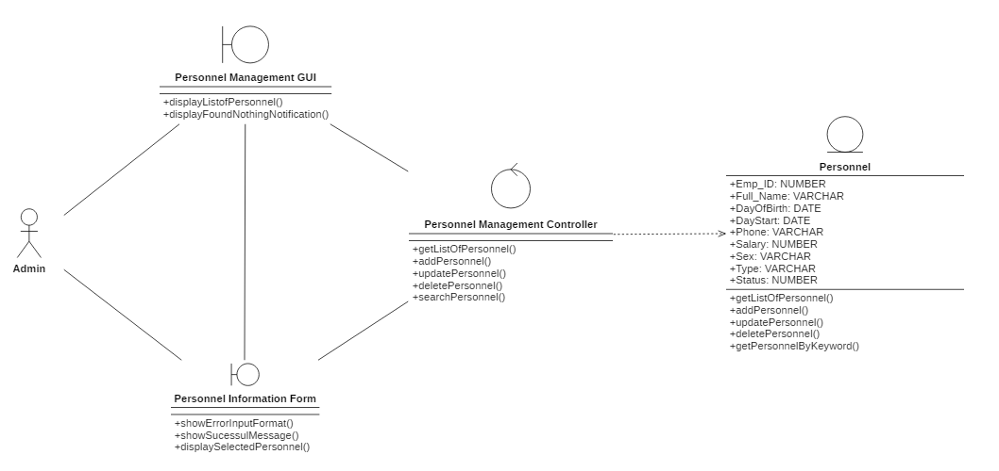

#### Account Management

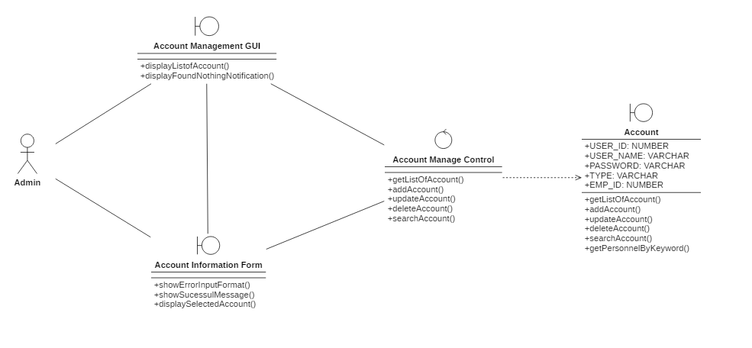

### Class Diagram: Material information management

#### Delivery_note_creation Class Diagram

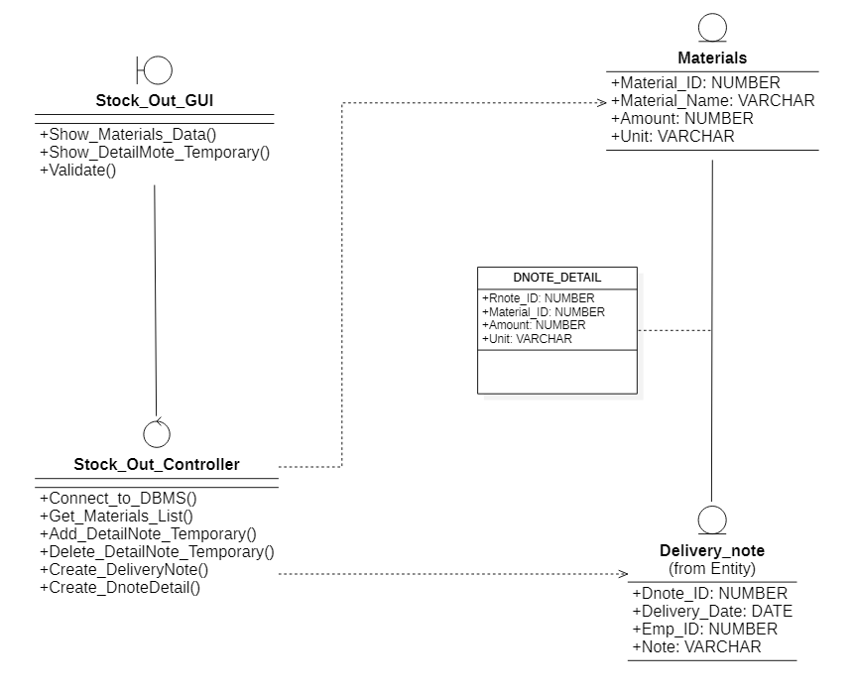

#### Materials_add Class Diagram

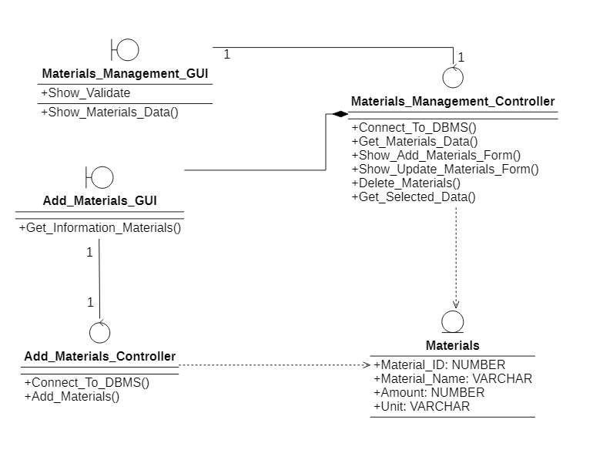

#### Materials_delete Class Diagram

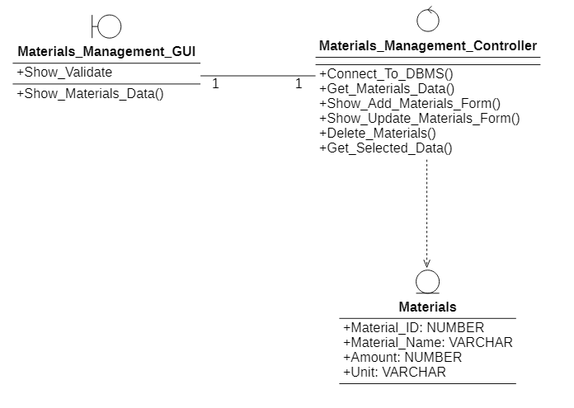

#### Materials_update Class Diagram

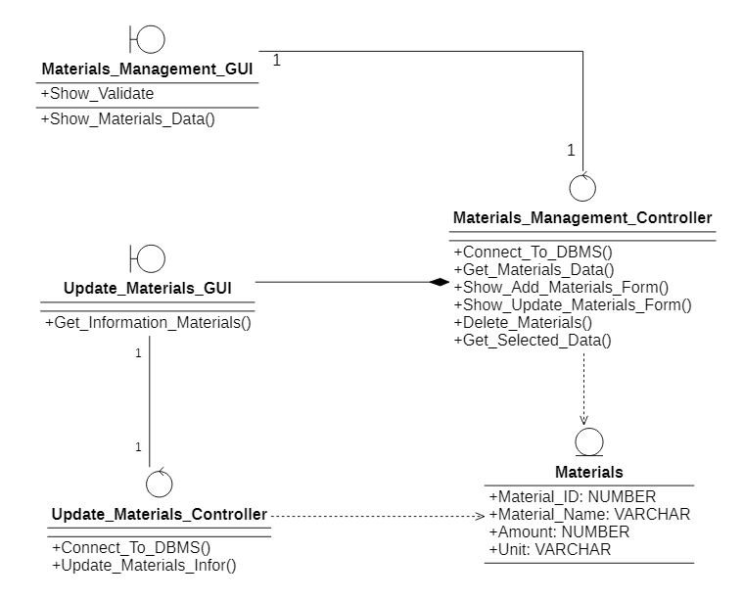

#### Receipt_note_creation Class Diagram

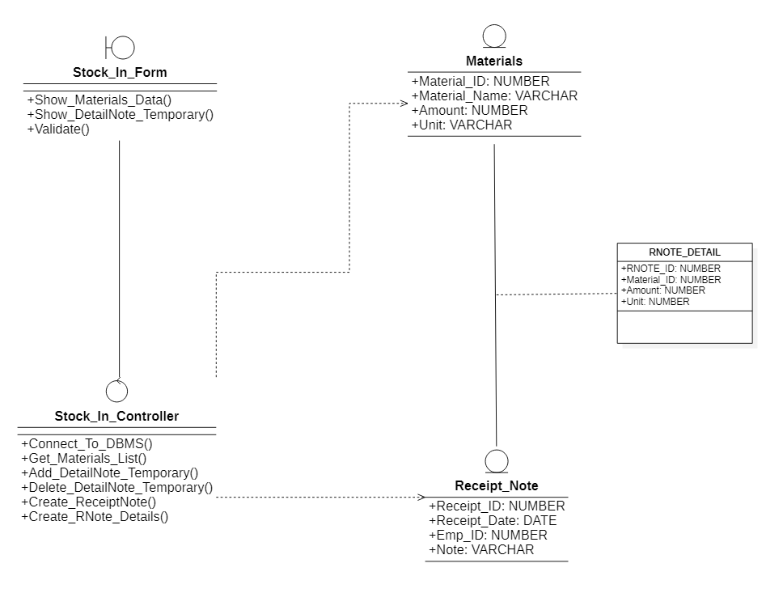

#### Search_delivery_note Class Diagram

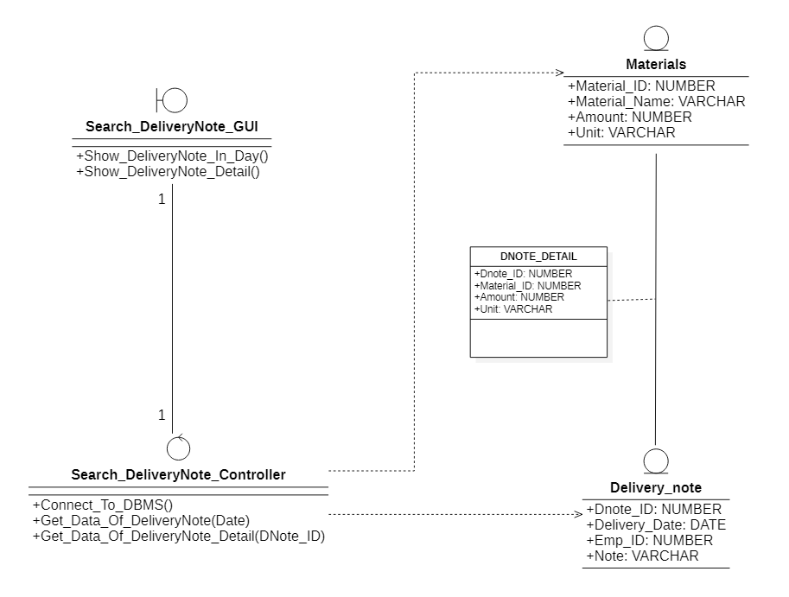

#### Search_Receipt_Note Class Diagram

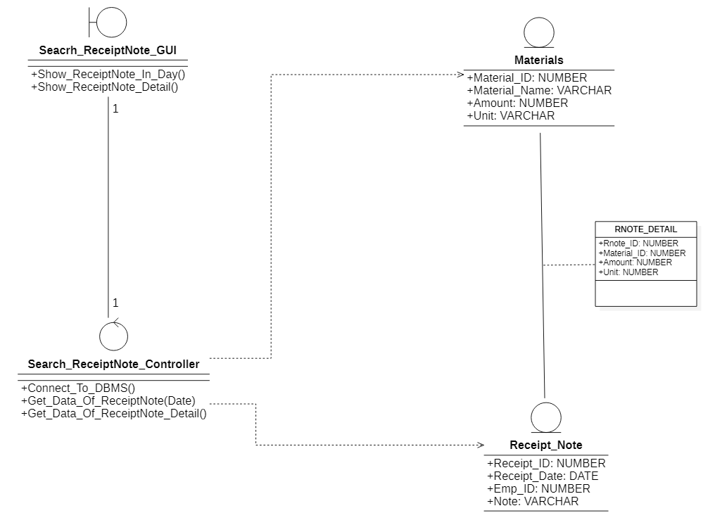

### Class Diagram: Service Process Management

#### Add drink Class Diagram

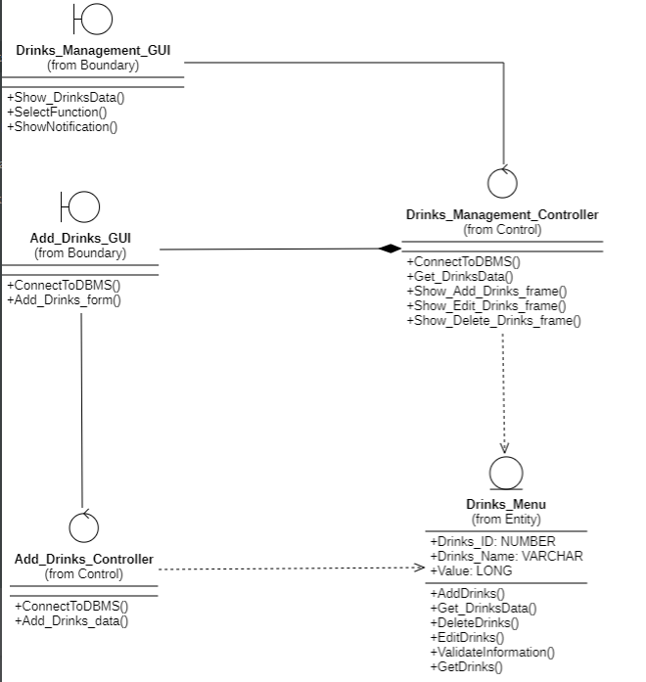

#### Add table Class Diagram

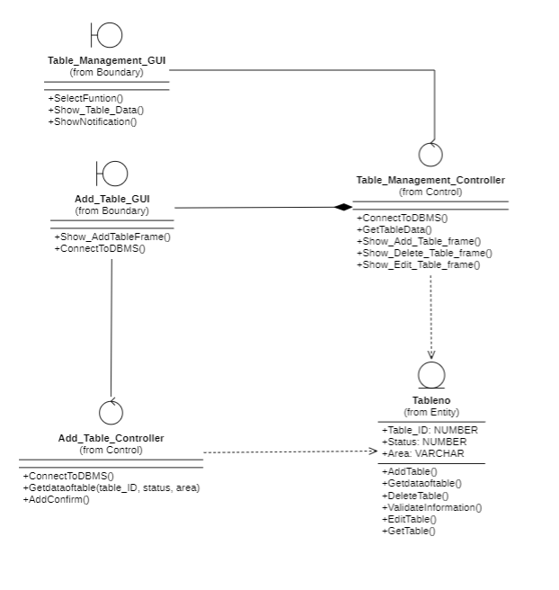

#### Delete Drinks Class Diagram

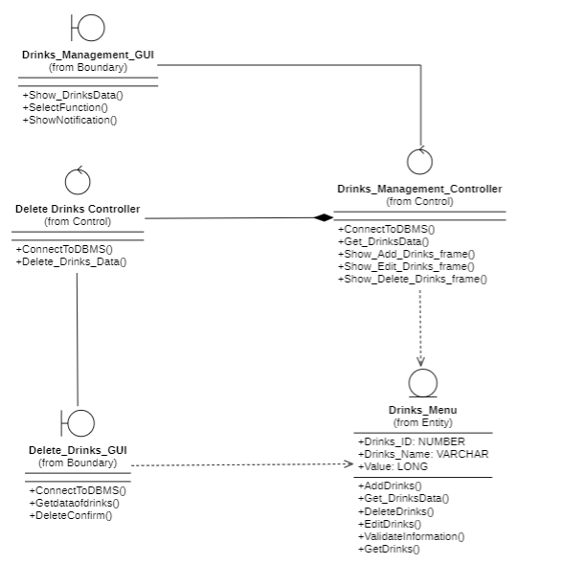

#### Delete Table Class Diagram

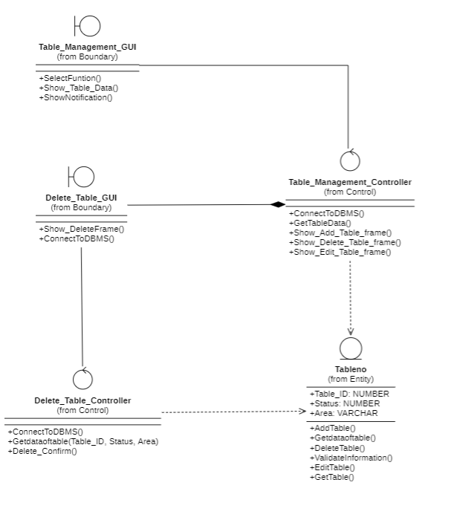

#### Edit Drinks Class Diagram

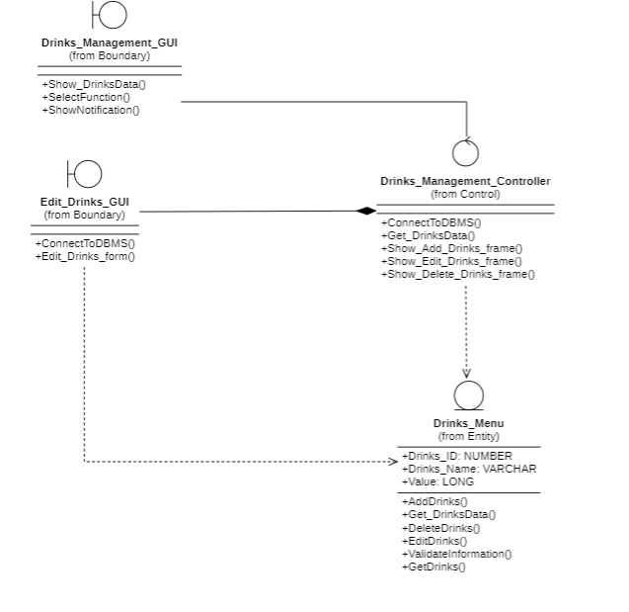

#### Edit Table Class Diagram

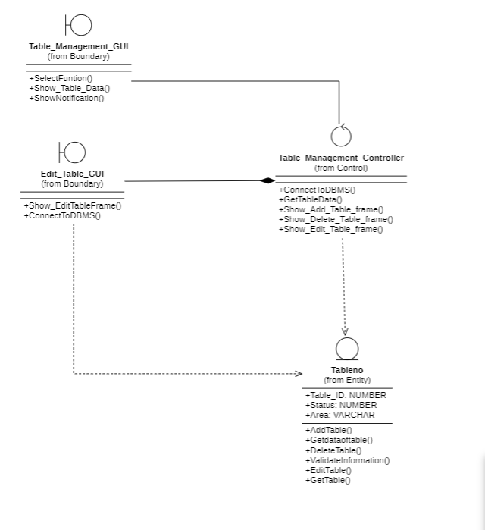

#### Payment Class Diagram

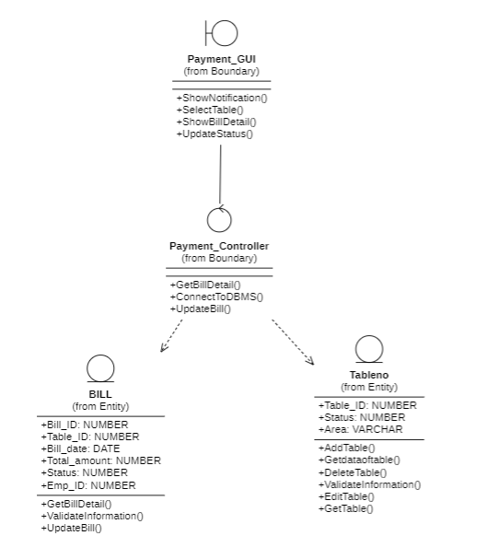

### Class Diagram: Financial statistics

#### Revenue Statistic of Area Statistics



#### Revenue Statistic of Drinks Statistics

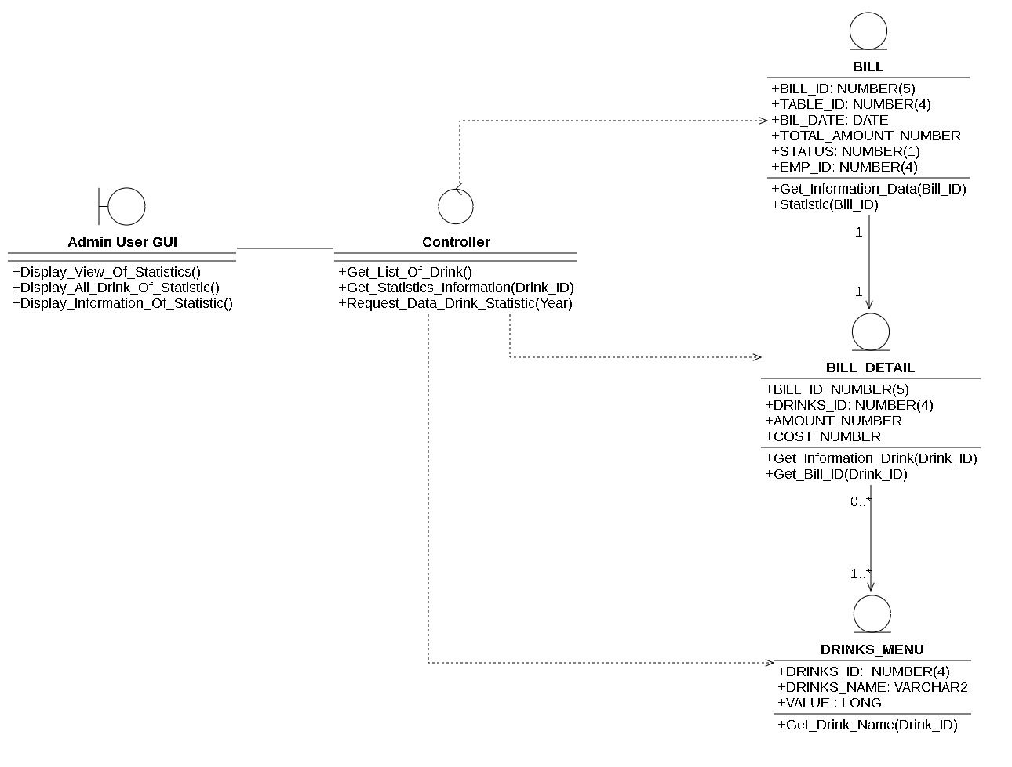

#### Revenue Statistic of Days

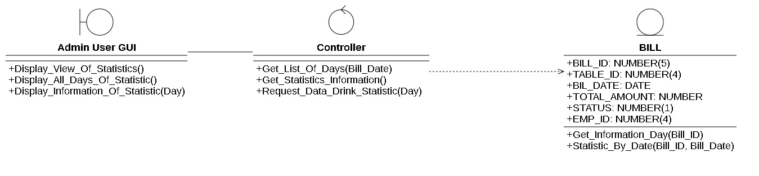

## List of State Diagram

### Payment State Diagram

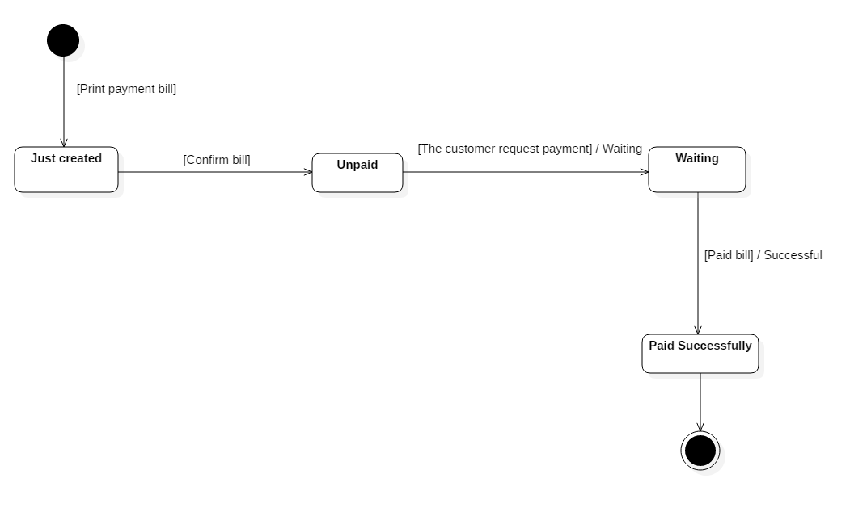

### Table booking State Diagram

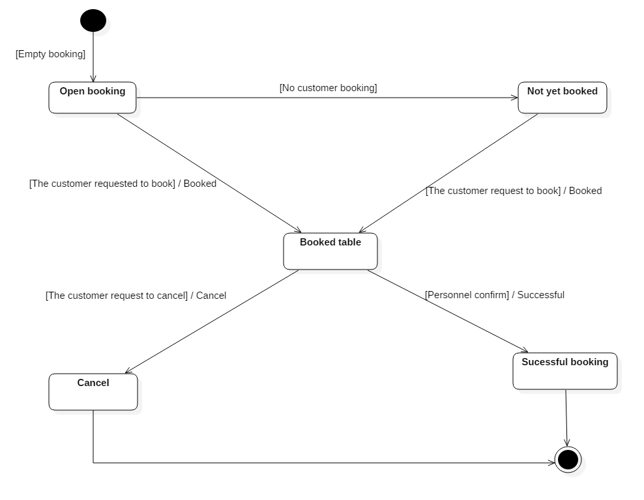

# DATABASE DESIGN

## Detailed description of Entity Models (Concept Level)

### **Name of entity:** ACCOUNT

**Descriptions of entity:** A specific entity representing the account of the employee and owner of the café

Entity details include the following information:

|  |  |  |  |  |
| --- | --- | --- | --- | --- |
|  | **ACCOUNT** | |  | **Date**: 23/05/2022 |
| **SERIALS** | **NAME OF ATTRIBUTES** | **INITIALS** | **TYPE OF DATA** | **DESCRIPTIONS** |
| 1 | ID of User | USER_ID | NUMBER | Represent each account for each employee individually |
| 2 | Name of User | USER_NAME | STRING | Each account has a separate account name that does not overlap to distinguish between this account and another account. |
| 3 | Password | PASSWORD | STRING | Each account has a password that may be different or the same as another account, used to log into the system. |
| 4 | Account type | TYPE | STRING | Each employee will have a separate position in the system |
| 5 | ID of employee | EMP_ID | NUMBER | Each employee will have a unique id to distinguish other employees in the system |

### Name of entity: BILL

**Descriptions of entity:** A specific entity representing each invoice.

Entity details include the following information:

|  |  |  |  |  |
| --- | --- | --- | --- | --- |
|  | **BILL** | |  | **Date**: 23/05/2022 |
| **SERIALS** | **NAME OF ATTRIBUTES** | **INITIALS** | **TYPE OF DATA** | **DESCRIPTIONS** |
| 1 | ID of bill | BILL_ID | NUMBER | Each invoice will have a separate invoice code to distinguish this invoice and other invoices. |
| 2 | ID of Table | TABLE_ID | NUMBER | Each table will have a separate table code to distinguish this table and other tables. |
| 3 | Date of bill | BILL_DATE | DATE | Each invoice will have an invoice date |
| 4 | Total amount of each bill | TOTAL_AMOUNT | NUMBER | Total price of each invoice |
| 5 | Status | STATUS | NUMBER | Each invoice will have its own status. 1 is paid, 0 is unpaid |
| 6 | ID of Employee | EMP_ID | NUMBER | Each employee will have a unique ID code to distinguish the other employees |

### Name of entity: BILL_DETAIL

**Descriptions of entity:** A specific entity representing details for each invoice

Entity details include the following information:

|  |  |  |  |  |
| --- | --- | --- | --- | --- |
| **BILL_DETAIL** | | | | **Date**: 23/05/2022 |
| **SERIALS** | **NAME OF ATTRIBUTES** | **INITIALS** | **TYPE OF DATA** | **DESCRIPTIONS** |
| 1 | ID of bill | BILL_ID | NUMBER | Each invoice will have a separate invoice code to distinguish this invoice and other invoices. |
| 2 | ID of Drinks | DRINKS_ID | NUMBER | Each drink has its own unique ID to differentiate other drinks |
| 3 | Amount of drinks | AMOUNT | NUMBER | Amount of each drink in each bill |
| 4 | Cost of each drinks | COST | NUMBER | The total amount of each beverage in each bill |

### Name of entity: DRINKS_MENU

**Descriptions of entity:** a specific entity representing the beverage menu

Entity details include the following information:

|  |  |  |  |  |
| --- | --- | --- | --- | --- |
|  | **DRINKS_MENU** | |  | **Date**: 23/05/2022 |
| **SERIALS** | **NAME OF ATTRIBUTES** | **INITIALS** | **TYPE OF DATA** | **DESCRIPTIONS** |
| 1 | ID of Drinks | DRINK_ID | NUMBER | Each drink has its own unique ID to differentiate other drinks |
| 2 | Name of Drinks | DRINKS_NAME | STRING | Each drink will have a unique name to distinguish the other drinks |
| 3 | Value of each drinks | VALUE | LONG | Each drink will have its own price |

### Name of entity: DELIVERY_NOTE

**Descriptions of entity**: an entity representing goods import orders

Entity details include the following information:

|  |  |  |  |  |
| --- | --- | --- | --- | --- |
|  | **DELIVERY_NOTE** | |  | **Date**: 23/05/2022 |
| **SERIALS** | **NAME OF ATTRIBUTES** | **INITIALS** | **TYPE OF DATA** | **DESCRIPTIONS** |
| 1 | ID of Delivery | DNOTE_ID | NUMBER | Each import voucher will have its own ID to distinguish other goods |
| 2 | Date of Delivery | DELIVERY_NOTE | DATE | Each entry form will have an import date |
| 3 | ID of employee | EMP_ID | NUMBER | Each import order will have a delivery staff |

### **Name of entity:** DELIVERY NOTE DETAIL

**Initials: DNOTE_DETAIL**

**Descriptions of entity:** An entity representing details of each import order

Entity details include the following information:

|  |  |  |  |  |
| --- | --- | --- | --- | --- |
|  | **DNOTE_DETAIL** | |  | **Date**: 23/05/2022 |
| **SERIALS** | **NAME OF ATTRIBUTES** | **INITIALS** | **TYPE OF DATA** | **DESCRIPTIONS** |
| 1 | ID of delivery note | DNOTE_ID | NUMBER | Each entry will have its own unique ID code to differentiate other line items |
| 2 | ID of material | MATERIAL_ID | NUMBER | Each type of goods will have its own ID to distinguish other types of goods |
| 3 | Amount of delivery note | AMOUNT | NUMBER | Quantity of each type of material |
| 4 | Unit of each material | UNIT | STRING | Unit of each type of material |

### Name of entity: RECEIPT_NOTE

**Descriptions of entity:** is the entity representing the receipt order

Entity details include the following information:

|  |  |  |  |  |
| --- | --- | --- | --- | --- |
|  | **RECEIPT_NOTE** | |  | **Date**: 23/05/2022 |
| **SERIALS** | **NAME OF ATTRIBUTES** | **INITIALS** | **TYPE OF DATA** | **DESCRIPTIONS** |
| 1 | ID of receipt note | RNOTE_ID | NUMBER | Each receipt has its own unique ID code to distinguish the others |
| 2 | Date of receipt | RECEIPT_DATE | DATE | Each receipt has a receipt date |
| 3 | ID of employee | EMP_ID | NUMBER | Each receipt has a staff to handle the goods |

### Name of entity: RECEIPT NOTE DETAIL

**Initials: RNOTE_DETAIL**

**Descriptions of entity:** is the entity representing each receipt in detail

Entity details include the following information:

|  |  |  |  |  |
| --- | --- | --- | --- | --- |
|  | **RNOTE_DETAIL** | |  | **Date**: 23/05/2022 |
| **SERIALS** | **NAME OF ATTRIBUTES** | **INITIALS** | **TYPE OF DATA** | **DESCRIPTIONS** |
| 1 | ID of Receipt note | RNOTE_ID | NUMBER | Each invoice item has its own unique ID to differentiate each other |
| 2 | ID of Material | MATERIAL_ID | NUMBER | Each item received has its own unique ID |
| 3 | Amount | AMOUNT | NUMBER | Quantity of each type of material |
| 4 | Unit of material | UNIT | STRING | Unit of each type of material |

### Name of entity: MATERIALS

**Descriptions of entity:** is the entity representing the material

Entity details include the following information:

|  |  |  |  |  |
| --- | --- | --- | --- | --- |
|  | **MATERIALS** | |  | **Date**: 23/05/2022 |
| **SERIALS** | **NAME OF ATTRIBUTES** | **INITIALS** | **TYPE OF DATA** | **DESCRIPTIONS** |
| 1 | ID of Materials | MATERIALS_ID | NUMBER | Each material will have its own ID to distinguish other materials |
| 2 | Name of Materials | MATERIALS_NAME | STRING | Name of each material |
| 3 | Amount of materials | AMOUNT | NUMBER | Quantity of each type of material |
| 4 | Unit of Materials | UNIT | STRING | Unit of each material |

### Name of entity: TABLE NUMBER

**INITIALS: TABLENO**

**Descriptions of entity:** The entity representing the ordinal number of each table

Entity details include the following information:

|  |  |  |  |  |
| --- | --- | --- | --- | --- |
|  | **TABLENO** | |  | **Date**: 23/05/2022 |
| **SERIALS** | **NAME OF ATTRIBUTES** | **INITIALS** | **TYPE OF DATA** | **DESCRIPTIONS** |
| 1 | ID of table | TABLE_ID | NUMBER | Each table has its own ID to distinguish the other tables |
| 2 | Name of Status | STATUS_NAME | STRING | Each table has its own status including guests or no guests |
| 3 | Area of Table | AREA | STRING | The area of the table |
| 4 | Note of booking | BOOKING_NOTE | STRING | Save the reservation information |

### Name of entity: EMPLOYEE RECORD

**INITIALS: EMP_RECORD**

**Descriptions of entity:** The entity represents the information of each employee

Entity details include the following information:

|  |  |  |  |  |
| --- | --- | --- | --- | --- |
|  | **EMP_RECORD** | |  | **Date**: 23/05/2022 |
| **SERIALS** | **NAME OF ATTRIBUTES** | **INITIALS** | **TYPE OF DATA** | **DESCRIPTIONS** |
| 1 | ID of employee | EMP_ID | NUMBER | Each employee has a unique ID code to distinguish the other employees |
| 2 | Full name of employee | FULLNAME | STRING | Full name of each employee |
| 3 | Day of birth of employee | BIRTHDAY | DATE | Day of birth’s employee |
| 4 | Day of Starting | DAYSTART | DATE | Every employee has a day to work |
| 5 | Phone | PHONE | NUMBER | Each employee has their own contact phone number |
| 6 | Salary of each employee | SALARY | NUMBER | Each employee has their own contact phone number |
| 7 | Sex of each employee | SEX | STRING | Each employee has specific gender information |
| 8 | Type of each employee | TYPE | STRING | Each employee is defined by employee type |
| 9 | Status of each employee | STATUS | NUMBER | Each employee has his or her own situation. 1 is still working, 0 is quitting |

## Entity model / Associate (ERD) model to Physical model (Physical Level)

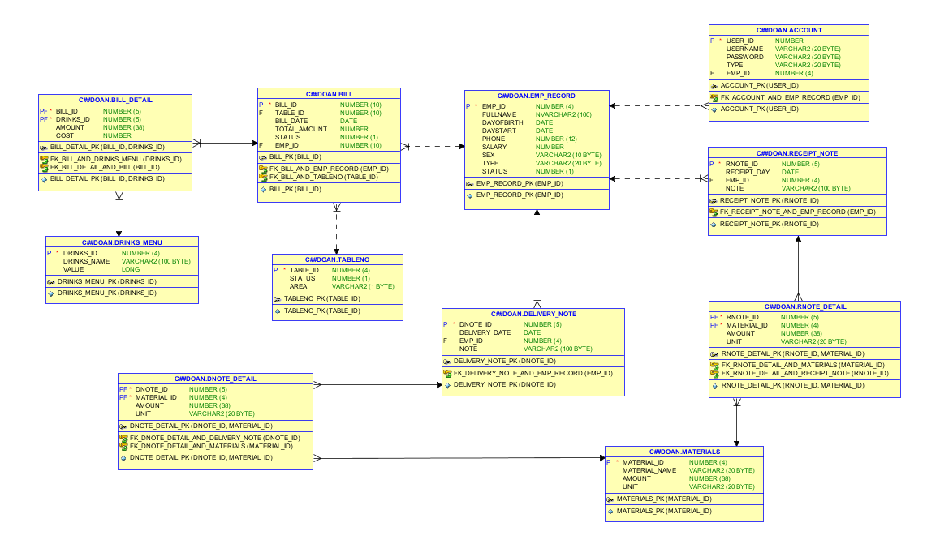

# INTERFACE DESIGN AND HANDLING

|  |  |
| --- | --- |
| **Serial** | **NAME** |
| 1 | Login |
| 2 | Input Warehouse |
| 3 | Output Warehouse |
| 4 | Material table |
| 5 | Add, edit materials |
| 6 | Note management |
| 7 | Order |
| 8 | Payment |
| 9 | Menu management |
| 10 | Add, edit menu |
| 11 | Employee management |
| 12 | Add, Edit employee |
| 13 | Account management |
| 14 | Add Account, change password |
| 15 | Table Management |
| 16 | Add table |
| 17 | View Statistic of Area |
| 18 | View Statistic of Days |
| 19 | View Statistic of Drinks |

## Login

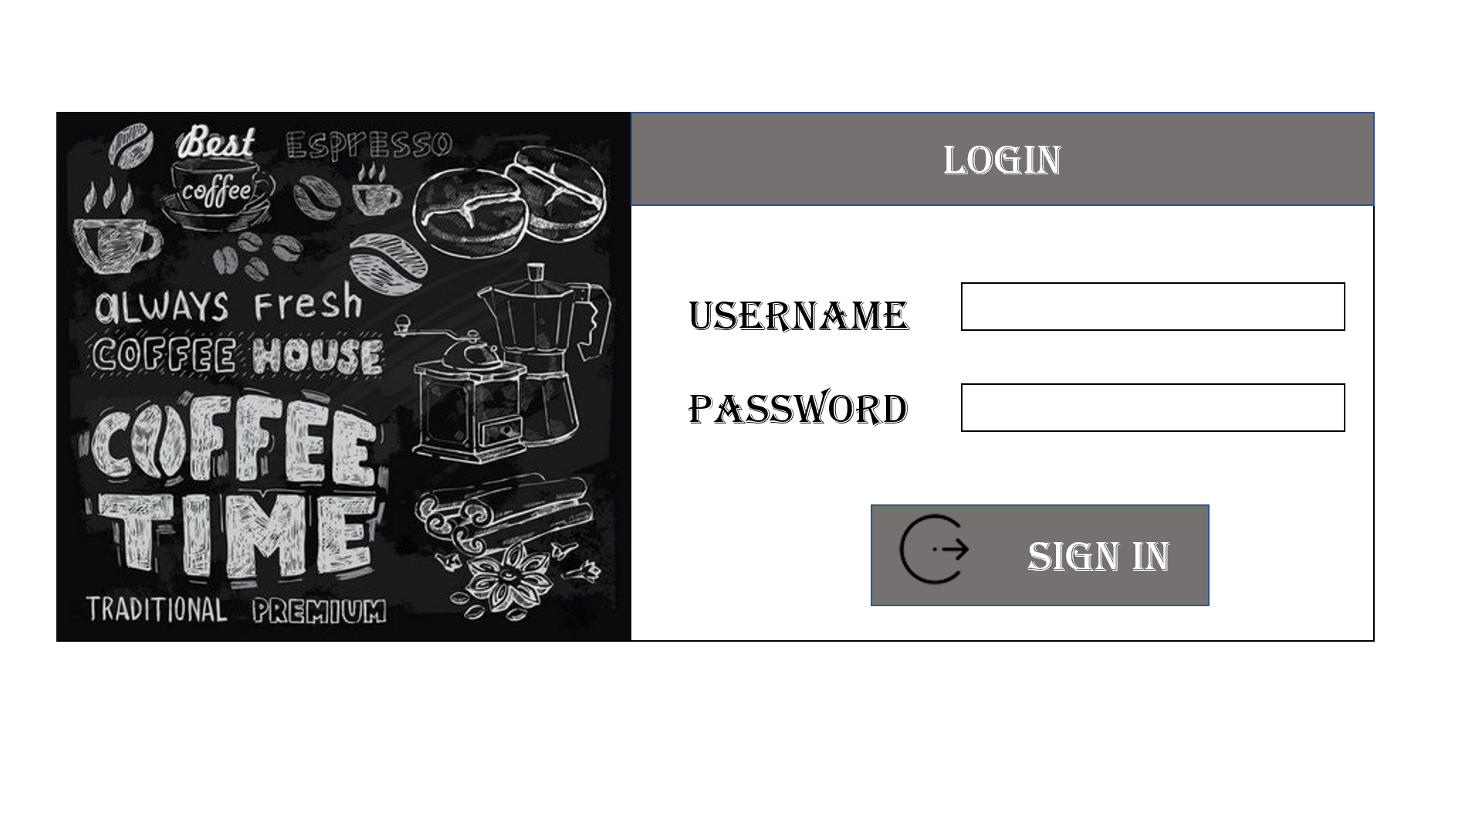

## Input Warehouse

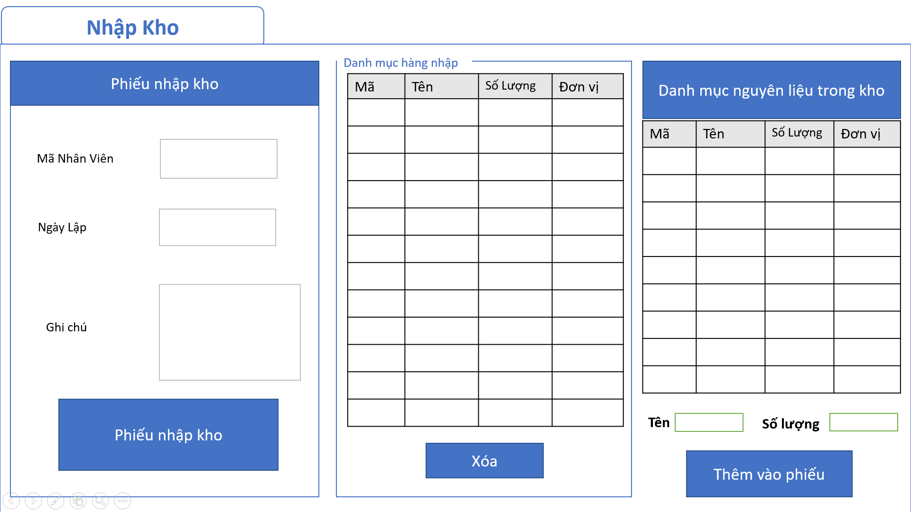

## Output Warehouse

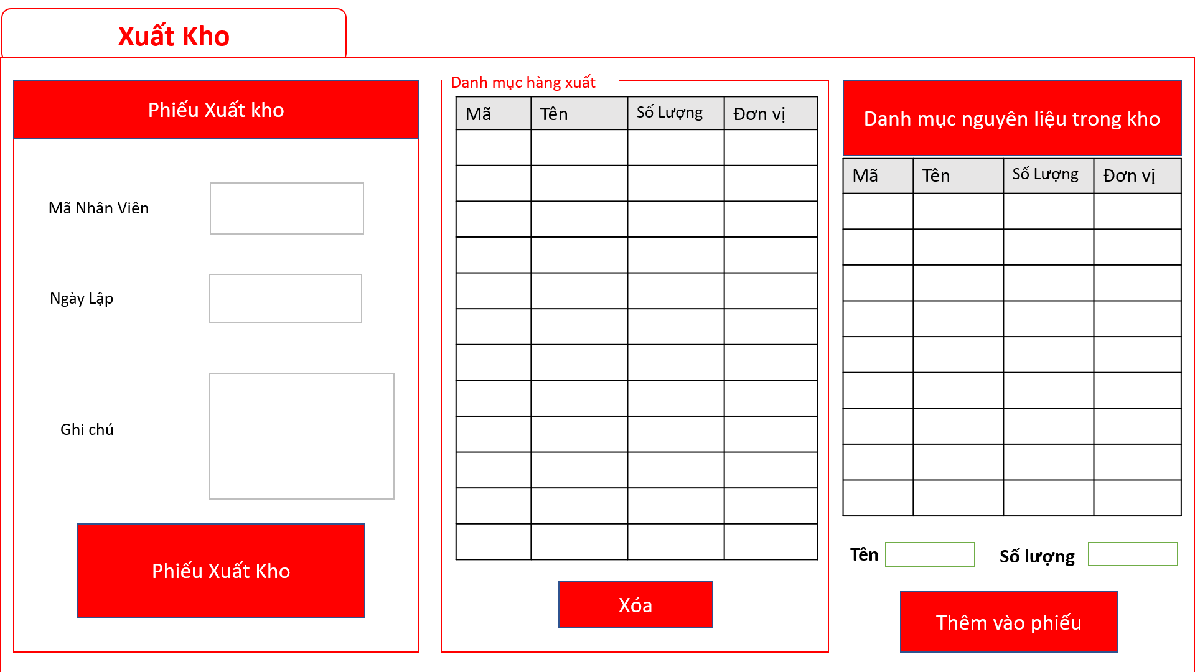

## Material table

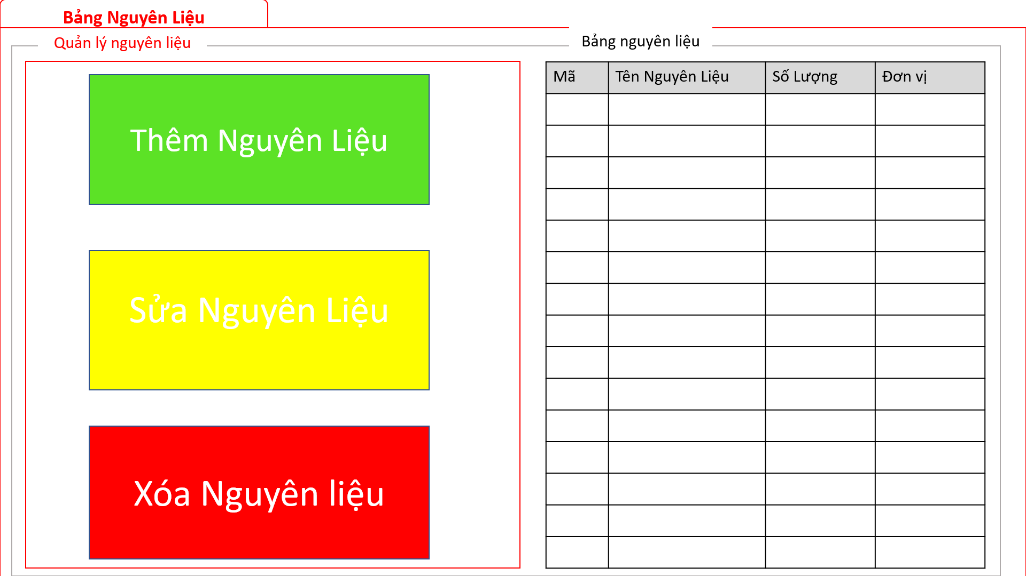

## Add, edit materials

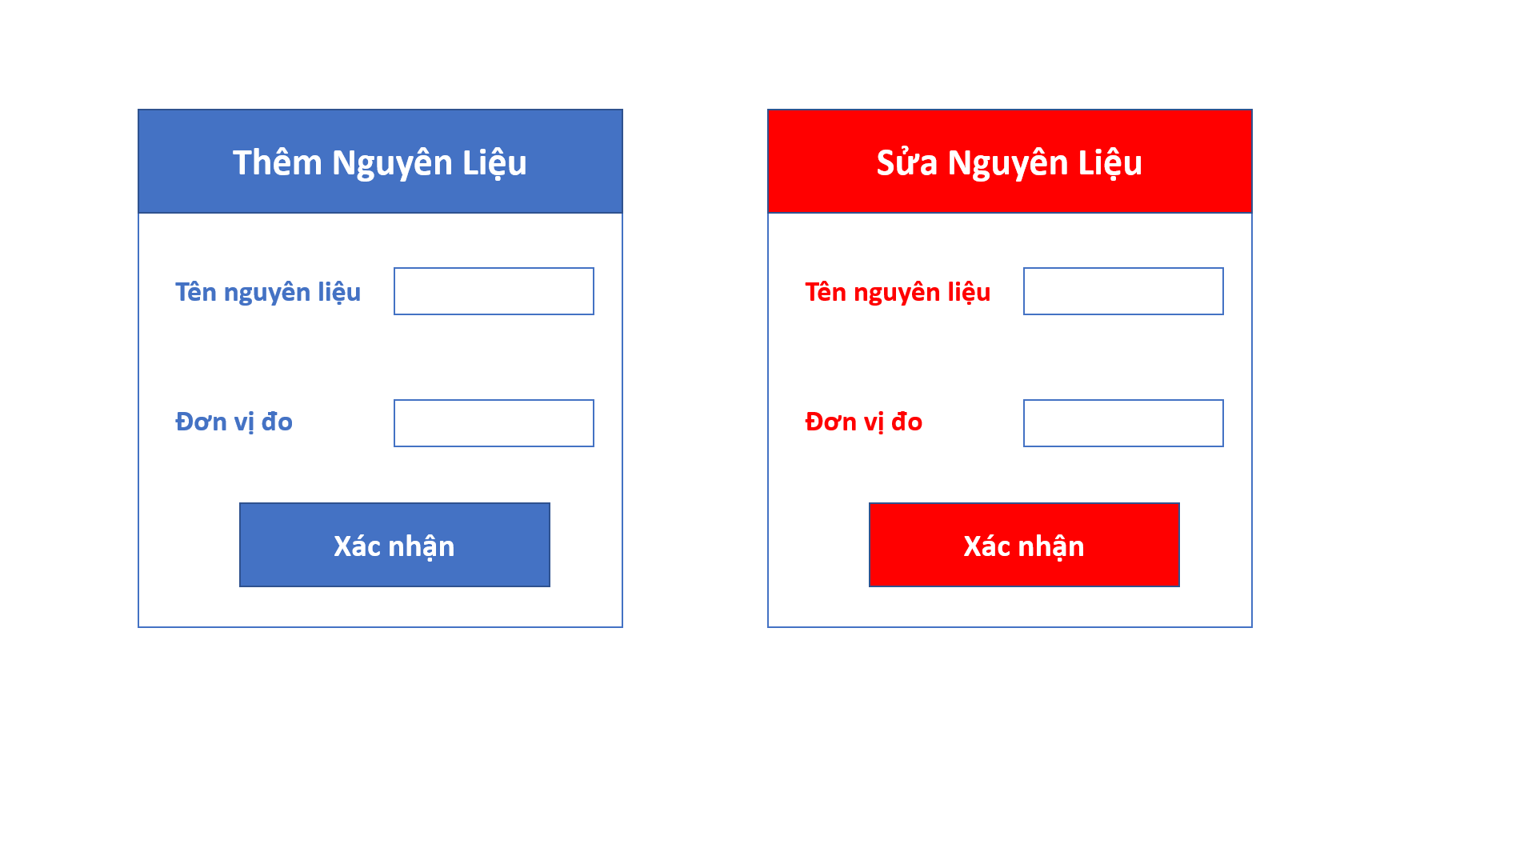

## Slip management

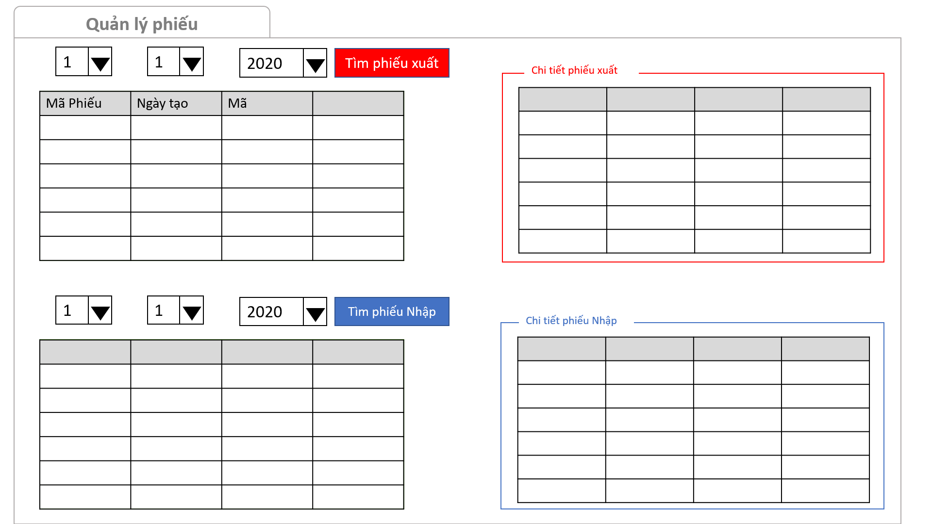

## Order

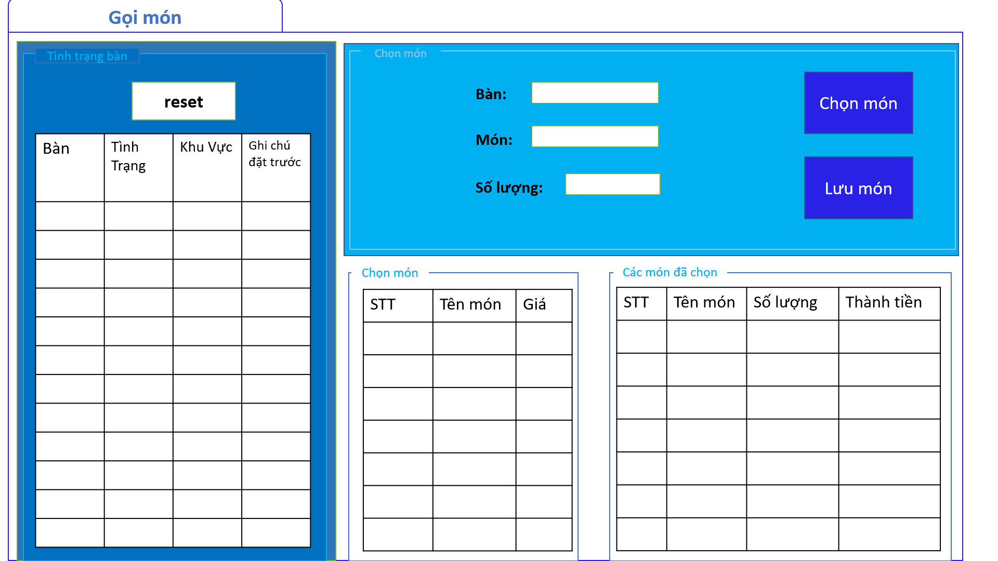

## Payment



## Menu Management

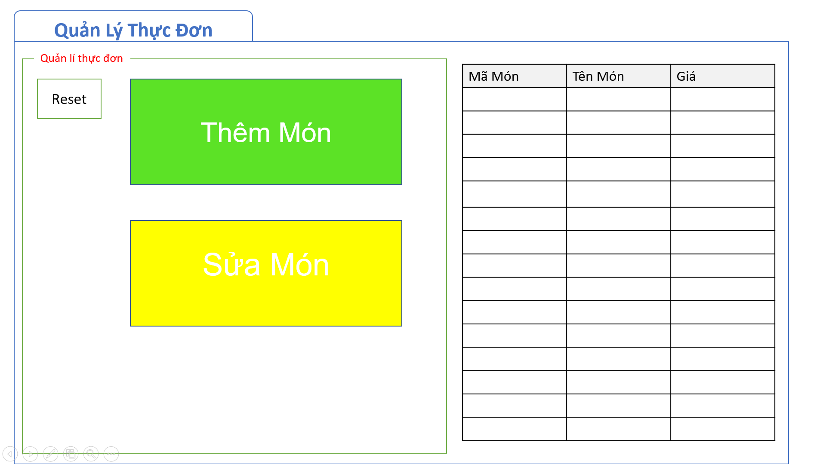

## Add, Edit Menu

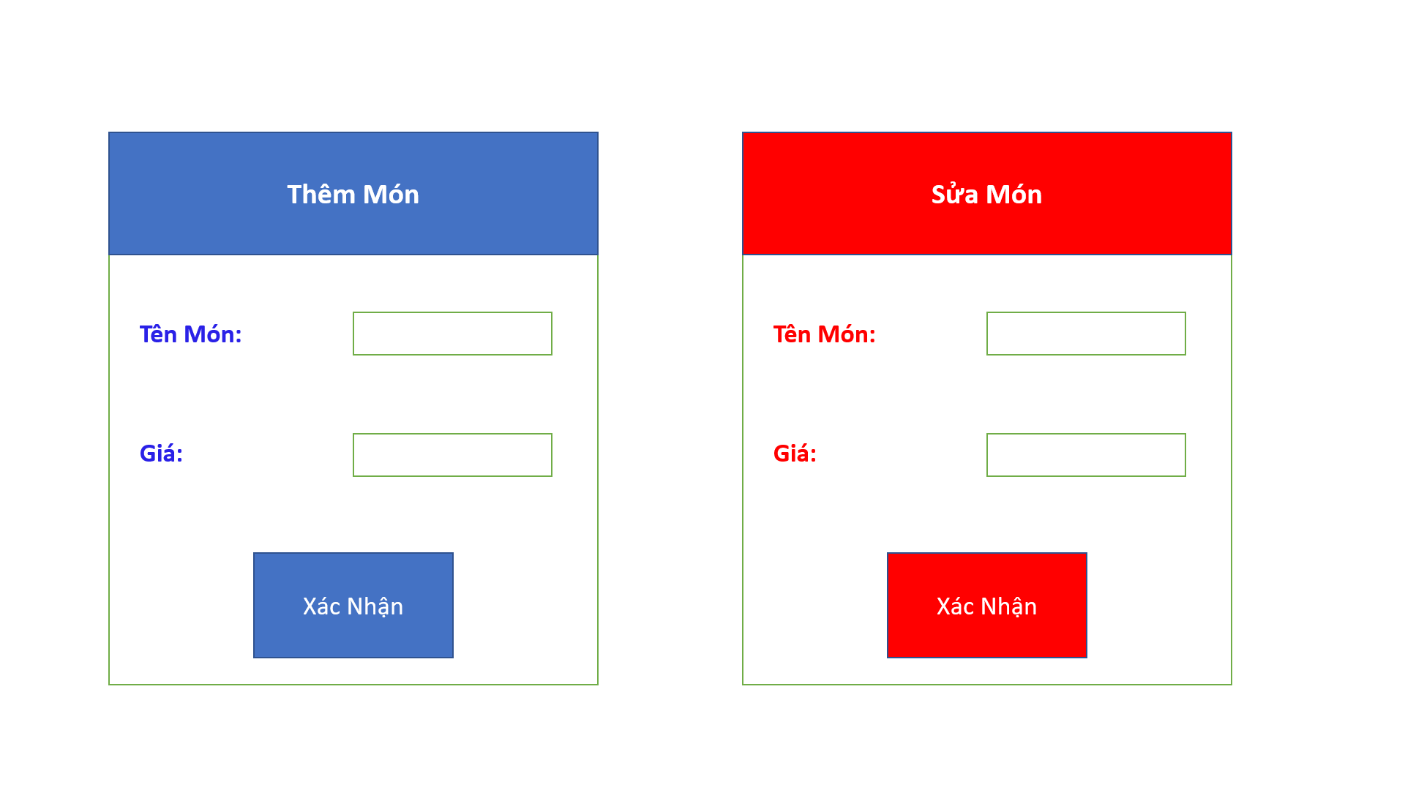

## Employee Management

## 

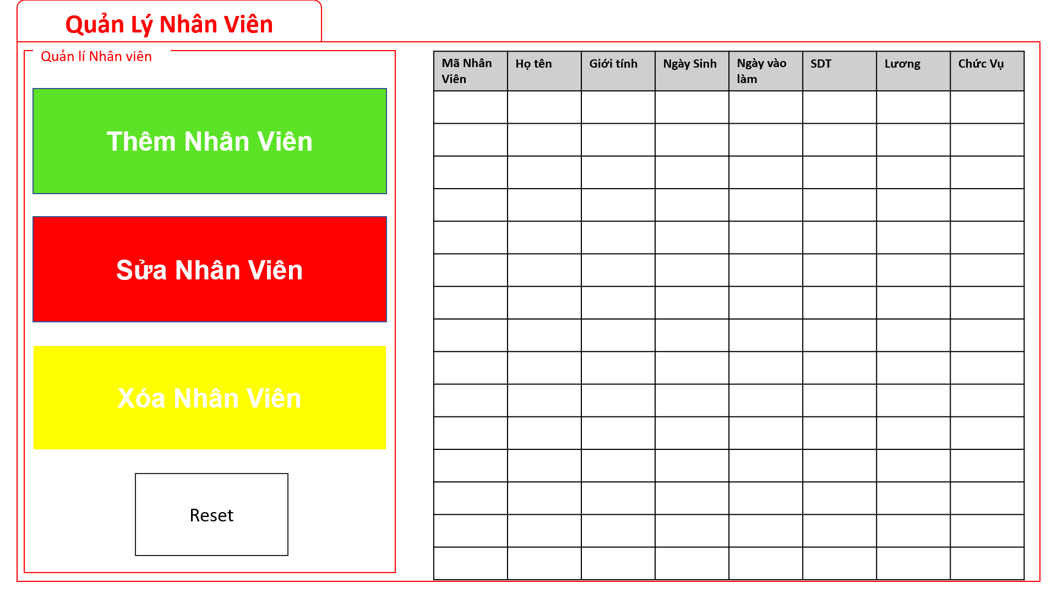

## Add, edit employee

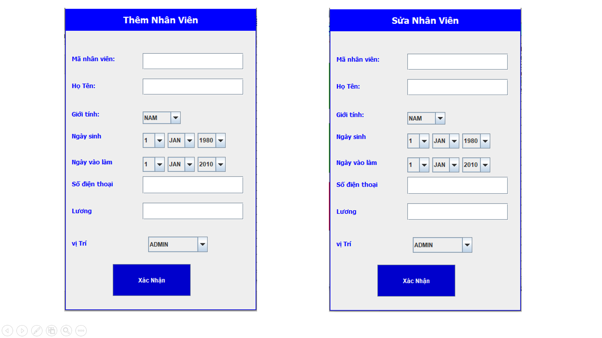

## Account management

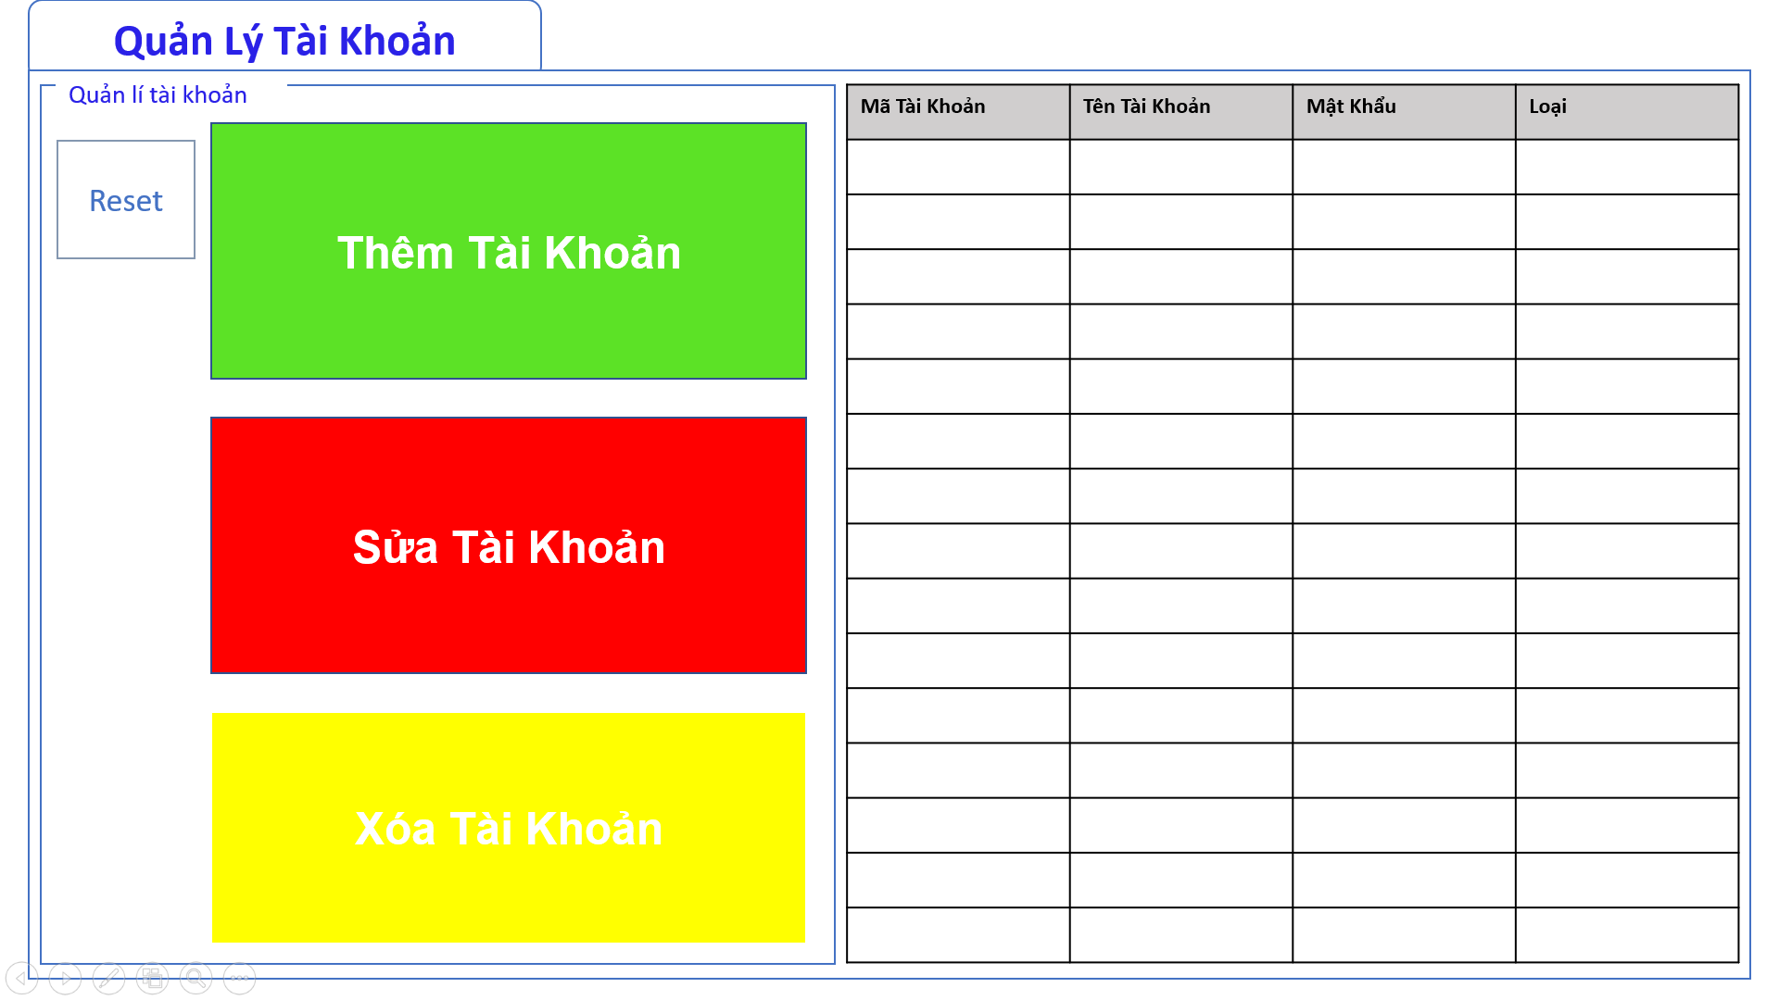

## Add account, change password

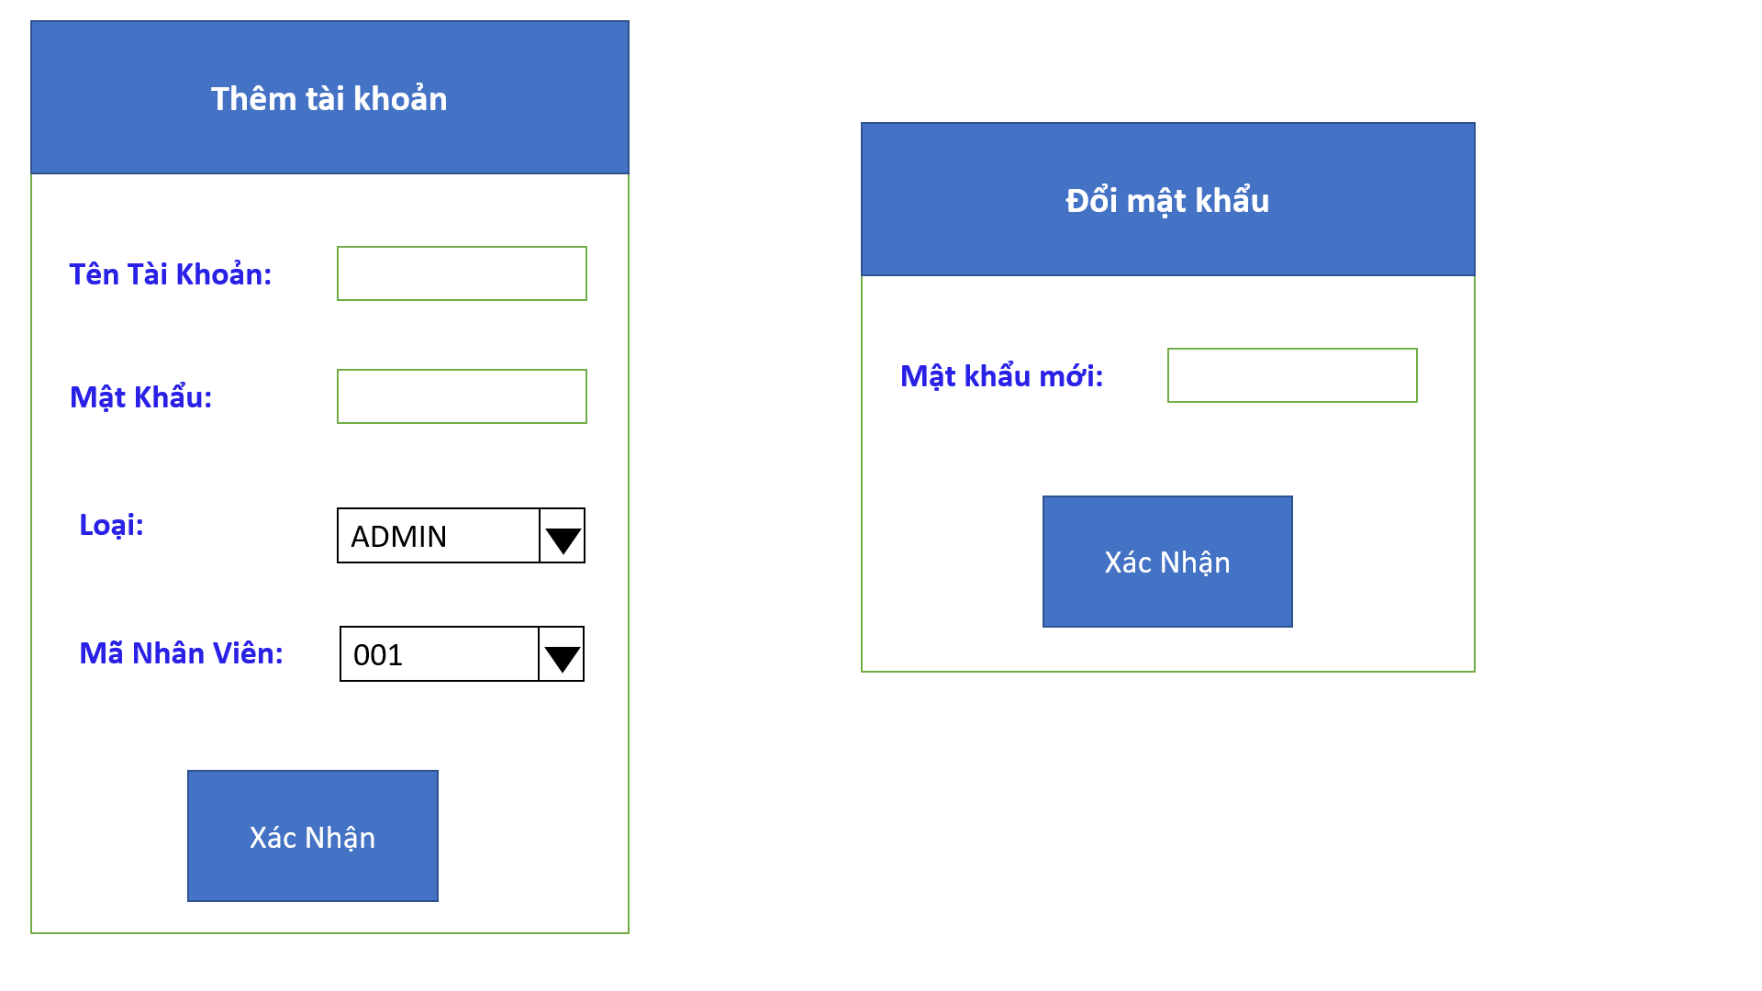

## Table Management

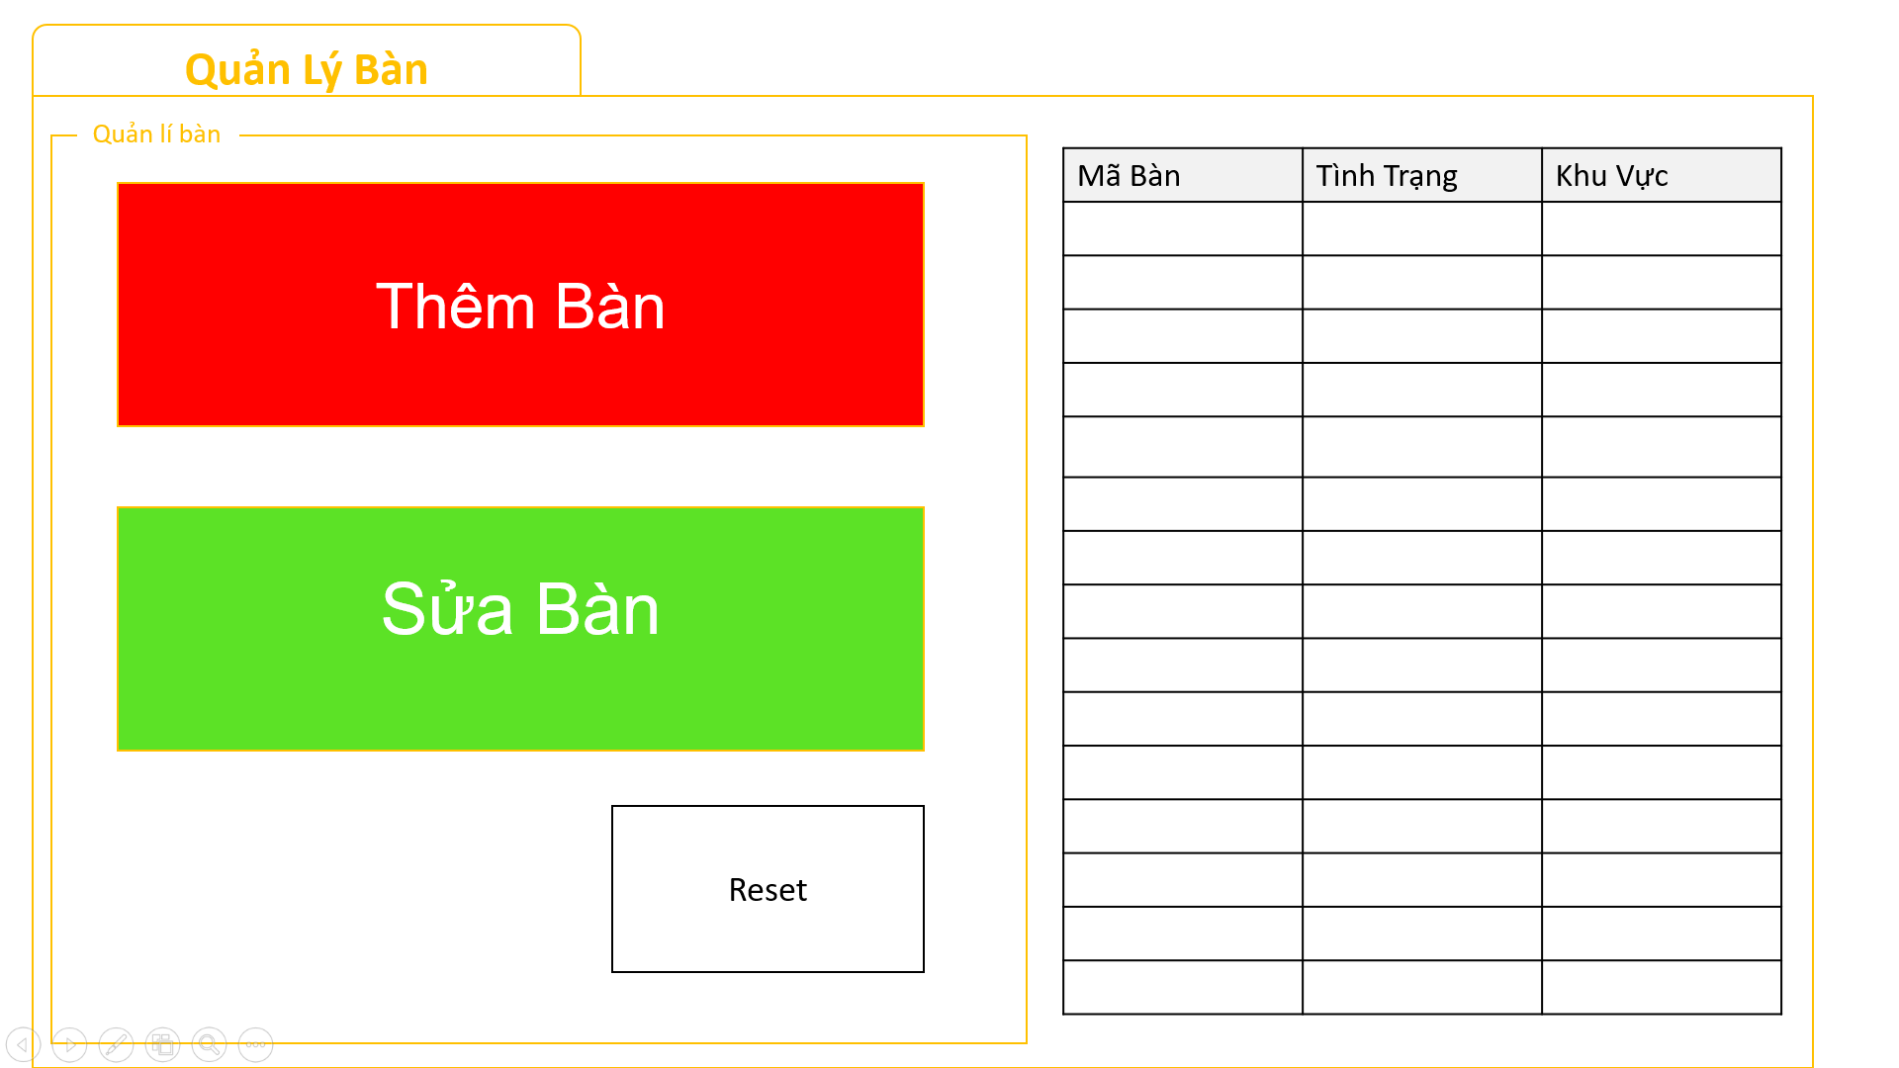

## Add table

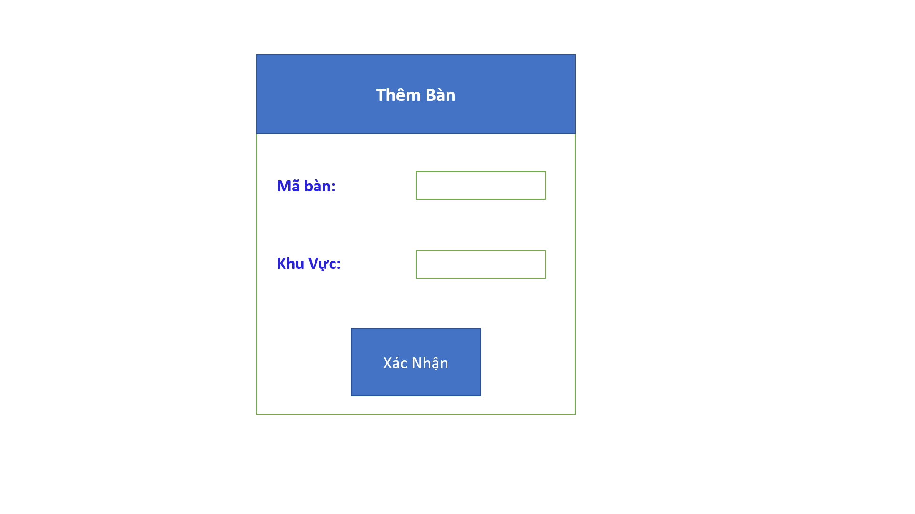

## View Statistic of Area

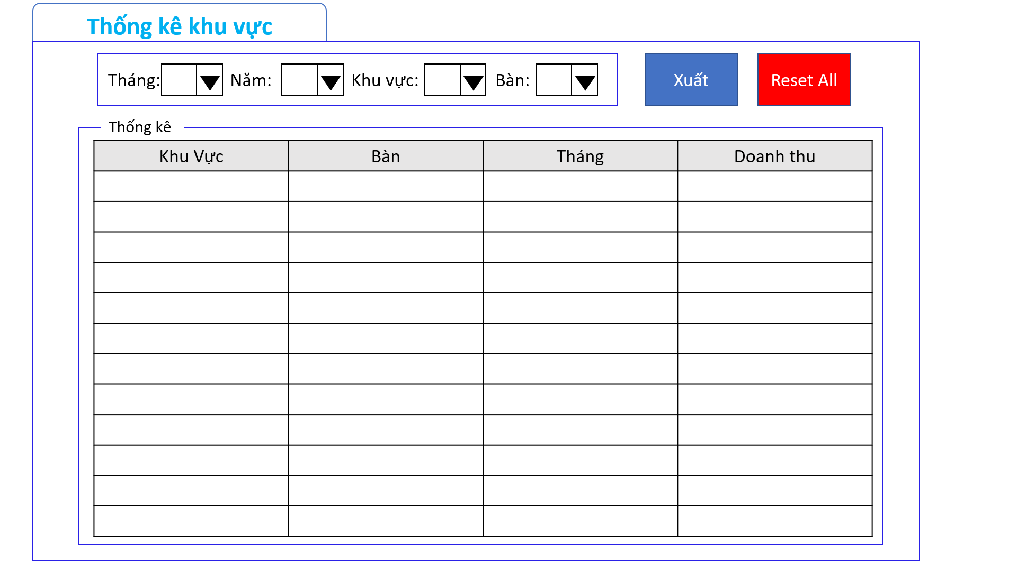

## View Statistic of Days

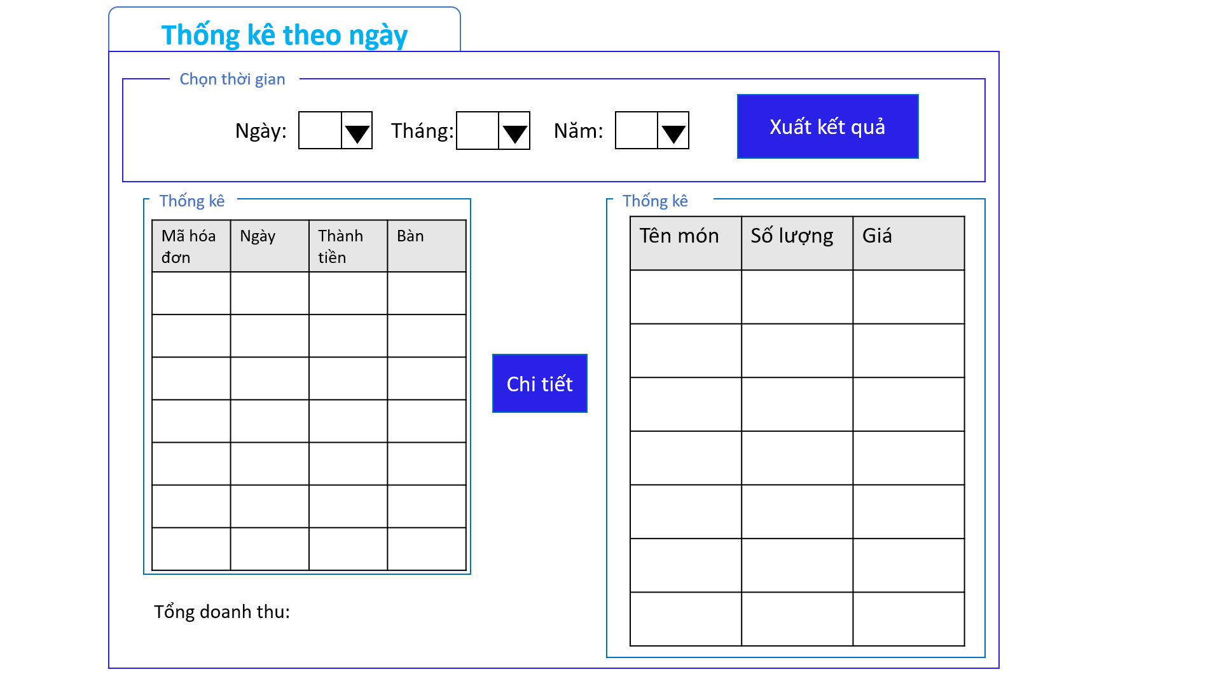

## View Statistic of Area

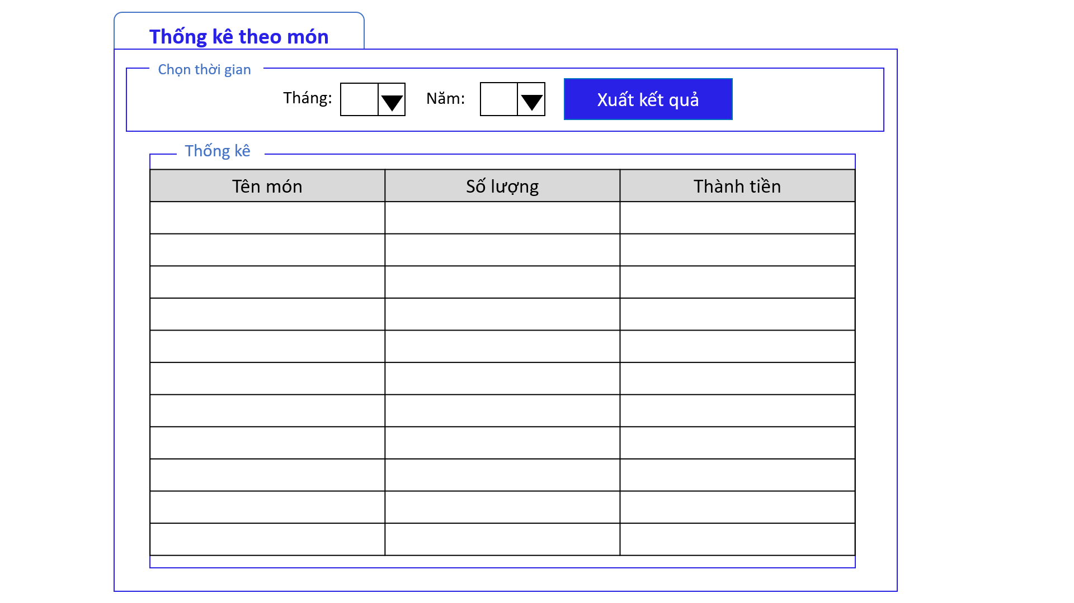

# CONCLUSION

## Gained result

Over the last semester, our team has learned how to apply the knowledge of Analysis and Design of information systems and has achieved some results as follows:

* On the side of knowledge gained:
* Steps to analyze and design a topic.
* Understand and master the subject knowledge provided.
* Simulating the business of a topic through use case diagrams, agents.
* Analyze the design of processing components according to the method of structuring through DFD and ERD diagrams.

Analyze the design of processing components according to the object-oriented method through the Use case Diagram, Activity Diagram, Sequence Diagram and Class Diagram.

* On the silde of obtained project:
* Building a "cafe management system" with basically the following functions:
* Login
* Information management of materials
* Employee information management
* Service process management
* Financial statistics
* Management is not as complicated as before.
* Easy to deploy to software development.
* Improving students' creative ideas in the process of acquiring knowledge and applying it in reality
* Apply knowledge from subjects such as Information Technology Project Management, Java Programming and Database Management System to support and complete the application.

## Disavantages

Due to the short time plus a large workload, we encountered some limitations during the implementation of the project:

- The management system still faces many difficulties due to the lack of some management items

- The simultaneous handling scenarios are not yet realistic

- Not adept in using UI / UX drawing support tools and other diagrams.

## Development

In order to overcome our group's limitations as well as software development, the group proposed some solutions as follows:

* Proficient in using of diagram tools and UI/UX
* Improve knowledge in surveying the current situation and actual needs in system development
* Actively adding skills in drawing diagrams